UNITED STATES
SECURITIES AND EXCHANGE COMMISSION
Washington, D.C. 20549
SCHEDULE 14A INFORMATION
Consent Solicitation Statement Pursuant to Section 14(a) of the
Securities Exchange Act of 1934

Filed by the Registrant |  |  | x
Filed by a Party other than the Registrant |  |  | ☐
Check the appropriate box:
☐ |  |  | Preliminary Proxy Statement
☐ |  |  | Confidential, for Use of the Commission Only (as permitted by Rule 14a-6(e)(2))
x |  |  | Definitive Proxy Statement
☐ |  |  | Definitive Additional Materials
☐ |  |  | Soliciting Material pursuant to § 240.14a-12
CASS INFORMATION SYSTEMS, INC.
(Name of registrant as specified in its charter)
(Name of Person(s) Filing Proxy Statement, if other than the Registrant)
Payment of Filing Fee (check the appropriate box):
x |  |  | No fee required
☐ |  |  | Fee paid previously with preliminary materials

Cass Information Systems, Inc.
12444 Powerscourt Drive, Suite 550
St. Louis, Missouri, 63131
Notice of Annual Meeting of Shareholders
To be held on April 21, 2026
The Annual Meeting of Shareholders of Cass Information Systems, Inc. will be held at the location specified below on Tuesday, April 21, 2026, at 8:00 a.m. local time, for the following purposes:
1.To elect seven directors to serve, each for a one-year term;
2.To approve, through a non-binding advisory vote, the Company's executive compensation;
3.To ratify the appointment of KPMG LLP as the independent registered public accounting firm for 2026; and
4.To act upon such other matters as may properly come before the Annual Meeting or any adjournment thereof.
The close of business on March 2, 2026 has been fixed as the record date for determining shareholders entitled to notice of and to vote at the Annual Meeting or any adjournment thereof.
This year’s Annual Meeting will be held at The Bogey Club, located at 9266 Clayton Road, Saint Louis, Missouri 63124.
All shareholders are cordially invited to attend the Annual Meeting.
This booklet includes the notice and proxy statement, which describes the business we will conduct at the meeting and provides information about the Company that you should consider when you vote your shares. The Company has not planned a communications segment or any presentations for the Annual Meeting.
Whether or not you intend to be present, it is important that your shares be represented and voted at the Annual Meeting. You can vote your shares by one of the following methods: vote over the internet or by telephone using the instructions on your proxy card, or mark, sign, date and promptly return your proxy card. The presence, in person or by properly executed proxy, of a majority of the common stock outstanding on the record date is necessary to constitute a quorum at the Annual Meeting.
Please note that you will be required to present an admission ticket to attend the Annual Meeting. Your admission ticket is attached to your proxy card. If your shares are held in the name of a broker, trust, bank or other nominee, you can request an admission ticket by contacting our Investor Relations department at (314) 506-5500 or ir@cassinfo.com.
By Order of the Board of Directors,

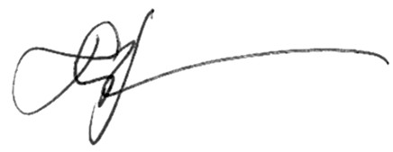
Matthew S. Schuckman
Secretary
St. Louis, Missouri
March 6, 2026
1

Important Notice Regarding the Availability of Proxy Materials for the Annual Meeting of Shareholders to be held on April 21, 2026:
The Company’s Proxy Statement and annual report on Form 10-K for the 2025 fiscal year are available free of charge at www.investorvote.com/cass and on our Investor Relations site at www.cassinfo.com.
The Company makes available free of charge, through its website www.cassinfo.com, its annual report on Form 10-K, quarterly reports on Form 10-Q, current reports on Form 8-K and amendments to those reports filed and furnished pursuant to Section 13(a) or 15(d) of the Securities Exchange Act of 1934, as amended (the Exchange Act), as soon as reasonably practicable after such documents are electronically filed with, or furnished to, the Securities and Exchange Commission (the SEC).

2

CASS INFORMATION SYSTEMS, INC.
Proxy Statement
Table of Contents
Proposal No. 1 - Election of Directors |  |  | 6
Director Biographies |  |  | 7
Corporate Governance |  |  | 12
Corporate Governance Guidelines |  |  | 12
Board Evaluation |  |  | 12
Board Leadership Structure |  |  | 12
Risk Management Oversight |  |  | 13
Communications with Directors |  |  | 14
Board Meetings and Committees |  |  | 14
Board Diversity |  |  | 17
Director Compensation |  |  | 17
Certain Relationships and Related Party Transactions |  |  | 19
Report of the Audit and Risk Committee |  |  | 20
Information Security and Data Privacy |  |  | 20
Insider Trading Policy and Procedures |  |  | 21
Environmental, Social, and Governance |  |  | 21
Shareholder Engagement |  |  | 22
Proposal No. 2 - Advisory Vote on Executive Compensation |  |  | 23
Executive Compensation |  |  | 24
Compensation Discussions and Analysis |  |  | 24
Committee Review of Executive Compensation |  |  | 27

Shareholder Feedback on Say on Pay |  |  | 28
Role of the Compensation Committee's Independent Consultant |  |  | 28
Executive Summary of Results |  |  | 28
Elements of Compensation |  |  | 29
CEO Pay Ratio |  |  | 36
Post-Fiscal Year Compensation Actions |  |  | 36
Compensation Committee Report |  |  | 38
Executive Officers |  |  | 38
Summary Compensation Table |  |  | 40
Grants of Plan-Based Awards |  |  | 41
Outstanding Equity Awards at Fiscal Year-End |  |  | 42
Pay Versus Performance Table |  |  | 43
Stock Vested |  |  | 50
Ownership of Common Stock |  |  | 51
Directors and Officers |  |  | 51
Proposal No. 3 - Ratification of Appointment of Independent Registered Public Accounting Firm |  |  | 54
Shareholder Proposals for the 2027 Annual Meeting |  |  | 55
Other Matters; Householding; Availability of Proxy Materials |  |  | 57
Annex A |  |  | 58
Reconciliation of Non-GAAP Financial Information |  |  | 58

3

Proxy Statement
Cass Information Systems, Inc.
12444 Powerscourt Drive, Suite 550
St. Louis, Missouri, 63131
Proxy Statement
Annual Meeting of Shareholders to be held April 21, 2026
This Proxy Statement is being furnished to the common shareholders of Cass Information Systems, Inc. (the Company) on or about March 6, 2026 in connection with the solicitation of proxies on behalf of the Board of Directors of the Company (the Board) for use at the annual meeting of shareholders (the Annual Meeting) to be held on April 21, 2026 at the time and place and for the purposes set forth in the accompanying Notice of Annual Meeting, and at any adjournment of that meeting.
Holders of common stock, par value $0.50 per share, of the Company at its close of business on March 2, 2026 (the Record Date) are entitled to receive notice of and vote at the Annual Meeting. On the Record Date, there were 12,908,298 shares of common stock outstanding and entitled to vote at the Annual Meeting. Holders of record of common stock are entitled to one vote per share of common stock they held of record on the Record Date on each matter that may properly come before the Annual Meeting. Company management and members of the Board, in the aggregate, directly or indirectly controlled approximately 3.42% of the common stock outstanding on the Record Date.
Shareholders of record on the Record Date are entitled to cast their votes in person or by properly executed proxies at the Annual Meeting. The presence, in person or by properly executed proxy, of a majority of the shares of common stock outstanding on the Record Date is necessary to constitute a quorum at the Annual Meeting. If a quorum is not present at the time the Annual Meeting is convened, the Company may adjourn the Annual Meeting.
If a quorum is present, the affirmative vote of a majority of the shares entitled to vote which are present in person or represented by proxy at the Annual Meeting is required to elect directors; approve, by advisory vote, executive compensation; ratify the appointment of KPMG LLP as the Company’s independent registered public accounting firm for 2026; and to act on any other matters properly brought before the Annual Meeting. This means that of the shares represented at the Annual Meeting and entitled to vote, a majority of them must be voted “for” a director nominee for such nominee to be elected or “for” such other proposal for it to be approved. Shareholders may not cumulate their votes in the election of directors.
In tabulating the voting results, abstentions and shares represented by broker non-votes (explained below) will be counted as present and entitled to vote for purposes of determining a quorum. For purposes of determining whether the shareholders have elected a director nominee or approved a matter, abstentions are treated as shares represented and entitled to vote on each proposal and will thus have the same effect as a vote “against” a director nominee or such other proposal. Shares held by brokers that do not have discretionary authority to vote on a proposal and have not received voting instructions from their clients are considered “broker non-votes.” Broker non-votes will not be considered in determining the number of votes necessary for approval of a matter and will have no effect on the outcome of the vote for directors or other proposals. As such, for your vote to be counted, you must submit your voting instruction form to your broker.
Please note that brokers may not use discretionary authority to vote shares on the election of directors if they have not received instructions from their clients. Please vote your proxy so your vote can be counted. The inspector of elections appointed for the Annual Meeting will separately tabulate and certify affirmative and negative votes, abstentions and broker non-votes.
Any proxy given pursuant to this solicitation may be revoked by the person giving it at any time before it is voted. Proxies may be revoked by (i) filing with the Secretary of the Company, at or before the Annual Meeting, a written notice of revocation bearing a date later than the date of the proxy, (ii) duly executing and dating a subsequent proxy relating to the common stock and delivering it to the Secretary of the Company at or before the vote is taken at the Annual Meeting, or (iii) attending the Annual Meeting and voting in person (although attendance at the Annual Meeting will not in and of itself
4

constitute a revocation of a proxy). Any written notice revoking a proxy, or any subsequent proxy, should be sent to Cass Information Systems, Inc., Attn: Matthew S. Schuckman, Secretary, 12444 Powerscourt Drive, Suite 550, St. Louis, Missouri 63131.
All common stock represented at the Annual Meeting by properly executed proxies received prior to or at the Annual Meeting and not properly revoked will be voted at the Annual Meeting in accordance with the instructions indicated in such proxies. If no instructions are indicated, such proxies will be voted FOR the election of the Board’s director nominees; FOR approval, on an advisory basis, of executive compensation; FOR the ratification of the appointment of KPMG LLP as the Company’s independent registered public accounting firm for 2026; and in the discretion of the proxies with respect to any other matter that is properly brought before the Annual Meeting or any adjournment thereof. The Board does not know of any matters other than the matters described in the Notice of Annual Meeting attached to the Proxy Statement that will come before the Annual Meeting.
The Board solicits the proxies. In addition to the use of the mails, proxies may be solicited personally or by telephone or electronic transmission by directors, officers or regular employees of the Company. It is contemplated that brokerage houses, custodians, nominees and fiduciaries will be requested to forward the soliciting material to the beneficial owners of common stock held of record by such persons and will be reimbursed by the Company for expenses incurred therewith. The cost of solicitation of proxies will be borne by the Company.

5

Proposal No. 1
Election of Directors
Composition of the Board, Board Diversity and Director Qualifications
Proposal 1: Election of Directors
The Board recommends a vote FOR each director nominee.
Committee
Memberships*
Name and  Principal Occupation |  |  | Independent |  |  | Age |  |  | Director Since |  |  | ARC |  |  | CC |  |  | NGC
Eric H. Brunngraber  Director |  |  | No |  |  | 69 |  |  | 2003
John J. Drabik  Director |  |  | Yes |  |  | 53 |  |  | N/A
Benjamin F. Edwards, IV  Director |  |  | Yes |  |  | 70 |  |  | 2005 |  |  |  |  |  |  |  |  | ò
Wendy J. Henry  Director |  |  | Yes |  |  | 64 |  |  | 2022 |  |  | ò
Ann W. Marr  Director |  |  | Yes |  |  | 68 |  |  | 2022 |  |  |  |  |  | ò |  |  | ò
Martin H. Resch  Director |  |  | No |  |  | 60 |  |  | 2023
Joseph D. Rupp  Director |  |  | Yes |  |  | 75 |  |  | 2016 |  |  |  |  |  | ò
Key to Committees:
ARC |  |  | Audit and Risk Committee |  |  | CC |  |  | Compensation Committee |  |  | NGC |  |  | Nominating and Corporate Governance Committee
*Reflective of current committee membership as of the date of this Proxy Statement.

Composition of the Board
The size of the Company's Board at December 31, 2025 was 12 members, and as currently proposed will be 10 members after the annual meeting of shareholders on April 21, 2026.
On January 21, 2025, the Board approved and adopted the Third Amended and Restated Bylaws of the Company (as so amended, the “Bylaws”). Prior to the adoption of the amended Bylaws, the Board was divided into three classes as each director was elected for a three-year term, and the term of each class of directors expired in successive years. The amended Bylaws work to declassify the Board as directors’ terms expire as follows: each director elected at the 2025 annual meeting of shareholders was elected for a one-year term expiring at the 2026 annual meeting of shareholders; each director elected at the 2026 annual meeting of shareholders will be elected for a one-year term expiring at the 2027 annual meeting of shareholders; and at the 2027 annual meeting of shareholders and at each annual meeting of shareholders thereafter, all directors will be elected for a one-year term expiring at the next annual meeting of shareholders.
6
Proposal No. 1 - Election of Directors
Nominees and Continuing Directors
Ralph W. Clermont, James J. Lindemann, and Sally H. Roth are retiring from the Board of Directors as of the 2026 Annual Meeting of Shareholders. The Nominating and Corporate Governance Committee has nominated incumbent directors Eric H. Brunngraber, Benjamin F. Edwards, IV, Wendy J. Henry, Ann W. Marr, Martin H. Resch, and Joseph D. Rupp for re-election, each to serve a one-year term. John J. Drabik, Executive Vice President and Chief Financial Officer of Energizer Holdings, Inc. is also being nominated by the Nominating and Corporate Governance Committee for a one-year term. Mr. Drabik was recommended for nomination by a non-management director of the Board.
Each of the nominees has consented to serve if elected. If any of them become unavailable to serve as a director before the Annual Meeting, the Board may designate a substitute nominee. In that case, the persons named as proxies will vote for the substitute nominee designated by the Board. Proxies cannot be voted for a greater number of nominees than those named in this Proxy Statement.
The following information is submitted with respect to the nominees for election to the Board, together with the members of the Board whose terms will continue after the Annual Meeting or until their respective successors are duly elected and qualified:

Director Biographies
The following is a brief biographical summary of the experience of our director nominees and continuing directors:
Director nominees to serve a one-year term until 2027:
Eric H. Brunngraber
Eric H. Brunngraber, 69, has been a director since 2003. Mr. Brunngraber currently serves as Chairman of the Company. Prior to becoming Chairman in April 2025, Mr. Brunngraber was Executive Chairman since his retirement as CEO effective April 18, 2023. Mr. Brunngraber served as CEO and Chairman of the Board of Directors from 2015 until his retirement as CEO. Mr. Brunngraber has served in several executive and numerous other positions with the Company since his employment with the Company began in 1979, including as CEO from 2008 until April 2023, President from 2006 to 2022, Chief Operating Officer (COO) from 2006 to 2008, Chief Financial Officer (CFO) from 1997 to 2006, and Executive Vice President of Cass Commercial Bank, the Company’s bank subsidiary. Mr. Brunngraber is and has been active in numerous civic, charitable, and professional organizations in the St. Louis metropolitan area.
The Board selected Mr. Brunngraber to serve as a director because of his long tenure with the Company that has provided him with a deep understanding of its strategy, business lines, operations, finance, regulatory environment, and culture.
John J. Drabik
John J. Drabik, 53, has been nominated by the Board to be a new director in April 2026. Mr. Drabik serves as the Executive Vice President and Chief Financial Officer at Energizer Holdings, Inc., a position he has held since October 2021. Mr. Drabik joined Energizer's corporate finance organization in 2001 and held previous roles of Senior Vice President, Corporate Controller and Chief Accounting Officer (2019-2021), Vice President, Corporate Controller and Treasurer (2017-2019), and Vice President of Corporate Development and Treasurer (2015-2017). Prior to his tenure at Energizer, Mr. Drabik began his career in public accounting at Arthur Andersen and later worked in May Department Stores' import/export division. Mr. Drabik holds a Bachelor of Science in Accountancy from the University of Missouri and an MBA from Washington University in St. Louis.
The Board selected Mr. Drabik for his financial expertise, including understanding the complex financial and accounting issues that face multi-faceted organizations such as the Company, in addition to his experience with the complex regulatory and other issues facing the CFO of a public company.

7
Proposal No. 1 - Election of Directors

Benjamin F. Edwards, IV
Benjamin F. Edwards, IV, 70, has been a director since 2005. He is Chairman, CEO and President of Benjamin F. Edwards & Company, a St. Louis-based investment firm. Previously, Mr. Edwards was branch manager of the Town & Country, Missouri office of A.G. Edwards/Wachovia Securities LLC, a national investment firm. Mr. Edwards’ career with A.G. Edwards began in 1977, where he held numerous positions including Employment Manager, Financial Advisor, Associate Branch Manager, Regional Officer, Director of Sales and Marketing and President, as well as a member of the Board of Directors of A.G. Edwards from 1994 to 2007. He currently is a member of the Board of The Bogey Club in St. Louis and a member of the CEO Forum.
The Board selected Mr. Edwards to serve as a director because of his management expertise in investment banking, including experience with capital markets transactions and investments in both public and private companies.
Wendy J. Henry
Wendy J. Henry, 64, has been a director since 2022. Ms. Henry served as Managing Partner of the BKD, LLP (BKD), now Forvis Mazars, LLP, St. Louis office until her retirement in 2021. Prior to becoming Managing Partner, Ms. Henry served as an Audit Partner in BKD’s Colorado office, where she held various positions and managed the audits of numerous organizations. Her career at BKD began in 1993 when her prior firm merged into BKD. Ms. Henry is a retired certified public accountant and member of the American Institute of Certified Public Accountants and has previously served on the board of directors at United Way of Greater St. Louis, St. Louis Zoo, Mercy Health East Communities, and Regional Business Council. She earned her bachelor’s degree in business with a concentration in accounting from Illinois College.
The Board selected Ms. Henry for her financial and risk management expertise, including understanding the complex risk management, financial and accounting issues that face multi-faceted organizations such as the Company.

Ann W. Marr
Ann W. Marr, 68, has been a director since August 2022. She joined World Wide Technology, Inc. (WWT), a St. Louis based systems integrations, value added reseller and software development company, in 1997 as Executive Vice President of Global Human Resources, a position she served in until her retirement in January 2024. Ms. Marr has over 30 years of experience in human resources and has previously held positions with Enterprise Rent-A-Car and Anheuser Busch Companies. Ms. Marr also managed WWT’s Corporate Development Program, which includes diversity and inclusion, supplier diversity and small business enterprise, and was President of the WWT Charitable Foundation. She is very active in the St. Louis community, having served on the Board of Trustees for Maryville University, the St. Louis Regional Chamber Association, the United Way of Greater St. Louis, Charmaine Chapman Society, The St. Louis Police Foundation, and the Gateway Arch Park Foundation. Ms. Marr is also on the Advisory Board of the National Association of African Americans in Human Resources and a member of the Society for Human Resource Management.
The Board selected Ms. Marr to serve as a director because of her extensive background in human capital management, bringing perspective to the dramatic changes in the work environment and her leadership and oversight experience with respect human resources and other executive compensation related matters.

8
Proposal No. 1 - Election of Directors
Martin H. Resch
Martin H. Resch, 60, was elected to serve as a director in 2023. Mr. Resch is President and CEO of the Company, positions he has held since 2022 and April 2023, respectively. Prior to joining the Company in November 2020, Mr. Resch was senior executive at Bank of the West in San Francisco, California. As executive vice president, Mr. Resch functioned as the commercial banking group’s chief administrative officer/chief operating officer with responsibility for strategy, operations, finance, technology and human resources and collaborated with a B2B FinTech incubator. His other roles at Bank of the West included serving as corporate treasurer and leading the regulatory response to the Dodd-Frank and Volcker legislation. Mr. Resch earned his bachelor’s degree in computer science from Oregon State University and master’s degree in business administration from Cornell University.
The Board selected Mr. Resch to serve as a director because of his role as the Company’s CEO in which he is responsible for the strategic direction and day-to-day leadership of the Company. Furthermore, Mr. Resch has highly relevant technology experience and valuable insights running banks.

Joseph D. Rupp
Joseph D. Rupp, 75, has been a director since 2016. He currently serves as Lead Director of the Board, a position he has held since 2019. He retired from a 45-year tenure with Olin Corporation (Olin), a publicly traded global manufacturer and distributor of chemical products and a leading U.S. manufacturer of ammunition located in Clayton, Missouri. During his time at Olin, Mr. Rupp served as Chairman of the Board from 2016 until his retirement in 2017, as Chairman and CEO from 2015 to 2016, as Chairman, President and CEO from 2005 to 2014, and as President and CEO from 2002 to 2005. Mr. Rupp previously served on the board of directors of Nucor Corporation, a publicly traded producer of steel and related products, Dot Foods, Inc., a privately held foodservice redistribution company, and O-I Glass, Inc., a publicly traded glass bottle manufacturer. He earned his bachelor’s degree in metallurgical engineering from Missouri University of Science and Technology.
The Board selected Mr. Rupp to serve as Lead Director because it believes he has valuable experience understanding the day-to-day and more complex issues that face multi-faceted, publicly traded organizations.
The Company's Board recommends a vote "FOR" the seven nominees for election to the Board of Directors.
9
Proposal No. 1 - Election of Directors
Directors to serve until 2027:
Robert A. Ebel
Robert A. Ebel, 70, has been a director since 2006. He was CEO of Universal Printing Company, a privately-held printing company headquartered in St. Louis, Missouri, until the sale of the company in 2017. Mr. Ebel began his tenure with Universal Printing Company as CFO and Board member in 1986. In 1996, he was appointed to the position of CEO. Mr. Ebel currently serves on the Board of the St. Louis Graphic Arts Joint Health and Welfare Fund and is active in various civic and charitable organizations in the St. Louis metropolitan area.
The Board selected Mr. Ebel to serve as a director because it believes he brings valuable business management and finance expertise to the Board. His duties as CEO of a privately-held business based in St. Louis provided him with a strong knowledge of the local commercial marketplace served by the Company’s subsidiary bank.

Randall L. Schilling
Randall L. Schilling, 63, has been a director since 2009. He is the founder and owner of OPO Startups, a co-working center for digital startups providing space and access to mentors, investors, programming, educational resources, and a community of local entrepreneurs. He was the President and CEO of BoardPaq LLC, a privately-held software company based in St. Charles, Missouri, from 2010 until the sale of the company in 2019. From 1992 to 2010, he was the CEO of Quilogy, Inc., a nationally recognized, privately-held information technology professional services company. Mr. Schilling is currently the President & CEO of Munibit, a privately held software company based in St. Charles, Missouri. Additionally, Mr. Schilling has been active in various other civic and charitable organizations in the St. Louis metropolitan area, including Partners for Progress – Education Chairman.
The Board selected Mr. Schilling to serve as a director because he possesses information technology expertise helpful in addressing the challenges the Company faces in the rapidly changing information technology arena.
Franklin D. Wicks, Jr.
Franklin D. Wicks, Jr., 72, has been a director since 2006. He was Executive Vice President and President of Applied Markets of Sigma-Aldrich Corporation (Sigma-Aldrich), which was a publicly-traded life science and high technology company located in St. Louis, Missouri, until his retirement in 2015. Dr. Wicks worked for Sigma-Aldrich for 33 years, beginning as a research chemist and subsequently working in marketing, then as President of Sigma Chemical and Vice President of Worldwide Operations, Sigma-Aldrich. He served as President, Scientific Research Division, Sigma-Aldrich from 1999 to 2002 and was responsible for operations in 34 countries. Prior to his appointment as Executive Vice President and President of Applied Markets of Sigma-Aldrich, Dr. Wicks served as President-SAFC. After receiving his Ph. D., Dr. Wicks served for four years on the staff of the Navigators at the Air Force Academy and at the University of Colorado at Boulder before joining Sigma-Aldrich. He currently serves as Vice-Chairman on the advisory Board of Covenant Theological Seminary.
The Board selected Dr. Wicks to serve as a director because of his public company senior management experience, familiarity with corporate governance, and knowledge of local and global marketplace issues
Director Independence
Based on the independence standards as defined by the Nasdaq marketplace rules, the Board has determined in its business judgment that all of the directors and director-nominees are independent as such term is defined in the Nasdaq listing standards, except for Mr. Brunngraber and Mr. Resch. In addition, each of the members of the Audit and Risk Committee and Compensation Committee meets the heightened independence standards set forth in the SEC rules and the Nasdaq listing standards. In making these determinations, the Board has reviewed all transactions and relationships between each director (or any member of his or her immediate family) and the Company, including transactions and relationships described in the directors’ responses to questions regarding employment, business, family, and other relationships with the Company and its management. These included transactions relating to non-audit accounting services provided to the Company by Forvis, LLP, Ms. Henry’s former employer, and commissions paid in connection with the Company’s share repurchase program to Benjamin F. Edwards & Company, of which Mr. Edwards serves as Chairman, CEO and President. The Board has concluded that these transactions did not impair director independence for a variety of reasons, including that (i) the amounts in
10
Proposal No. 1 - Election of Directors
question were considerably under the thresholds set forth in applicable independence standards, in each case less than 1% of the recipient's consolidated gross revenues, (ii) Ms. Henry and Mr. Edwards did not have a direct or indirect interest in the transactions, and (iii) the relationships overall were deemed immaterial. As a result of this review, the Board concluded, as to each independent director, that no relationship exists which, in the opinion of the Board, would interfere with the exercise of independent judgment in carrying out the responsibilities of a director.

11

Corporate Governance

Corporate Governance Guidelines
The Board oversees and guides the Company’s management and its business affairs. Committees support the role of the Board on issues that benefit from consideration by a smaller, more focused subset of directors. All committee members are elected by and serve at the pleasure of the Board. In its oversight of the Company, the Board sets the tone for the ethical standards and performance of management, staff, and the Company as a whole. The Board has adopted Corporate Governance Guidelines that capture the long-standing practices of the Company as well as current corporate governance best practices. The guidelines are available on our Investor Relations site at www.cassinfo.com.
The Company has adopted a Code of Conduct and Business Ethics policy, applicable to all Company directors, executive officers and employees. This policy is publicly available and can be viewed on the Company's Investor Relations site at www.cassinfo.com.

Board Evaluation
The Board conducts a self-assessment annually to review its performance over the past year and determine whether it and its committees are functioning effectively. The Chairman of the Nominating and Corporate Governance Committee is responsible for leading the review of the Board and summarizing the overall findings. Each member of the Board conducts a thorough evaluation of the Board as a whole and each member of the Board individually. This assessment seeks to review areas in which the Board and/or management believes a better contribution could be made. The Chairman of the Nominating and Corporate Governance Committee reviews the evaluations and presents a summary of findings to the Board. The Board uses this information to create a set of action items for any areas in which members feel could improve the Board’s effectiveness.
Each individual Board committee also conducts its own self-assessment annually and presents a summary to the Board. The Board then determines if there are steps that should be taken to improve the efficiency and effectiveness of each committee.
The purpose of these annual evaluations is not to focus on individual Board members, but the Board and each committee as a whole. A separate assessment of each individual director is made by the Nominating and Corporate Governance Committee when deciding whether to nominate such director for reelection to the Board.
The Nominating and Corporate Governance Committee periodically reviews the self-assessment process and makes changes it deems necessary to improve the process and its effectiveness.

Board Leadership Structure
The Company’s Corporate Governance Guidelines provide guidance and flexibility that allows the Board to determine the best leadership structure to promote Board effectiveness and ensure that authority and responsibility are effectively allocated between the Board and management. The Board recognizes that no single leadership model is right for all companies and at all times, and depending on the circumstances and personnel, different leadership structures may be appropriate. Accordingly, the Board formally reviews its leadership structure not less than annually as part of its self-evaluation process to ensure that the proper balance is present in the Company’s current model.
The Company's Corporate Governance Guidelines stipulate various qualifications for candidacy as a director of the Company, including protections against "overboarding". These guidelines provide that no director of the Company shall serve on more than four public company boards (inclusive of the Company) while serving on the Board.
In April 2023, as part of a planned succession process, Mr. Brunngraber transitioned roles from Chairman and CEO to Executive Chairman of the Board. In April 2025, Mr. Brunngraber transitioned from Executive Chairman to non-executive Chairman of the Board. Mr. Resch succeeded Mr. Brunngraber as CEO and was elected to the Board. The Board thoroughly
12
Corporate Governance
evaluated its leadership structure in the period leading up to this transition. The Board believes that given Mr. Brunngraber's prior service as CEO and an executive with extensive experience with the Company, he remains best positioned to serve as Chairman at this time. His deep understanding of the Company's operations and long-term strategic priorities uniquely qualify him to provide the continuity necessary to continue to support a smooth transition of the CEO role.
The Board believes that Mr. Rupp, as Lead Independent Director, brings to the Board experience, oversight, and expertise from outside the Company that allows him to provide strong independent oversight of management. The Company’s Corporate Governance Guidelines provide that the Lead Director must qualify as independent in accordance with the Corporate Governance Guidelines. It is the Lead Director’s role to promote the appropriate involvement of the independent directors in governance matters and ensure the effectiveness of the independent directors in their role on behalf of the shareholders. In particular, the Lead Director is responsible for (a) staying regularly informed about the strategy of the Company and about critical issues and performance of the Company; (b) working with both the Chairman and CEO to set the agendas for Board meetings; (c) calling meetings of the independent directors when needed; (d) providing Board leadership in times of crisis; (e) setting the agenda for and chairing executive sessions of the independent directors; (f) acting as liaison between the independent directors and the Chairman for matters raised in executive sessions; (g) chairing meetings of the Board or shareholders when the Chairman is not in attendance; (h) attending meetings of the committees of the Board when necessary or at his/her discretion and communicating regularly with the chairs of the Board committees; (i) working with the Chairman to ensure the conduct of Board meetings provides adequate time for serious discussion of important issues and that appropriate information is made available to Board members on a timely basis; (j) being available on request for consultation and direct communication with major shareholders; and (k) performing such other duties as may be requested from time to time by the Board or by a majority of the independent directors.
For these reasons, and after considering the perspectives of the independent directors, the Board determined that this leadership structure continues to be in the best interests of shareholders at this time. With a former CEO serving as Chairman, there is unified leadership and continuity, while the Lead Independent Director holds management accountable for the Company's continued success. While the Board has determined that this leadership structure is best for the Company and its shareholders at this time, the Board will continue to monitor its effectiveness and appropriateness.
In accordance with the Company’s Corporate Governance Guidelines, non-management directors convene quarterly without the presence of management directors or executive officers of the Company.

Risk Management Oversight
The Board believes that risk is inherent in innovation and the pursuit of long-term growth opportunities. The Company’s management is responsible for day-to-day risk management activities. The Board, acting directly and through its committees, is responsible for the oversight of the Company’s risk management practices. The Board’s role in the Company’s risk oversight process includes regular reviews of information from senior management (generally through Board committee presentation) regarding the areas of material risk to the Company. A description of certain material risks affecting the Company can be found in the Annual Report on Form 10-K for the year ended December 31, 2025. The Compensation Committee is responsible for overseeing the management of risks relating to the Company’s executive compensation plans and arrangements. The Audit and Risk Committee oversees management of financial reporting, legal and regulatory compliance, and information technology risks, including cybersecurity and artificial intelligence risks. The Nominating and Corporate Governance Committee manages risks associated with the independence of the Board, potential conflicts of interest, and environmental, social, and governance (ESG) matters. Each committee reports regularly to the full Board on its activities. In addition, the Board participates in regular discussions with the Company’s senior management on many core subjects, including strategy, operations, finance, legal compliance, technology and security, and public policy matters, in which risk oversight is an inherent element. The members of the Board also receive regular training from outside counsel and thought leaders on key risk topics, including legal and regulatory compliance, public company reporting requirements, ESG matters, AI, information technology, cybersecurity and data privacy, as well as other topics of importance to public company governance, in order to remain current on best practices in managing risk.

13
Corporate Governance
Communications with the Board of Directors
The Board has established a process by which shareholders can communicate with the Board. Shareholders may communicate with any and all members of the Board by transmitting correspondence to the following address: Cass Information Systems, Inc., Name of Director(s), Attn: Matthew S. Schuckman, Secretary, 12444 Powerscourt Drive, Suite 550, St. Louis, Missouri 63131.
The Secretary will forward all correspondence to the Chairman or the identified director as soon as practicable. Correspondence addressed to the full Board will be forwarded to the Chairman, who will present the correspondence to the full Board or a committee thereof.

Board Meetings and Committees of the Board
The Board holds regularly scheduled meetings in January, April, July, and October. During the fiscal year ended December 31, 2025, the Board held its four regular meetings, and one additional offsite planning meeting was held in November to discuss the Company’s strategic plan. All directors attended at least 75% of the aggregate number of meetings of the Board and committees on which they served in 2025. The Company’s directors are encouraged, but not required, to attend the Company’s Annual Meeting. Each director who was serving on the Board at the time of the 2025 Annual Meeting of Shareholders attended the 2025 Annual Meeting of Shareholders.
The Company has three standing committees: the Audit and Risk Committee, the Nominating and Corporate Governance Committee, and the Compensation Committee. Each of these committees has a written charter approved by the Board annually. A copy of each charter can be found in the Investor Relations section of the Company’s website at www.cassinfo.com.
The following table represents the current membership of each of the Board committees and number of meetings held by each committee in 2025 (in parentheses). Each of the committees is comprised entirely of independent directors, as defined by Nasdaq and SEC rules.
Audit and Risk (5) |  |  | Nominating and Corporate Governance (4) |  |  | Compensation (5)
Ralph W. Clermont |  |  | Ralph W. Clermont |  |  | James J. Lindemann *
Robert A. Ebel |  |  | Benjamin F. Edwards, IV |  |  | Ann W. Marr
Wendy J. Henry* |  |  | Ann W. Marr |  |  | Joseph D. Rupp
Randall L. Schilling |  |  | Sally H. Roth |  |  | Franklin D. Wicks, Jr.
 |  |  | Franklin D. Wicks, Jr. *
*Committee Chairman
Mr. Clermont, Mr. Lindemann and Ms. Roth will cease to be members of the Committees upon their retirement as of the 2026 Annual Meeting of Shareholders.
14
Corporate Governance
Audit and Risk Committee
The Audit and Risk Committee operates pursuant to the written charter approved by the Board. The charter is reviewed annually by the Committee and the Board and amended as appropriate to reflect the changing needs of the Company for risk oversight and the role of the Audit and Risk Committee in providing sound oversight in accordance with current best practices.
The Audit and Risk Committee oversees the accounting and financial reporting processes of the Company and the audits of the Company’s financial statements. The Audit and Risk Committee is responsible for appointing, determining funding for and overseeing the independent registered public accountants for the Company, and meeting with and communicating between the independent registered public accountants and other corporate officers to review and participate in matters relating to corporate financial reporting and accounting procedures and policies. Among other responsibilities, the Audit and Risk Committee reviews financial information provided to shareholders and others, assesses the adequacy of financial and accounting controls, oversees implementation of new accounting standards and evaluates the scope of the audits of the independent registered public accountants and reports on the results of such reviews to the Board. In addition, the Audit and Risk Committee assists the Board in its oversight of the performance of the Company’s internal auditors. The Audit and Risk Committee meets with the internal auditors on a quarterly basis to review the scope and results of their work.
The Audit and Risk Committee also has primary responsibility for overseeing risks related to legal and regulatory compliance, information technology, data protection and cybersecurity, including the implementation of artificial intelligence, although the full Board also exercises oversight over these risks. This oversight includes receiving reports from the Company’s CIO on data protection and cybersecurity matters and strategies on a quarterly basis, with more frequent consultation should the need arise due to a specifically identified threat event or risk. Changes to the Company's information security policies and programs are approved by the Audit and Risk Committee.
The Audit and Risk Committee is composed entirely of independent directors, each of whom meets the SEC's independence and experience requirements. Further, the Board has determined that Ms. Henry qualifies as an “audit committee financial expert,” as defined by the SEC and in accordance with the Nasdaq listing rules. In accordance with the charter, the Audit and Risk Committee meets as often as it determines necessary to fulfill its responsibilities, but not less than quarterly. The Committee met five times in 2025.
Compensation Committee
The Compensation Committee fulfills the Board’s responsibilities relating to compensation of the Company’s directors, CEO, and other executives. The Compensation Committee also has responsibility for approving, evaluating, and administering the compensation plans, policies, and overall programs of the Company. The Compensation Committee is able to delegate any of its responsibilities to one or more subcommittees as it deems appropriate in its discretion.
Compensation Processes and Procedures
As specified in its charter, the Compensation Committee recommends annual retainer fees, Board and committee meeting fees, and terms and awards of stock compensation for non-management directors, subject to appropriate approval by the Board or shareholders.
The Compensation Committee also establishes and administers the Company’s executive compensation program and related benefits. While the Compensation Committee may seek input and recommendations from the CEO, CFO, or the Senior Vice President, Chief Human Resources Officer concerning the elements of executive and director compensation, and confer with them on compensation philosophies, all significant matters regarding compensation for executives are ultimately the responsibility of the Compensation Committee. The Compensation Committee annually reviews corporate goals and objectives relative to the CEO’s compensation and determines the CEO’s compensation level based on this evaluation, subject to Board approval. The Compensation Committee is responsible for recommending to the Board salary levels and incentive stock compensation for executive officers of the Company, and approving incentive stock compensation for other members of management as recommended by the CEO. The responsibility for allocating cash bonuses for executive officers other than the CEO is delegated to the CEO, in accordance with provisions of the profit-sharing program approved by the Board.
15
Corporate Governance
Periodically, the Company uses compensation specialists to assist in designing or modifying some components of its overall compensation program and to provide comparison data of compensation at other organizations with which the Company competes for executive management talent. In such circumstances, the Compensation Committee does not rely solely on survey data or the consultant’s judgment or recommendation, but considers such data when exercising its judgment in evaluating the Company’s compensation program.
Compensation Committee Interlocks and Insider Participation
Ms. Marr and Messrs. Lindemann, Rupp and Wicks served on the Compensation Committee during the entire fiscal year ended December 31, 2025. None of the members of the Compensation Committee during the last fiscal year is or has been an officer or employee of the Company. None of the Company’s executive officers currently serves, or in the past fiscal year has served, as a member of the Board of Directors or compensation committee (or other Board committee performing equivalent functions) of any entity that has one or more of its executive officers serving on the Board or the Compensation Committee.
None of the members of the Company’s Compensation Committee or other members of the Board is a person having a relationship requiring disclosure by the Company pursuant to Item 404 of Regulation S-K.
Nominating and Corporate Governance Committee
The Nominating and Corporate Governance Committee is responsible for identifying individuals qualified to become members of the Board, recommending director-nominees, and developing and addressing corporate governance principles and issues applicable to the Company and its subsidiaries. The Nominating and Corporate Governance Committee also oversees the Company’s progress on ESG matters, working with the Company’s management and ESG Committee.
In recommending director-nominees to the Board, the Nominating and Corporate Governance Committee solicits candidate recommendations from its own members, other directors, and management. In evaluating candidates, the Nominating and Corporate Governance Committee takes into consideration such factors as it deems appropriate, including any legal requirements or listing standards requirements. The Nominating and Corporate Governance Committee considers a candidate’s judgment, skills, integrity and moral character, experience with organizations of comparable size and complexity, the interplay of the candidate’s experience with the experience of other Board members, and the extent to which the candidate would be a desirable and valuable addition to the Board and any committees of the Board. Furthermore, the Nominating and Corporate Governance Committee also evaluates candidates’ relevant experience in business generally and within the financial industry, as well as a candidate’s education and other matters, and seeks candidates with skills and acumen relating to audit and finance functions, corporate governance, culture, human capital management, operations and technology, cybersecurity, risk management, and specific industries strategically important to the Company. With respect to incumbent candidates, the Committee also considers meeting attendance, meeting participation and the Board evaluation. The criteria and selection process are not standardized and could vary from time to time.
In general, no person who will have reached the age of 75 prior to election date may be nominated for election or re-election to the Board. However, the Board will review individual circumstances and the best interests of the Company and its shareholders when considering the nomination of directors and may from time to time choose to nominate a director who is 75 years old or older, particularly where such a director possesses unique skills, experience, or leadership traits, or would otherwise continue to be a valuable contributor to the mission of the Board. It is also the Board’s practice to limit new directors to no more than two per year in order to maintain Board continuity. Mr. Rupp, who is 75 at the time of his nomination, is viewed by the Nominating and Corporate Governance Committee as a valuable resource for the Board and management, given his many years of experience as a public company CEO and board member.

Although the Nominating and Corporate Governance Committee does not specifically solicit suggestions for possible candidates from shareholders, the Nominating and Corporate Governance Committee will consider candidates recommended by shareholders who meet the criteria discussed above and set by the Nominating and Corporate Governance Committee, with the concurrence of the full Board. The criteria will be re-evaluated periodically and will include those criteria set out in the Corporate Governance Guidelines and the Nominating and Corporate Governance Committee’s charter. The Bylaws require that shareholders send timely notice of director nominations to our Secretary and that any such notice include the information set forth in the Bylaws, as further discussed in the section “Shareholder Proposals for the 2027 Annual Meeting” elsewhere in this Proxy Statement.

16
Corporate Governance
Director Snapshot
83%  Independent |  |  | 13 years  Average Tenure
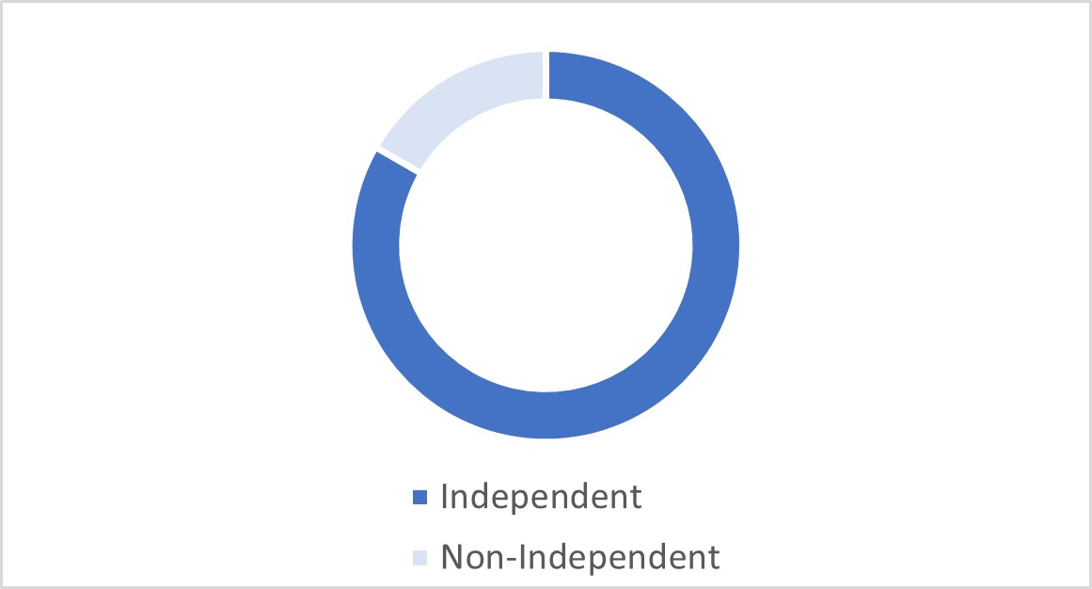 |  |  | 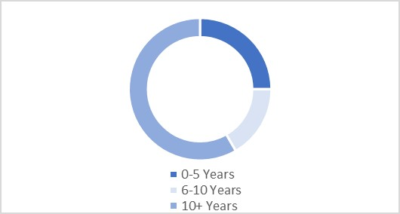
While the Nominating and Corporate Governance Committee does not have a formal policy with respect to diversity, the Company and the Board strongly believe diversity is critical to the Company’s success and creating long-term value for shareholders. The Company believes that a Board consisting of individual directors with diverse backgrounds ensures broader representation and inspires deeper commitment to management, employees, and the community. Diversity in gender, ethnic background, professional experience, and other experiences are important considerations for the Company when evaluating candidates for director.

Director Compensation
Each director of the Company who is not an officer or employee of the Company receives compensation for his or her services as follows:
 |  |  |  | Annual Retainer ($)
Chairman |  |  |  | 70,000
Lead Director |  |  |  | 27,500
Board Member |  |  |  | 52,000
Audit and Risk Committee Chair |  |  |  | 15,000
Audit and Risk Committee Member |  |  |  | 7,500
Compensation Committee Chair |  |  |  | 12,000
Compensation Committee Member |  |  |  | 5,000
Nominating and Corporate Governance Committee Chair |  |  |  | 10,000
Nominating and Corporate Governance Committee Member |  |  |  | 5,000
Restricted Stock Award * |  |  |  | 80,000
*Directors will receive the equity equivalent of the dollar amounts indicated above
Restricted stock awards to directors are issued under the Company’s 2023 Omnibus Stock and Performance Compensation Plan (the Omnibus Plan), which was approved by shareholders in 2023. Because they are time-based awards, shares of restricted stock and restricted stock unit (RSU) awards accrue dividends and dividend equivalents, which will be paid upon vesting of the awards. Restricted stock carries voting rights from the date of grant, and RSU awards provide voting rights upon settlement in shares. Shares vest in full on the first anniversary date of the awards or, if elected by the director, vest at retirement from the Board, as disclosed below. The grant date of restricted stock and RSU awards to non-employee directors is typically two days following the Annual Meeting, when the full Board approves the awards. In accordance with the Company’s stock ownership guidelines, directors are expected to retain all shares granted to them during their service as Board members and are encouraged to acquire stock in amounts consistent with their financial resources.
17
Corporate Governance
The Company maintains a non-employee director compensation election program to allow non-employee directors to receive their annual board member retainer fees in the form of restricted stock or RSUs and provide for a separate election to defer the vesting of awards and any underlying dividends or dividend equivalents until the date of termination of service as a director. Elections must be made prior to the calendar year for which the election will apply and made annually, with the exception of the first year in which a director becomes eligible to participate, after which the election must be made within 30 days.
Summary Compensation - Directors
The table below sets forth the following compensation for each director who is not a named executive officer or employee for the fiscal year ended December 31, 2025: (i) dollar value of fees earned or paid; (ii) aggregate grant date fair value of restricted stock awards; (iii) all other compensation; and (iv) dollar value of total compensation.
Name (1) |  |  | Fees Earned or Paid in Cash ($) (2) |  |  | Stock Awards ($) (3) |  |  | All Other Compensation ($) (4) |  |  | Total ($)
Eric H. Brunngraber |  |  | 91,500 |  |  | 79,986 |  |  | 26,084 |  |  | 197,570
Ralph W. Clermont |  |  | 87,000 |  |  | 79,986 |  |  | 27,742 |  |  | 194,728
Robert A. Ebel |  |  | 74,500 |  |  | 79,986 |  |  | 19,794 |  |  | 174,280
Benjamin F. Edwards, IV |  |  | 57,000 |  |  | 79,986 |  |  | 1,904 |  |  | 138,890
Wendy J. Henry |  |  | 67,000 |  |  | 79,986 |  |  | 7,709 |  |  | 154,695
James J. Lindemann |  |  | 69,000 |  |  | 79,986 |  |  | 32,497 |  |  | 181,483
Ann W. Marr |  |  | 62,000 |  |  | 79,986 |  |  | 6,296 |  |  | 148,282
Sally H. Roth |  |  | 72,000 |  |  | 79,986 |  |  | 13,591 |  |  | 165,577
Joseph D. Rupp |  |  | 84,500 |  |  | 79,986 |  |  | 25,355 |  |  | 189,841
Randall L. Schilling |  |  | 59,500 |  |  | 79,986 |  |  | 32,497 |  |  | 171,983
Franklin D. Wicks, Jr. |  |  | 72,000 |  |  | 79,986 |  |  | 29,837 |  |  | 181,823

(1)Compensation for Mr. Resch is set forth in Executive Officers – Summary Compensation Table and related tables. Because Mr. Resch is an employee of the Company, he did not receive any additional compensation for services as a director in 2025. Mr. Brunngraber served as a non-executive employee of the Company through April 15, 2025. He was compensated through that date pursuant to his Executive Chairman compensation arrangement, which is described below, and he did not receive any additional compensation for services as a director through April 15, 2025. After April 15,2025, Mr. Brunngraber received compensation for his services as a director.
(2)Represents fees paid during 2025 for services as a director. For Mr. Rupp, the amount also includes fees received as the Lead Director. For Mr. Brunngraber, the amount also includes fees received as Chairman after April 15, 2025. Amounts include the following fees for service on the Executive Loan Committee of Cass Commercial Bank, the Company's bank subsidiary: Mr. Clermont, $15,000; Ms. Roth $15,000; and Mr. Ebel, $15,000. Messrs. Clermont, Lindemann, Rupp, Schilling, and Wicks elected to receive their Board retainer fees in the form of restricted stock and each received 1,203 shares of restricted stock in lieu of $52,000 of cash payments. The restricted stock vests in full on the first anniversary of the grant date of the awards or, if elected by the director, vests at retirement from the Board.
(3)These amounts represent the aggregate grant date fair value computed in accordance with FASB ASC Topic 718 for restricted stock and RSU awards granted to directors in fiscal 2025. Shares vest in full on the first anniversary of the grant date or, if elected by the director, upon the director’s retirement from the Board. These amounts were computed in accordance with the Financial Accounting Standard Board’s Accounting Standard Codification Topic 718 (FASB ASC Topic 718). These amounts do not represent the actual amounts paid to or realized by the directors during fiscal year 2025. The value as of the grant date for restricted stock is recognized over the number of days of service required for the grant to become vested. See Note 12 to the Company's audited financial statements included in the Company's Annual Report on Form 10-K for the year ended December 31, 2025 for a complete description of the material assumptions applied in determining grant date fair value. The aggregate number of shares of restricted stock and RSU awards issued and outstanding at December 31, 2025 for each director was as follows and for Mr. Brunngraber includes prior stock-based awards received in his role as CEO and Executive Chairman with performance-based shares of 29,016 assumed to vest at the target level of performance:
18
Corporate Governance
Name |  |  | Shares * |  |  | RSUs *
Eric H. Brunngraber |  |  | 29,016 |  |  | 21,370
Ralph W. Clermont |  |  | 20,410 |  |  | 3,229
Robert A. Ebel |  |  | 14,401 |  |  | 2,026
Benjamin F. Edwards, IV |  |  | — |  |  | 2,026
Wendy J. Henry |  |  | 4,655 |  |  | 2,026
James J. Lindemann |  |  | 24,245 |  |  | 3,229
Ann W. Marr |  |  | 3,128 |  |  | 2,026
Sally H. Roth |  |  | 9,399 |  |  | 2,026
Joseph D. Rupp |  |  | 18,485 |  |  | 3,229
Randall L. Schilling |  |  | 24,245 |  |  | 3,229
Franklin D. Wicks, Jr. |  |  | 22,100 |  |  | 3,229
* If elected, included shares received in lieu of cash retainer fees and/or shares deferred until retirement
(4)Represents dividends paid or accrued on unvested time-based restricted stock and RSU awards for all directors. Mr. Brunngraber also received additional compensation for his services in fiscal 2025 as an employee Executive Chairman, as more fully discussed in the narrative below.

Effective April 2023, Mr. Brunngraber retired as CEO of the Company and remained an employee of the Company in the Executive Chairman role until April 2025, for which he received the following compensation: (i) a base salary of $562,000; (ii) eligibility to receive an annual target profit-sharing bonus of 40% of his base salary; (iii) a long-term incentive compensation (LTIC) opportunity at target based on 100*% of his base salary (for 2025, comprised of 40% time-based RSUs and 60% performance-based restricted stock); and (iv) continuation of certain employee benefits and perquisites.

For fiscal 2025, Mr. Brunngraber received the following compensation as Executive Chairman: (i) salary payments of $177,246; (ii) a grant date fair value of $561,990 based on a 2025 LTIC award of 5,422 time-based RSUs and 8,133 shares of performance-based restricted stock that may be earned at the target achievement level; (iii) matching 401(k) contributions of $12,441; and (iv) other benefits and perquisites totaling $10,385. The number of performance-based LTIC awards that will ultimately be earned and vest, if any, will vary in an amount from 0% to 150% of the target amount awarded based on the achievement of pre-established financial performance goals over the prospective three-year performance period from the date of grant. The terms and conditions of the Company’s LTIC program, including as they relate to Mr. Brunngraber’s 2025 awards, are fully described in “Executive Compensation and Related Information—Compensation Discussion and Analysis” section of this Proxy Statement. The grant date fair value of Mr. Brunngraber’s LTIC awards is computed in accordance with FASB ASC Topic 718, is based on the target number of performance-based restricted stock or RSUs, as applicable, and is calculated using the fair market value of the Company’s common stock on the date of grant of $41.46 for the grant made on January 23, 2025. These amounts do not represent the actual amounts paid to or realized by Mr. Brunngraber. The value as of the grant date for restricted stock is recognized over the number of days of service required for the grant to become vested. See Note 12 to the Company's audited financial statements included in the Company's Annual Report on Form 10-K for the year ended December 31, 2025 for a complete description of the material assumptions applied in determining grant date fair value.

Certain Relationships and Related Party Transactions
Some of the directors and executive officers of the Company, and members of their immediate families and firms and corporations with which they are associated, have had transactions with the Company’s subsidiary bank, including borrowings and investments in depository accounts. All such loans and investments have been made in the ordinary course of business, on substantially the same terms, including interest rates charged or paid and collateral required, as those prevailing at the same time for comparable transactions with unaffiliated persons, and did not involve more than the normal risk of collectability or present other unfavorable features.
Mr. Brunngraber, a director of the Company, also served as an employee of the Company as Executive Chairman until April 2025. Compensation paid to Mr. Brunngraber for his services as Executive Chairman during fiscal 2025 are included in “Summary Compensation – Directors” above.
19
Corporate Governance
As provided by the Audit and Risk Committee’s charter, the Audit and Risk Committee must review and approve all transactions between the Company and any related person that are required to be disclosed pursuant to Item 404 of Regulation S-K. “Related person” and “transaction” shall have the meanings given to such terms in Item 404 of Regulation S-K, as amended from time to time. In determining whether to approve or ratify a particular transaction, the Audit and Risk Committee will take into account any factors it deems relevant.

Report of the Audit and Risk Committee
The Audit and Risk Committee assists the Board in providing oversight of the systems and procedures relating to the integrity of the Company’s financial statements, the Company’s financial reporting process, its systems of internal accounting and financial controls, the internal audit process, risk management, the annual independent audit process of the Company’s annual financial statements, the Company’s compliance with legal and regulatory requirements, and the qualification and independence of the Company’s independent registered public accounting firm. These responsibilities are laid out in the Audit and Risk Committee's charter, which is available on the Investor Relations section of the Company's website at www.cassinfo.com.
The Audit and Risk Committee reviews with management the Company’s major financial risk exposures and the steps management has taken to monitor, mitigate, and control such exposures. Management has the responsibility for the implementation of these activities. In fulfilling its oversight responsibilities, the Committee reviewed and discussed with management the audited financial statements in the Company’s Annual Report on Form 10-K for the fiscal year ended December 31, 2025, including a discussion of the quality and the acceptability of the Company’s financial reporting and controls.
The Company’s independent registered public accounting firm is responsible for expressing an opinion on the conformity of those audited financial statements with U.S. generally accepted accounting principles and on the effectiveness of the Company’s internal control over financial reporting. The Committee reviewed with the independent registered public accounting firm the firm’s judgments as to the quality and the acceptability of the Company’s financial reporting and such other matters as are required to be discussed with the Committee under auditing standards of the Public Company Accounting Oversight Board (PCAOB) (United States), including the matters required to be discussed by the Statement on Auditing Standards No. 1301 (Communications with Audit Committees), and the rules and regulations of the SEC. In addition, the Committee has discussed with the independent registered public accounting firm the firm’s independence, including the impact of non-audit-related services provided to the Company, and has received the written disclosures and the letter from the independent registered public accounting firm required by applicable requirements of the PCAOB regarding the independent accounting firm’s communications with the Audit and Risk Committee concerning independence.
The Committee also discussed with the Company’s internal auditors and the independent registered public accounting firm in advance the overall scope and plans for their respective audits. The Committee meets regularly with the internal auditor and the independent registered public accounting firm, with and without management present, to discuss the results of their examinations, their evaluations of the Company’s internal controls, and the overall quality of the Company’s financial reporting.
In reliance on the reviews and discussions referred to above, the Committee recommended to the Board that the audited financial statements be included in the Company’s Annual Report on Form 10-K for the fiscal year ended December 31, 2025 for filing with the SEC.
Wendy J. Henry, Chairperson
Ralph W. Clermont
Robert A. Ebel
Randall L. Schilling

Information Security and Data Privacy
The Company has a comprehensive Information Security Policy and ensures data privacy policies adhere to the requirements of the General Data Protection Regulation, California Consumer Privacy Act, and other state and local data privacy regulations to the extent they impact the Company’s operations and handling of personal data. All employees are required to
20
Corporate Governance
take regular training on information security requirements and must acknowledge policies and standards annually. In addition, the Company conducts ongoing phishing campaigns to test and educate all employees on how to spot phishing attacks and to measure the effectiveness of our training program. The Cass Global Data Privacy Policy, which addresses the privacy of our clients’ information, is available on our Investor Relations site at www.cassinfo.com. The Cass Commercial Bank Legal Disclaimers, Privacy Statement and Cookie Policy is also available on our Investor Relations site at www.cassinfo.com.

Insider Trading Policy and Procedures
The Company has adopted insider trading policies and procedures applicable to our directors, officers, and employees, and has implemented processes for the Company that it believes is reasonably designed to promote compliance with insider trading laws, rules, and regulations, and the Nasdaq listing standards. The Company’s insider trading policy, among other things, (i) prohibits directors, officers, and employees from trading in securities of the Company and certain other companies while in possession of material, non-public information; (ii) prohibits our directors, officers, and employees from disclosing material, non-public information of the Company and certain other companies to others; and (iii) requires that directors and certain designated officers obtain pre-clearance before trading in Company securities and only transact in Company securities during an open window period, subject to limited exceptions. A copy of the Company’s insider trading policy can be found as an exhibit to the Annual Report on Form 10-K for the year ended December 31, 2025.

Environmental, Social, and Governance
Acting with the highest degree of honesty, integrity, and compassion for all of the Company’s stakeholders, from clients and employees to the communities and the world around us, has been a hallmark of the Company’s culture for over 100 years. The Company is increasingly focused on and committed to strong ESG practices and believes ESG standards and business practices are aligned with the Company’s corporate purpose and values. The Company recognizes the importance for stakeholders to know and understand ESG initiatives and encourages stakeholders to read the Company’s annual ESG Report available on our Investor Relations site at www.cassinfo.com.
The Nominating and Corporate Governance Committee of the Board of Directors oversees the Company’s position and practices on ESG matters and other significant public policy issues, including but not limited to the protection of the environment, corporate social responsibility, and sustainability.
Environmental
The Company monitors its energy consumption and is committed to improving metrics such as emissions per transaction and as a percent of revenue. The Company also supports its clients with many sustainable products and services as more fully described in the Company’s ESG Report available on our Investor Relations site at www.cassinfo.com.
Social
The Company is focused on engaging its employees. The Company offers many attractive benefits to help support its employees, including profit sharing and an employee assistance program. The Company also has robust policies on equal opportunities, anti-harassment and non-discrimination. The health and safety of employees and work-life balance are actively promoted as more fully described in the Company’s ESG Report.
Governance
The Company strongly supports adherence to the Company’s Code of Conduct and Business Ethics and anonymous reporting of unethical or questionable practices without retaliation. The Company believes in a conservative and long-term view of risk management by various specialized committees, including strict focus on information and data privacy risk management. The Company has developed strong governance practices, including Board oversight as described above and in the Company’s ESG Report.

21
Corporate Governance
Shareholder Engagement
The Company greatly values feedback from its shareholders and relies on such feedback to help tailor its business policies and practices. Accordingly, in addition to soliciting feedback through proxy voting, the Company frequently interacts with shareholders throughout the year by participating in investor conferences and presentations and holding other meetings with current and prospective shareholders to provide transparency around emerging issues, discuss milestones, and inform decision-making.
During fiscal 2025, incorporating input from discussions and meetings with shareholders, the Company hired an external investor relations firm to assist in its overall investor relations efforts.

22

Proposal No. 2
Advisory Vote on Executive Compensation
The Board is committed to excellence in governance and recognizes that executive compensation is an important matter for the Company’s shareholders. At the Company’s Annual Meeting of Shareholders on April 15, 2025, the shareholders were given the opportunity to endorse or not endorse, on a non-binding advisory basis, the Company’s compensation program for named executive officers by voting for or against a resolution calling for the approval of such program for the 2025 fiscal year. Shareholders approved the compensation program with approximately 97% of the votes cast by the holders of common stock.
The core of the Company’s executive compensation philosophy and practice continues to be to pay for performance. The Company’s executive officers are compensated in a manner consistent with the Company’s strategy, competitive practice, sound corporate governance principles, and shareholder interests and concerns. The Company believes its compensation program is strongly aligned with the long-term interests of shareholders, as exhibited in the Compensation Discussion and Analysis section of this Proxy Statement, which provides additional details on executive compensation, compensation philosophy and objectives, and the compensation of the named executive officers for the prior fiscal year. Shareholders are asked to vote on the following resolution:
“RESOLVED, that the shareholders approve the compensation paid to the Company’s named executive officers as disclosed pursuant to the SEC’s compensation disclosure rules, including the Compensation Discussion and Analysis, compensation tables and any related material contained in this Proxy Statement.”
The above-referenced disclosures are included in this Proxy Statement under the Executive Compensation and Related Information section.
The Board urges shareholders to endorse the compensation program for our executive officers by voting FOR the above resolution. As discussed in the Compensation Discussion and Analysis contained in this Proxy Statement, the Compensation Committee of the Board believes that the Company’s executive compensation is reasonable and appropriate, is justified by the performance of the Company, and is the result of a carefully considered approach.
As an advisory vote, this proposal is non-binding and will not overrule any decision by the Board or require the Board to take any action. However, the Board and the Compensation Committee value the opinions of the Company’s shareholders and will consider the outcome of the vote when making future compensation decisions for the named executive officers. It is expected that the next say-on-pay vote will occur at the 2027 Annual Meeting of Shareholders. The Company currently holds the say-on-pay vote every year.
The Company's Board recommends a vote "FOR" the Company's executive compensation program as described in the Compensation Discussion and Analysis, the compensation tables and otherwise in this Proxy Statement.

23

Executive Compensation and Related Information

Compensation Discussion and Analysis
Overview of Compensation Philosophy and Objectives
The Compensation Committee believes that the skill and dedication of executive officers and other management personnel are critical factors affecting the Company’s long-term success in meeting its objectives and fostering growth and profitability. In support of this objective, compensation programs have been designed to attract and retain a high level of talented leadership, reward performance in accordance with results, provide an incentive for future performance and align Company executives’ long-term interests with those of the shareholders.
The Compensation Discussion and Analysis (CD&A) describes, in detail, the Company’s executive compensation philosophy and programs provided to named executive officers as they are determined under SEC rules. For 2025, named executive officers, as determined and designated by the Company, included the following individuals:
Name |  |  | Title in Fiscal 2025
Martin H. Resch |  |  | President and Chief Executive Officer (CEO)
Michael J. Normile |  |  | Executive Vice President and Chief Financial Officer (CFO)
James M. Cavellier |  |  | Executive Vice President and Chief Information Officer (CIO)
Matthew S. Schuckman |  |  | Executive Vice President, General Counsel, and Corporate Secretary
Dwight D. Erdbruegger |  |  | President, Cass Commercial Bank
The overall compensation program is designed to result in compensation that is commensurate with Company and individual performance. The Company believes that high levels of performance should yield compensation that is competitive externally and equitable internally. The Compensation Committee periodically assesses the Company’s compensation programs to confirm incentives are in place to retain key management talent, reward attainment of longer-term objectives, and assure these programs do not encourage risky behavior on the part of individuals or the executive management team.
In order to assure executive compensation is both competitive and appropriate, the Compensation Committee reviews executive compensation in its entirety before determining any adjustments to specific compensation components. In this process, the Compensation Committee primarily considers the value of cash and incentive equity compensation. Benefits, such as retirement benefits provided under the Company’s defined contribution plan are also considered, though these elements are given less weight. Gains from prior equity incentive awards are also given less weight, as these were awards earned and granted based on prior performance.
For fiscal 2025, the components of total direct compensation (TDC) for the named executive officers and their purposes were as follows:
24
Executive Compensation
Compensation Element |  |  | Fixed/Variable |  |  | Key Features |  |  | Purpose
Base Salary |  |  | Fixed |  |  | Reviewed by Compensation Committee annually  Varies with experience, duties, and scope of responsibility |  |  | Provides a base level of fixed pay to attract and retain executives that is internally equitable and externally competitive
Profit-Sharing Bonus |  |  | Variable |  |  | Paid two times a year provided the Company is profitable overall, and then based on a pool of funds set at 18.5% of net income after taxes (NIAT), providing bonuses to all employees unless specifically excluded due to their employment class or failure to meet minimum performance expectations. If there is no NIAT, then the pool of funds will be $0.  CEO is eligible to receive up to 7.2% of the total pool of funds available for distribution depending on the change in NIAT, not to exceed 70% of base salary for the year. At a target 8% increase in NIAT, the CEO receives 45% of salary in profit sharing.  Other named executive officers receive amounts based on change in NIAT and individual performance not to exceed 50% of base salary of any officer. Target change in NIAT is set at 8%. |  |  | Provides annual incentive opportunity and rewards employees for overall Company and individual performance
Long-Term Incentive Equity Compensation (LTIC) |  |  | Fixed  Variable |  |  | Granted annually with 3-year cliff vesting  CEO target is 125% of base salary;  other named executive officers target is 70-75% of base salary. LTIC compensation is issued in the following forms:  40% time-based restricted stock/units  60% performance-based restricted stock/units |  |  | Encourages retention through a 3-year cliff vesting  Supports the achievement of the Company's longer-term financial goals of sustained earnings per share (EPS) growth and target return on equity (ROE)  Aligns interests of executives with shareholders
The charts that follow show the percentages of each component of TDC paid to the CEO and the average percentages of each of the TDC components paid to the other named executive officers for fiscal 2025.
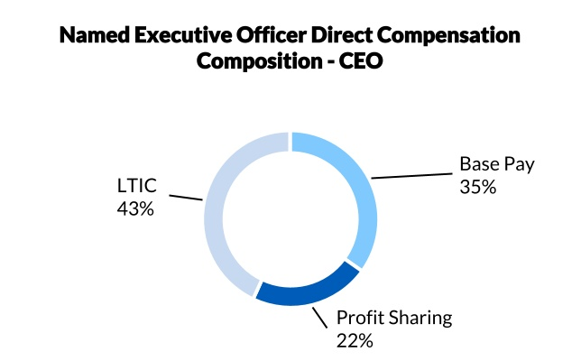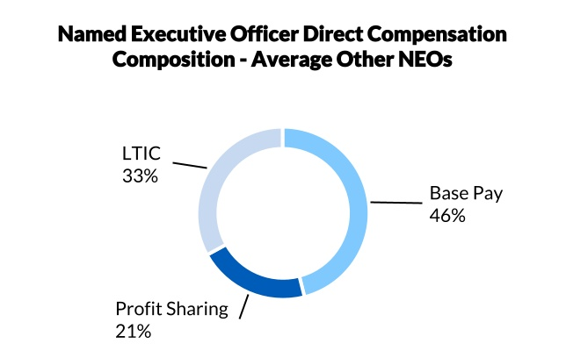
25
Executive Compensation
Based on the market data provided by Pay Governance, an independent third-party compensation consultant, as part of the annual review of executive compensation, the Committee believes the composition of TDC for named executive officers is in alignment with companies of a similar size and in similar industries as the Company. For 2025, approximately 65% of the CEO’s TDC was in the form of performance-based profit-sharing, to emphasize the importance of annual profitability, and LTIC, to emphasize the importance of long-term strength, profitability and growth in the value of the Company’s common stock.
In its determination of the level, composition and administration of executive compensation, the Committee understands the importance of aligning executive compensation with the performance of the Company and the long-term interests of its shareholders and in promoting good corporate governance. It therefore employs the following best practices:
•Pay for performance – The profit-sharing plan provides annual cash bonuses directly tied to earnings growth. The LTIC grants are comprised of 60% performance-based awards based on the achievement of preset EPS growth and ROE performance targets over a three-year performance period with the remaining 40% being time-based restricted stock/units.
•Caps on short and long-term bonuses – Short-term profit-sharing bonuses are capped at 70% of base salary for the CEO and 45% to 50% of base salary for the other named executive officers. The maximum amount of performance-based LTIC awards ultimately earned is capped at 150% of the target award, and no performance-based LTIC awards are earned if performance falls below the threshold achievement level.
•“Clawback” policy – The Company's Clawback Policy requires the Company to recover all erroneously paid incentive-based compensation to current and former executive officers if the Company must prepare an accounting restatement due to its material noncompliance with any financial reporting requirements under the securities laws.
•Stock ownership guidelines – The CEO must receive approval from the Lead Director of the Board before selling shares of the Company’s stock, and the other named executive officers must consult with the CEO and CFO, who further consult with the General Counsel, before selling shares of the Company’s common stock. Except for special circumstances, such as financial hardship, approval to sell would not be given if such sale would result in holdings of less than five times base salary in the case of the CEO and less than three times base salary in the case of the other named executive officers.
•“Double trigger” of LTIC vesting due to change of control – LTIC grants will only result in accelerated vesting if a change of control results in termination of employment.
•No long-term employment agreements – All executives are hired “at-will” and there are no long-term employment arrangements that provide for compensation beyond an employee’s termination date. The only payments beyond the termination date are payments from one of the Company’s retirement plans and allowable vesting of LTIC awards upon certain conditions.
•No dividends paid on unearned LTIC – There are no dividends paid or accrued on unearned performance-based awards until such time the awards are earned and settled. Any dividends declared on unearned time-based awards will be retained by the Company until such awards are earned.
•No tax gross-ups – There are no automatic tax gross-ups on any form of compensation provided to the CEO or any other executive officer.
•Insider trading and other prohibitions - all named executive officers are expressly covered by the Company’s policies prohibiting insider trading, short selling, and hedging transactions in Company stock. More detailed information about the Company's anti-hedging policy are included in Restrictions on Hedging below.
•No perquisite benefits for named executive officers.
By keeping in mind transparency and best practices for pay-for-performance and shareholder alignment in its executive compensation programs, the Committee has designed executive compensation to avoid rewarding executives for taking excessive and unnecessary risk, providing guaranteed compensation increases and employment terms, rewarding executives for underperformance, and paying dividends on unearned performance-based equity awards.

26
Executive Compensation
Committee Review of Executive Compensation
For the past several years the Compensation Committee has retained Pay Governance to conduct an annual review of executive compensation. Pay Governance provides the Committee with external market data on the executive compensation levels, mix and design of companies of a similar size and in similar industries as the Company. During 2024, for pay decisions for fiscal year 2025, the Company reviewed survey and proxy data from a broad range of industries rather than a specific compensation peer group.
Given the Company’s unique operating structure with operations in banking, fintech and business services there has traditionally been a lack of sufficient benchmarks for evaluating the competitiveness of executive compensation at the Company. However, Pay Governance and the Compensation Committee determined that a representative compensation peer group was feasible to develop in 2022 given the increased availability of publicly traded banks with diversified business models (i.e., banks with additional business operations beyond traditional lending) and the emergence of a number of publicly traded fintechs in 2021. The use of a consistent compensation peer group across the named executive officer group was preferred by the Compensation Committee as it provides transparent, line-by-line data for each peer company and the ability to review industry trends and compensation design practices on a year-over-year basis.
As such, Pay Governance developed, and the Compensation Committee approved, a single initial peer group for evaluating executive compensation in 2022. Initially, 21 U.S.-based, publicly traded companies were selected using the following criteria:
•Banks with Diversified Business Models: Community Banks or Diversified Financial Services companies with revenue generating business operations beyond traditional lending or those with a fintech focus. Financial screening criteria included assets ranging from 0.5x to 4.0x the Company, market capitalization ranging from 0.2x to 5.0x the Company, and a ratio of market capitalization to book value of greater than 1.0x.
•Financial Technology/Business Services: Companies in the Payments/Transaction or Data Processing industries. Financial screening criteria included revenues ranging from 0.5x to 3.75x the Company and market capitalization ranging from 0.2x to 5.0x the Company.
During 2023, one of the initial peer group selections in the financial technology/business services group was acquired. During 2025, Pay Governance and the Compensation Committee determined that two of the original peers should be removed due to an outsized market cap and replaced by 2 new peers with a market cap closer to that of the Company. The current group of 20 peer group companies is as follows:
Banks with Diversified Business Models (n=15) |  |  |  |  |  | Financial Technology / Business Services (n=5)
Alerus Financial Corporation |  |  | Heritage Commerce Corp |  |  | Cantaloupe, Inc.
Business First Bancshares, Inc. |  |  | Live Oak Bancshares, Inc. |  |  | Cardlytics, Inc.
Coastal Financial Corporation |  |  | Metropolitan Bank Holding Corp |  |  | i3 Verticals, Inc.
Equity Bancshares, Inc. |  |  | MVB Financial Corp. |  |  | Priority Technology Holdings, Inc.
Esquire Financial Holdings, Inc. |  |  | NewtekOne, Inc. |  |  | Repay Holdings Corporation
First Bancorp |  |  | Pathward Financial, Inc.
First Financial Corporation |  |  | Triumph Financial, Inc.
First Internet Bancorp
The compensation peer group consists of 75% of banks with diversified business models and 25% of technology/business services companies. The intent was to ensure that the mix was tilted toward the banking-industry companies to recognize the strong alignment with the Company’s unique business model. The Committee intends to continue to monitor the market for additional comparable banks for inclusion in the peer group.
For the review of executive compensation in 2025 in preparation for the Compensation Committee’s 2026 compensation recommendations, Pay Governance provided market data that consisted of annual salary, short-term incentives, and long-term incentives. Pay Governance’s market data was based primarily on proxy-disclosed information from the compensation peers, as detailed above. Size-adjusted survey data published by Mercer and other reputable, national executive
27
Executive Compensation
compensation surveys was used for staff roles in the absence of robust position-specific data from the compensation peer group.
It is the Compensation Committee’s philosophy that performance, more than evaluating market compensation levels alone, should drive executive compensation levels. The Compensation Committee reviews market data to gain a better understanding of general compensation practices within the market. However, the Compensation Committee takes into account a number of other considerations when making compensation decisions, including individual and Company performance, experience, and scope of responsibilities of the executive officers, desire to retain key personnel and the Company’s objective to maintain internal pay equity.
The Compensation Committee determines base salary and incentive compensation adjustments for the CEO and other executive officers, subject to Board approval. In evaluating compensation adjustments for the executive officers other than the CEO, the Compensation Committee gives consideration to the CEO’s recommendations concerning each executive’s performance and related salary and incentive stock levels. Cash bonuses for the CEO and executive officers are allocated in accordance with the Company’s Board-approved profit-sharing program, as further described in Profit-sharing Bonus below.

Shareholder Feedback on Say on Pay
The Compensation Committee also considered the results of the advisory vote on the “say-on-pay” proposal presented to shareholders at the 2025 Annual Meeting of Shareholders. Shareholders expressed significant support for the compensation program offered to the Company’s named executive officers, with approximately 97% of votes cast in favor. Accordingly, the Compensation Committee made no direct changes to the overall mix of compensation to named executive officers and the Company’s compensation philosophies generally. The Committee will continue to consider the results of shareholders’ advisory votes on executive compensation when making decisions about the Company’s executive compensation program.

Role of the Compensation Committee's Independent Consultant
For a number of years, the Compensation Committee has retained the services of Pay Governance as a compensation consultant to provide independent counsel and advice on executive compensation matters. In 2025, Pay Governance reviewed the Company’s historical market pricing approach and pay philosophy, assessed the compensation peer group for relevancy, and provided a competitive market assessment of executive compensation design and levels for the Committee’s review.
Pay Governance attends Compensation Committee meetings upon request. While the Compensation Committee considers input from Pay Governance when making compensation decisions, the Compensation Committee’s final decisions reflect many factors and considerations.
The Compensation Committee annually reviews the independence of its compensation consultant. The Compensation Committee considered the Company’s relationship with Pay Governance, assessed the independence of Pay Governance pursuant to Nasdaq and Exchange Act rules, and concluded that there are no conflicts of interest that would preclude Pay Governance from independently representing the Compensation Committee.

Executive Summary of Results
The Company recorded revenue from continuing operations of $190.8 million in fiscal 2025, up 5.3% from the prior year, largely due to an increase in net interest income, partially offset by a decrease in financial fees and a loss on sale of investment securities. Net income was $35.1 million, and diluted EPS was $2.61 per share, increases of 83.2% and 87.8% respectively, from the prior year.
The Company continues to operate profitably, posting a 1.43% return on average assets and 14.98% return on average equity. The Company’s common equity Tier 1 capital ratio was 15.10% at December 31, 2025, significantly exceeding regulatory requirements. In addition, the Company has maintained exceptional credit quality with non-performing loans to total loans of 0.66% at December 31, 2025 and no loan charge-offs during the year ended December 31, 2025.
28
Executive Compensation
The Company’s solid capital and liquidity positions, combined with ongoing earnings, are expected to continue to allow for investment in strategic opportunities when they become available, in addition to the return of capital to shareholders. The Company delivered $42.6 million in dividend payments and share repurchases during 2025. The Company continues to invest in the technology, processes, and people required to support its multi-national customer base.

Elements of Compensation
The key elements of the Company’s executive compensation program include base salary, annual cash bonus awards distributed pursuant to the Company’s profit-sharing program, and LTIC equity awards. A description of these elements and the Company’s benefit plans is included below.
Base Salary
Salaries are established for executive officers by balancing both internal and external factors. Internal equity is determined through comparison with other executives within the Company, taking into account the scope of responsibilities, performance, skills, and experience. Similarly, the Compensation Committee considers external data to validate competitiveness and reasonableness in the marketplace. Considerable weight is given to performance of the individual and his or her associated operating unit, taking into account factors such as revenue growth, cost efficiencies, technological advancements, and leadership. Specific individualized targets and quantitative performance measurements are not utilized. Base salaries are designed to attract and retain high levels of expertise and talent. The Compensation Committee reviews salaries of the CEO and other executive officers at the beginning of each fiscal year. The Compensation Committee determines any adjustments to the CEO’s salary and gives consideration to the CEO’s recommendation regarding adjustment to other executive officer salaries, based on the criteria referenced above.
The Compensation Committee believes that base salary increases for 2025 were reflective of the 2024 performance of individuals and individual operating units and competitive forces projected by the external market. The increases in base salary levels for all named executive officers were effective March 31, 2025. The increase in base salaries from 2024 to 2025 were approved as follows:
Name |  |  | Salary Prior to March 30. 2025  ($) |  |  | Salary On and After March 30. 2025  ($)
Martin H. Resch |  |  | 675,000 |  |  | 688,500
Michael J. Normile |  |  | 347,750 |  |  | 358,183
James M. Cavellier |  |  | 324,500 |  |  | 332,613
Matthew S. Schuckman |  |  | 288,000 |  |  | 296,640
Dwight D. Erdbruegger |  |  | 340,000 |  |  | 350,200

Profit-Sharing Bonus
The Company is unique in having a company-wide, cash-based profit-sharing program which has been in existence since 1968. These cash bonuses are paid to all eligible employees of the Company and its subsidiaries, according to the profit-sharing program approved by the Board. The purpose of this program is to facilitate the Company’s continued growth and success by providing rewards that are commensurate with achievement, thereby creating an incentive for superior performance and improved results for shareholders. The profit-sharing program is funded and paid semi-annually based on a target of 18.5% of the Company’s profits after taxes. As such, all cash bonuses paid by the Company are capped and are available only when, and to the extent that, the Company is profitable overall.
Total profit-sharing funds are divided into pools to be distributed among various employee groups, including the CEO, executives, and salaried staff.
The CEO is eligible to receive a percentage from 0% up to 7.2% of the total profit-sharing funds available, with the actual amount paid, based on a percentage change in NIAT from the prior year, subject to a maximum allowable distribution to the CEO of 70% of his base salary. The target amount for the CEO is set at 45% of base salary based on a target change in NIAT
29
Executive Compensation
of 8% from the prior year. The Compensation Committee believes this formula aligns compensation received by the CEO and Company performance by providing a higher payout for increased profits, based on both an increase in the total profit-sharing pool and an increase in the percentage of the pool received by the CEO, and a lower payout for decreased profits, based on both a decrease in the total profit-sharing pool and a decrease in the percentage of the pool received by the CEO. The Committee believes that the allocation of profit-sharing funds to the CEO maintains internal equity and results in a competitive pay package.
While the size of the executive officer profit-sharing pool is dependent on the overall size of the pool and change in NIAT, the individual distributions have historically been, and for fiscal 2025 were, based on a subjective assessment of each executive’s performance, taking into consideration factors such as performance of each individual and each executive’s associated operating unit. When conducting his evaluation of an executive’s performance, the CEO considers factors such as revenue growth, cost efficiencies and technological advancements within the executive’s operating unit, and leadership skills and other accomplishments during the fiscal year. Consideration is also given to profit-sharing payments that an individual has received in the past as well as those received by other named executive officers, in order to help achieve internal compensation equity.
The percentages of the total profit-sharing pool available to the CEO and other named executive officers have been set to result in payments that generally correlate to targeted salary percentages for the CEO and other named executive officers. The target percentage of base salary to be received by the CEO at target change in NIAT of 8% was 45% and could range from 0% to a maximum of 70%. The target percentage of salary at target change in NIAT for the other executive officers was 40%, with a range of 0% to a maximum of 45% in the case of Mr. Cavellier and Mr. Schuckman; and 0% to a maximum of 50% for Messrs. Normile and Erdbruegger. The targeted percentage salary ranges for the CEO and other named executive officers have, for the most part, been in place since the Company’s profit-sharing program was established. These ranges were established based on the following factors: (i) the goal to maintain internal equity that reflects the responsibilities of the position relative to other positions within the Company; (ii) the objective to provide incentive compensation that is adequate to attract and retain talent, validated through the Company’s recruitment efforts and periodic review of general marketplace survey data; and (iii) the desire to minimize overly risky compensation practices in line with the Company’s conservative risk profile.
The target salary percentage payouts and the distributions made to the CEO and other named executive officers are regularly reviewed by the Compensation Committee in accordance with the factors noted above. The Compensation Committee has determined that fiscal 2025 profit-sharing payments resulting from the methodology described above fall in line with the Company’s compensation philosophies and objectives and reflect the Company’s emphasis on performance-based compensation.
Fiscal 2025 bonuses were paid in August 2025 and February 2026.
For purposes of determining the change in NIAT for 2025 as compared to 2024, the Board approved an adjustment to NIAT in 2024 for the one-time expense related to the termination of the Company's defined benefit pension plan as well as $6.6 million of bad debt expense. The pre-tax expense of $10.0 million resulted in an after-tax adjustment to NIAT of $7.5 million. Accordingly, the Company's 2024 NIAT for determining 2025 bonus payments was set at $26.7 million which is reported net income of $19.2 million plus after-tax adjustments of $7.5 million. The Board determined that these adjustments to 2024 NIAT resulted in a better measurement of true operational performance. The adjustments effectively raised the benchmark for determining 2025 bonus payments, making it more difficult to achieve target level performance. See attached Annex A to this proxy statement for a reconciliation of the "As Adjusted" results to the Company's GAAP results found in our 2025 Annual Report on Form 10-K for purposes of Regulation G adopted by the SEC.
NIAT for 2025 compared to adjusted 2024 was an increase of 31.5%, resulting in the CEO position receiving a distribution of 7.0% of the profit-sharing pool for the year, with the payment made in August 2025 based on the funds available through June 30, 2025 and the balance paid in February 2026 based on the funds available for the year ended December 31, 2025. The total profit-sharing pool for the year ended December 31, 2025 was $6,494,700 and resulted in the CEO position receiving a total 2025 profit-sharing payment of $453,700, or 65.9% of 2025 base salary.
The total amount of the executive officer profit-sharing pool was also based on a 31.5% increase in adjusted NIAT for the year ended December 31, 2025 over the year ended December 31, 2024, and equaled 9.8% of the total profit-sharing pool. A payment was made in August 2025 based on the results through June 30, 2025, with the balance paid in February 2026 based on the results for the year ended December 31, 2025. As noted above, the amount of the executive officer profit-sharing pool allocated to individual executive officers, other than the CEO, primarily results from the change in NIAT. In
30
Executive Compensation
addition, individual distributions were ultimately based on a performance evaluation, conducted by the CEO, considering internal equity among the executive officers and other individual performance factors, including:
•Martin H. Resch: leadership and growth of the Company's Banking Services, Transportation Information Services and Expense Management business units.
•Michael J. Normile: overall stewardship of corporate financial processes, reporting, and controls.
•James M. Cavellier: leadership and ongoing development of the Company’s technology vision and strategic plan to ensure effective, efficient and secure systems and technologies.
•Matthew S. Schuckman: overall stewardship of effective risk management and compliance.
•Dwight D. Erdbruegger: ongoing growth of the Company's banking subsidiary while maintaining excellent credit quality.
Profit-sharing awards for 2025 represented an average of 46.5% of base pay for the named executive officers, other than the CEO.
A summary of the average percentage of base pay paid in profit sharing as compared to the average change in NIAT is as follows:
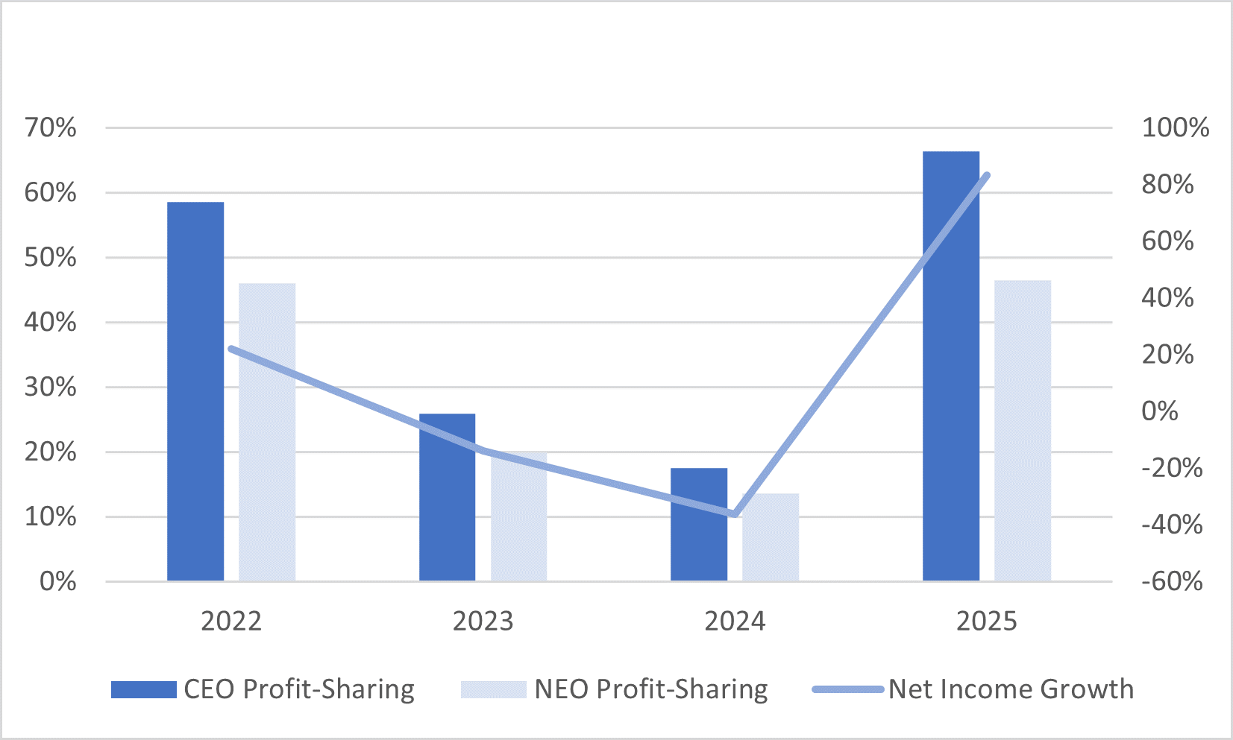
Long-Term Incentive Compensation
The objectives of the LTIC program are to provide an incentive which aligns executive officers’ interests with those of shareholders, assist in recruiting, encourage retention, and reward executive officers for the Company’s success.
LTIC has historically been awarded to various members of the Company’s management team, including all named executive officers, in accordance with the Amended and Restated Omnibus Stock and Performance Compensation Plan (the Prior Plan). The Prior Plan terminated in accordance with its terms on April 17, 2023, and shareholders approved the new Omnibus Plan at the 2023 Annual Meeting of Shareholders. LTIC awarded from April 2023 onward is pursuant to the Omnibus Plan.
31
Executive Compensation
The Committee believes that time-based awards reinforce the Company’s long-term objectives, serve as a retention incentive and reward the appreciation of the Company’s common stock price. The Committee believes that performance-based awards incentivize the named executive officers to meet or exceed the Company’s long-term ROE and EPS targets.
The value of target LTIC awards is set at 125% of base salary for the CEO and 70-75% of base salary for the other named executive officers. The target values are based, in part, on market data provided by Pay Governance and the Compensation Committee also considered historical grant levels, overall TDC targets and the Company’s desire to incentivize performance. The number of awards granted to an executive officer is determined by dividing the officer’s target LTIC award dollar value by the fair market value of the Company’s common stock using the closing stock price as reported on the Nasdaq on the grant date. Of the resulting number of shares, 40% of the awards is issued in the form of restricted stock or restricted stock units (RSUs) that cliff vest in three years from the date of grant, and 60% of the award is issued in the form of performance-based restricted stock or RSUs that vests three years from the date of grant with amounts earned, if any, based on the Company’s achievement of EPS and ROE performance targets for the prospective three-year performance period. The ultimate number of performance-based awards earned will range from 0% to 150% of the target award based on the Company’s achievement of EPS and ROE performance goals, with no performance-based awards being earned if threshold performance targets are not met. In the most recent several years, LTIC awards have been made in the form of restricted stock, subject to a participant’s election to receive the time-based portion in RSUs if eligible to make the retirement election (described below). In 2025, and in consultation with the Company’s compensation consultant, both the time- and performance-based portions of the LTIC awards were made in the form of RSUs.
The Committee selected growth of EPS and average ROE as the basis for awarding performance-based restricted stock because these are two key measurements used by the Company to measure the long-term growth and strength of the Company. The target levels of performance for each measurement were established based on the ongoing performance level that is expected by the Board, with the threshold representing the minimum acceptable level to earn any additional compensation and the maximum as the level of performance that would be considered an exceptional achievement. These pre-established targets are scheduled for a comprehensive review at least every three years and may be reviewed and adjusted earlier if current business conditions dictate a review is needed.
The performance goals for the 2025 performance-based grants made in January 2025 are as follows, and performance-based restricted stock will be earned if and to the extent the goals are met at the end of the three-year performance period ending on December 31, 2027:
 |  |  | Percentage of Target Performance-Based Shares Earned
 |  |  | 50% |  |  | 100% |  |  | 150%
Factor |  |  | Threshold |  |  | Target |  |  | Maximum
EPS annual growth |  |  | —% |  |  | 8% |  |  | 16%
Average ROE |  |  | 9% |  |  | 13% |  |  | 17%
The EPS growth goal, as shown in the table above, represents a compounding annual growth rate over a base year EPS, which is the year preceding the beginning of the three-year performance period. The EPS performance goals established for each three-year performance period will be presented as a dollar value based on these EPS growth percentages. The ROE goal presented in the table above will be based on the average ROE over the three-year performance period.
To provide an equal balance between profitability and growth, each factor will be weighted 50% to determine the total percentage of performance-based restricted stock earned. For each factor, target performance would result in 100% being earned related to that factor, performance at threshold would result in 50% being earned and maximum or higher performance would result in 150% being earned. Any performance below threshold would result in 0% earned related to that performance factor. Vesting percentages for performance that falls between threshold and target or target and maximum will be prorated between the respective vesting percentages. The percentage earned for each factor will then be multiplied by the 50% weighting and added together to determine the total percentage earned. The number of performance-based shares ultimately earned will then be determined by multiplying the number of performance-based shares granted at the beginning of the performance period by the total percentage earned, rounded to the nearest whole share.
Achievement of performance goals for performance-based restricted stock shall be determined based on generally accepted accounting principles and may be adjusted for any one-time unusual or non-recurring items that the Compensation Committee has determined, and Board of Directors has approved, as unusual and/or non-recurring.
32
Executive Compensation
The terms of the LTIC awards are set forth in a restricted stock or RSU award agreement entered into with each executive officer at the time of grant. Time-based restricted stock carries voting and dividend accrual rights and cliff vests on the three-year anniversary of the grant date. Time-based RSUs are settled in shares of common stock on the three-year anniversary of the grant date, have no voting rights, and dividend equivalents accumulate over the restriction period and will be paid upon vesting. In the event of disability or death of the named executive officer, time-based restricted stock and RSU awards vest immediately and performance-based restricted stock awards and RSUs vest under the original terms of the agreement. There are no dividends paid or accrued on unearned performance-based awards until such time as the awards are earned and settled. In the event of a change of control and termination of service of the named executive officer, time-based and performance-based restricted stock and RSU awards vest immediately with performance-based awards vesting at the target performance level.
For all LTIC grants prior to January 2025, the LTIC program contained a retirement provision, which allowed participants age 65 or older, with at least five years of service, to continue to vest in previously awarded grants after retirement. Due to this provision, and to delay the early taxation of the time-based restricted stock, the Company allowed participants who were age 62 or older, and would have 5 years of service upon vesting, to elect to receive time-based RSUs in lieu of the time-based restricted stock. Mr. Erdbruegger was the only named executive officer eligible to make this election for 2024 LTIC time-based awards. Effective with the 2025 LTIC grant, all participants receive both the time and performance-based components of the LTIC awards in the form of RSUs, regardless of age. The Compensation Committee adopted the “Rule of 65” for RSUs, which is more fully described in the section “—Post-Employment Payments” below. As of the time of the 2026 LTIC grants, the only named executive officers who have satisfied the Rule of 65 are Mr. Resch and Mr. Erdbruegger.
The Company does not allow the grant of awards to be timed with the release of material non-public information such that it would have an effect on the exercise price that would benefit the executive. The dollar value of LTIC awards granted to named executive officers and other eligible participants in 2025 was approved by independent Board members. Generally, this occurs at the January Board meeting and the grant date is approximately two days subsequent to the January Board meeting.
Outstanding Performance-Based LTIC Awards at Fiscal Year-End
At December 31, 2025, performance-based LTIC awards with respect to the 2024 to 2026 and 2025 to 2027 performance periods were still outstanding and have not yet been earned. Grants for these named executive officers are reflected in the Summary Compensation Table and the Grants of Plan-Based Awards table in the year of grant. The performance-based restricted stock grants relating to the 2024 to 2026 and 2025 to 2027 performance periods vest based on cumulative EPS goals and average ROE goals as described in this Long-Term Incentive Compensation section of the CD&A. If earned, these LTIC grants will be paid in the form of immediately vested shares of common stock.
Stock Vested in 2025
Performance-based LTIC awards of restricted stock that were granted on January 27, 2022 vested on January 24, 2025, following the end of the three-year performance period on December 31, 2024. Actual results for EPS and ROE are as follows for the years ended December 31, 2022, 2023, and 2024, respectively, which determine the vesting percentage of the performance-based restricted shares.
Performance Measurement |  |  | 2022 Actual |  |  | 2023 Actual |  |  | 2024 Actual(1)
EPS annual growth |  |  | $2.53 |  |  | $2.18 |  |  | $1.58
Average ROE |  |  | 16.53% |  |  | 14.24% |  |  | 9.51%
(1)Actual EPS and ROE for 2024 were $1.39 and 8.37%, respectively. The Board approved an adjustment to EPS and ROE in 2024 for the one-time expense related to the termination of the Company's defined benefit pension plan. The pre-tax expense of $3.5 million resulted in an after-tax adjustment to net income of $2.6 million. As such, adjusted net income for 2024 was determined to be $21.8 million which is reported net income of $19.2 million plus the pension adjustment of $2.6 million. Taking into account this adjustment, EPS and ROE for 2024 were adjusted to $1.58 and 9.51%, respectively, for the purpose of determining the value of the 2022 LTIC award. See attached Annex A to this proxy statement for a reconciliation of the “As Adjusted” results shown in the table below to our GAAP results found in our 2024 Annual Report on Form 10-K for purposes of Regulation G adopted by the SEC.

33
Executive Compensation
Actual cumulative EPS and average ROE for these periods compared to the levels set in 2022 at threshold, target, and maximum performance, along with the achievement percentage for these metrics are as follows:
 |  |  | Actual |  |  | Threshold |  |  | Target |  |  | Maximum |  |  | Achievement
Cumulative EPS |  |  | $6.29 |  |  | $6.00 |  |  | $7.01 |  |  | $8.13 |  |  | 67.8%
Average ROE |  |  | 13.43% |  |  | 7% |  |  | 11% |  |  | 15% |  |  | 130.3%
Total Achievement |  |  |  |  |  |  |  |  |  |  |  |  |  |  | 99.1%
As the cumulative EPS and average ROE metrics are each weighted at 50%, the total achievement for the 2022 performance-based LTIC awards resulted in a percentage of 99.1% of the target awards.
The number of shares of both time-based and performance-based awards that vested on January 24, 2025 for each named executive officer, adjusted for stock dividends during the performance period, are as follows:
Name |  |  | Vested Time-Based Restricted Shares/Units |  |  | Performance-Based Restricted Shares
 |  |  |  |  |  | Target Granted |  |  | Vested at 99.1%
Martin H. Resch |  |  | 4,851 |  |  | 7,276 |  |  | 7,211
Michael J. Normile |  |  | 2,264 |  |  | 3,396 |  |  | 3,365
James M. Cavellier |  |  | 2,158 |  |  | 3,236 |  |  | 3,207
Matthew S. Schuckman |  |  | 1,910 |  |  | 2,865 |  |  | 2,839
Dwight D. Erdbruegger |  |  | 2,246 |  |  | 3,369 |  |  | 3,339
Clawback Policy
In October 2023, the Compensation Committee and Board of Directors approved and adopted the Cass Information Systems, Inc. Clawback Policy in compliance with the SEC and Nasdaq listing rules. The Clawback Policy is administered by the Compensation Committee and requires the Company, subject to certain narrow exceptions permitted by the Nasdaq listing rules, to recover from covered executive officers erroneously awarded incentive-based compensation in the event of a restatement of the Company's financial statements due to material noncompliance with federal securities laws. Incentive-based compensation that is "received" during the three fiscal years preceding the restatement is subject to recoupment, effective from October 2, 2023 forward.
A copy of the Clawback Policy was filed as an exhibit to the Annual Report on Form 10-K for fiscal 2023.
Restrictions on Hedging
The Company’s restrictions on hedging common stock of the Company are incorporated within the Insider Trading Policy, which restricts directors, executive officers and other senior level employees who have access to material nonpublic information from engaging in short-term transactions involving the Company’s common stock. This includes short sales, purchasing on margin, or engaging in any transactions to hedge or offset any decrease in the market value of the Company’s common stock at any time. In addition, pursuant to the Company’s stock ownership guidelines, no executive officer may sell shares of the Company’s common stock without prior approval of the CEO and CFO, and in the case of sales of shares by the CEO the approval of the Lead Director of the Board is required.
Defined Contribution Retirement Plan
Cass Information Systems, Inc. 401(k) Plan
The Company provides defined contribution retirement benefits to eligible employees, including named executive officers, under the Cass Information Systems, Inc. 401(k) Plan. Eligible employees may enter the plan at the first of the month following one month of service. Employees may voluntarily defer the maximum level allowed by the IRS, which was $23,500 for 2025, plus an additional $7,500 catch-up contribution for employees age 50 to 59 or 64+ and $11,250 for employees age 60 to 63.
34
Executive Compensation
All employees eligible for the 401(k) Plan receive the same 3% contribution and 50% of the first 6% of employee contributions. All employee contributions vest immediately. Company contributions vest for each employee on the employee’s third anniversary of employment with the Company.
Post-Employment Payments
Named executive officers do not have employment agreements, nor are there any provisions for payments following or in connection with any termination of service or change of control, other than for provisions that allow LTIC awards to vest or continue to vest upon termination of service to the Company in certain instances in accordance with the terms of their respective award agreements. The equity compensation termination benefits provided to the named executive officers upon retirement do not discriminate in scope, terms or operation in favor of executive officers compared to the benefits offered to all other plan participants.

For LTIC awards made in 2024 and prior, terms governing a participant’s post-employment payments provide for forfeiture of awards upon the termination of a participant’s employment except as follows: (i) for time-based restricted stock and RSUs, awards vest in whole upon termination of a participant’s employment due to death, disability, or termination following a change of control, and awards continue vesting in accordance with the terms of the agreement upon retirement for participants who complete one year of service following the grant date and who are 65 years of age with five years of service (“Normal Retirement”); and (ii) for performance-based restricted stock, awards continue to vest in accordance with the terms of the agreement upon termination of a participant’s employment due to death, disability, or Normal Retirement, and awards vest immediately at target achievement level upon termination of a participant’s employment following a change of control.

For LTIC awards made in 2025 and thereafter, which were made in the form of RSUs, terms governing a participant’s post-employment payments provide for forfeiture of awards upon the termination of a participant’s employment (or, for employees who are also directors, termination of the later of employment or Board service) except as follows: (i) for time-based RSUs, awards vest in whole upon termination of a participant’s employment due to death, disability, or termination following a change of control, and awards continue vesting in accordance with the terms of the agreement upon retirement for participants who both remain in service to the Company on the last day of the calendar year in which the LTIC award was made and who satisfy the “Rule of 65” (“Rule of 65 Retirement”); and (ii) for performance-based RSUs, awards continue to vest in accordance with the terms of the agreement upon termination of a participant’s employment due to death, disability, or Rule of 65 Retirement (in the case of a Rule of 65 Retirement, the amount of performance-based RSUs that vest will be pro-rated for the participant’s time of service), and awards vest immediately at target achievement level upon termination of a participant’s employment following a change of control.
A participant will satisfy the “Rule of 65” if the employee is at least 60 years of age, and the sum of the employee’s whole years of age plus whole years of service equals at least 65. The Compensation Committee adopted the Rule of 65 to provide a further incentive for long-term employment, as well as to recognize that RSUs are part of annual compensation and, if an employee retires after satisfying certain age and service requirements, then he or she should get the benefit of outstanding RSUs. With respect to performance-based RSUs, the Rule of 65 applies to waive any continuing service requirement but does not waive any performance condition. The Compensation Committee believes that the benefits available under the Rule of 65 are customary and reasonable components of the Company’s compensation program, and it retains discretion to modify the terms and conditions applicable to the Rule of 65, including by applying it to restricted stock awards that may be issued.
The value of restricted stock or RSU awards that would continue to vest are reflected in the table Outstanding Equity Awards at Fiscal Year-End table provided later in this Proxy Statement. These amounts represent the value of payments a named executive officer would have received due to retirement, resignation, death or disability, or following a change of control if their employment would have terminated on the last day of the fiscal 2025.
Federal Income Tax Deductibility Limitations
While the Compensation Committee takes into consideration the tax consequences to employees and the Company when considering types of awards and other compensation granted to executives and directors, the accounting and tax treatment of compensation generally has not been a factor in determining the amount of compensation for the named executive officers. The Compensation Committee’s primary objective is to provide compensation programs to attract and retain a high level of talented leadership, reward performance in accordance with results, provide an incentive for future performance and
35
Executive Compensation
align Company executives’ long-term interests with those of the shareholders and therefore designs programs to achieve those objectives, even if such compensation is potentially not deductible to the Company for tax purposes.

CEO Pay Ratio
The Compensation Committee believes executive pay must be both internally equitable and externally competitive to attract and retain the talent necessary to produce exceptional financial results and value for shareholders. The Company is committed to internal pay equity and periodically reviews pay data to ensure it is both internally equitable and in line with similar positions in the external market. Due to the Company’s nature of business, a large portion of the employee population is clerical and administrative with approximately 15% of employees holding part-time positions and working less than 30 hours per week.
In calculating the CEO pay ratio, pursuant to Item 402(u) of Regulation S-K, companies are required to disclose the ratio of the CEO’s compensation to that of the median employee. The SEC permits the Company to identify its median employee once every three years provided that it reasonably believes there has been no change in its employee population or compensation arrangements that would significantly affect the pay ratio disclosure. The Company used the following methodology to identify the Company’s median employee:
•Compensation data was compiled as of the last pay period in November 2025 and reflects all cash compensation paid for the period ended November 30, 2025, including payments pursuant to the Company’s profit-sharing program.
•The compensation data represents all U.S. employees paid for the period ended November 30, 2025. This data excludes non-U.S. employees, as these employees make up less than 5% of the Company’s total employee count.
•For employees hired or terminated during the year, compensation was annualized as of November 30, 2025 by taking total regular pay and overtime pay divided by the number of days actually worked during the period, multiplying this amount by the 238 days paid through November 30, 2025 and adding additional compensation not related to hours worked, such as any cash bonuses or other cash or like-cash awards paid during the year.
•No adjustments were made to part-time employees’ total compensation except annualizing pay for part-time employees hired during the year, as explained above.
•The total cash compensation by employee was then ranked from highest to lowest for all 1,008 employees, excluding the CEO. The median employee was determined to be the employee that ranked number 504 in order from lowest to highest in total cash compensation paid in 2025 for the period ended November 30, 2025.
•The total annual compensation of the median employee was calculated in the same manner as that of the CEO for disclosure in the Summary Compensation Table of this Proxy Statement.
The Company provides the following with respect to the pay ratio for fiscal 2025:
•The median of annual total compensation of all employees of the Company for fiscal 2025 other than Mr. Resch was $59,763;
•The annual total compensation of Mr. Resch during 2025 was $2,046,984 (see the Summary Compensation Table) ; and
•Based on this information, the ratio of the annual total compensation of the CEO to the median of the annual total compensation of all Company employees is 33.3:1.
LTIC awards are an element of compensation provided to the CEO that is not included in compensation paid to the median employee. LTIC awards made in 2025 are included at grant date value and will not be earned until 2028, if at all, 60% of which are eligible to be earned only upon the achievement of performance goals.

Post-Fiscal Year Compensation Actions
Executive Compensation Comparative Data
In 2025, the Compensation Committee performed a review of executive compensation. As part of the review process, the Compensation Committee retained Pay Governance to provide comparative data on cash and total executive compensation.
36
Executive Compensation
Data reviewed was from (i) the Financial Services sector, including the Banking industry, and (ii) the Services Sector, including the Business Services industry. Consistent with prior years and the Company’s intent not to engage in benchmarking, the Compensation Committee did not rely solely on comparative data, but did consider such elements when exercising its own judgment in determining 2026 compensation.
Base Salary
Base salary increases for 2026 were approved in January 2026 based on the factors discussed herein, including overall performance of individuals, individual operating units, corporate earnings, and overall corporate growth over the past several years. Such base salary increases were approved as follows:
Name |  |  | Salary Prior to March 29, 2026  ($) |  |  | Salary on and After March 29, 2026  ($)
Martin H. Resch |  |  | 688,500 |  |  | 733,523
Michael J. Normile |  |  | 358,183 |  |  | 411,910
James M. Cavellier |  |  | 332,613 |  |  | 342,591
Matthew S. Schuckman |  |  | 296,640 |  |  | 309,989
Dwight D. Erdbruegger |  |  | 350,200 |  |  | 360,706
Long-Term Incentive Compensation
Vesting of 2023 LTIC Awards
The LTIC awards granted on January 26, 2023 cliff-vested on January 23, 2026 after the three-year restriction period elapsed. Actual results for EPS and ROE are as follows for the years ended December 31, 2023, 2024, and 2025, respectively, that determined the vesting percentage of the performance-based restricted shares.
Performance Measurement |  |  | 2023 Actual |  |  | 2024 Actual(1) |  |  | 2025 Actual
EPS annual growth |  |  | $2.18 |  |  | $1.58 |  |  | $2.61
Average ROE |  |  | 14.24% |  |  | 9.51% |  |  | 14.98%
(1)Actual EPS and ROE for 2024 were $1.39 and 8.37%, respectively. The Board approved an adjustment to EPS and ROE in 2024 for the one-time expense related to the termination of the Company's defined benefit pension plan. The pre-tax expense of $3.5 million resulted in an after-tax adjustment to net income of $2.6 million. As such, adjusted net income for 2024 was determined to be $21.8 million which is reported net income of $19.2 million plus the pension adjustment of $2.6 million. Taking into account this adjustment, EPS and ROE for 2024 were adjusted to $1.58 and 9.51%, respectively, for the purpose of determining the value of the 2023 LTIC award. See attached Annex A to this proxy statement for a reconciliation of the “As Adjusted” results shown in the table below to our GAAP results found in our 2025 Annual Report on Form 10-K for purposes of Regulation G adopted by the SEC.
Actual cumulative EPS and average ROE for these periods compared to the levels set in 2023 at threshold, target, and maximum performance, along with the achievement percentage for these metrics are as follows:
 |  |  | Actual |  |  | Threshold |  |  | Target |  |  | Maximum |  |  | Achievement
Cumulative EPS |  |  | $6.37 |  |  | $7.59 |  |  | $8.87 |  |  | $10.29 |  |  | —%
Average ROE |  |  | 12.91% |  |  | 7% |  |  | 11% |  |  | 15% |  |  | 123.9%
Target Achievement |  |  |  |  |  |  |  |  |  |  |  |  |  |  | 61.9%
As the cumulative EPS and average ROE metrics are each weighted at 50%, the total achievement for the 2023 LTIC awards resulted in a payout percentage of 61.9% of the target awards. The number of shares that vested on January 26 2026 for each named executive officer are as follows:
37
Executive Compensation
Name |  |  | Vested Time-Based Restricted Shares/Units |  |  | Performance-Based Restricted Shares
 |  |  |  |  |  | Target Granted |  |  | Vested at 61.9%
Martin H. Resch |  |  | 4,336 |  |  | 6,504 |  |  | 4,026
Michael J. Normile |  |  | 1,924 |  |  | 2,886 |  |  | 1,786
James M. Cavellier |  |  | 1,804 |  |  | 2,706 |  |  | 1,675
Matthew S. Schuckman |  |  | 1,598 |  |  | 2,397 |  |  | 1,484
Dwight D. Erdbruegger |  |  | 1,881 |  |  | 2,822 |  |  | 1,747
Grant of 2026 LTIC Awards
The LTIC awards made in January 2026 were made pursuant to the Omnibus Plan and were comprised of 40% time-based restricted shares or RSUs and 60% performance-based RSUs. In consultation with the Company’s compensation consultant, the 2026 LTIC awards were made in the form of RSUs rather than restricted stock. Both the time-based RSUs and the performance-based RSUs are scheduled to cliff vest three years from the grant date, subject to the terms and conditions of the awards. The number of performance-based RSUs vesting will vary in an amount from 0% to 150% of the amount awarded based on the achievement of pre-established ROE and EPS performance goals over the three-year performance period from January 1, 2026 to December 31, 2028. The awards were granted on January 22, 2026 and were valued using the closing stock price as reported on the Nasdaq on the grant date of $43.58.
The performance goals for the 2026 performance-based grants are as follows, and performance-based RSUs will be earned if and to the extent the goals are met at the end of the three-year performance period ending on December 31, 2028:
 |  |  | Percentage of Target Performance-Based RSUs Earned
 |  |  | 50% |  |  | 100% |  |  | 150%
Factor |  |  | Threshold |  |  | Target |  |  | Maximum
Cumulative EPS |  |  | $7.83 |  |  | $9.15 |  |  | $10.61
Average ROE |  |  | 9% |  |  | 13% |  |  | 17%
The target awards granted on January 22, 2026 to each named executive officer are detailed below.
Name |  |  | Time-Based RSUs |  |  | Target Number of Performance-Based RSUs
Martin H. Resch |  |  | 8,413 |  |  | 12,619
Michael J. Normile |  |  | 2,836 |  |  | 4,253
James M. Cavellier |  |  | 2,201 |  |  | 3,302
Matthew S. Schuckman |  |  | 1,992 |  |  | 2,988
Dwight D. Erdbruegger |  |  | 2,318 |  |  | 3,476

Compensation Committee Report
In the performance of its oversight function for the year ended December 31, 2025, the Compensation Committee reviewed and discussed with management the Compensation Discussion and Analysis required by Item 402(b) of Regulation S-K. Based upon such review and discussions, the Compensation Committee has recommended to the Board that the Compensation Discussion and Analysis be included in this Proxy Statement.
James J. Lindemann, Chairman
Ann W. Marr
Joseph D. Rupp
Franklin D. Wicks, Jr.

38
Executive Compensation
Executive Officers
Following are the names, ages and positions held by the Company’s current executive officers followed by information on compensation received or earned by the Company’s named executive officers during the periods presented.
Martin H. Resch, 60, President and CEO. Additional information on Mr. Resch can be found in the section “Election of Directors” contained herein.
Michael J. Normile, 50, Executive Vice President and CFO. Mr. Normile, CPA, joined the Company in January 2021 as Senior Vice President of Corporate Finance and was named Executive Vice President and CFO on March 4, 2021. Prior to joining the Company, he worked for FB Corporation/First Bank for 13 years serving as the Controller starting in 2007 and the CFO since 2015. Prior to FB Corporation/First Bank, Mr. Normile spent nine years working for KPMG, LLP and was a Senior Manager in the financial services audit practice.
Dwight D. Erdbruegger, 67, President, Cass Commercial Bank. Mr. Erdbruegger joined the Company in this role in 2018, after a 31-year career in commercial banking, the last 15 years spent with Commerce Bank. Most recently he served as chairman of CBIEF, the equipment finance subsidiary of Commerce Bank. Mr. Erdbruegger was also chief administrative officer for Commerce Bank East Group, with offices in Missouri, Indiana, Michigan, Ohio and Tennessee.
James M. Cavellier, 58, Executive Vice President and CIO. Mr. Cavellier joined the Company in this role in 2018. Prior to joining the Company, he worked for Comerica Bank since 2001 holding various technology leadership positions ranging from strategic technology planning to operational responsibility for all technology across the U.S. Most recently, Mr. Cavellier was a domain chief information officer for payment and wealth management technologies. Prior to Comerica Bank, Mr. Cavellier held technology leadership positions with The Auto Club Group, Ernst & Young, LLP, and Electronic Data Systems.
Matthew S. Schuckman, 52, Executive Vice President, General Counsel, and Corporate Secretary. Mr. Schuckman joined the Company in this role in 2020, after a 20-year career as a commercial and transactional attorney with the St. Louis office of Armstrong Teasdale LLP.
39
Executive Compensation

Summary Compensation Table
The following table includes the annual and long-term compensation of the named executive officers for all services rendered in all capacities to the Company for each respective fiscal year.
Name and Principal Position |  |  | Year |  |  | Salary ($) |  |  |  | Non-Equity  Incentive Plan  Compensation  ($) (1) |  |  | Stock  Awards ($) (2) |  |  | All Other  Compensation  ($) (3) |  |  | Total ($)
Martin H. Resch  President and CEO (4) |  |  | 2025 |  |  | 683,675 |  |  |  | 453,700 |  |  | 860,626 |  |  | 48,983 |  |  | 2,046,984
 |  |  | 2024 |  |  | 668,774 |  |  |  | 117,000 |  |  | 843,725 |  |  | 43,610 |  |  | 1,673,109
 |  |  | 2023 |  |  | 602,423 |  |  |  | 146,300 |  |  | 729,978 |  |  | 38,711 |  |  | 1,517,412
Michael J. Normile  Executive Vice President and CFO |  |  | 2025 |  |  | 355,665 |  |  |  | 179,092 |  |  | 250,709 |  |  | 59,176 |  |  | 844,642
 |  |  | 2024 |  |  | 344,824 |  |  |  | 53,989 |  |  | 243,418 |  |  | 28,427 |  |  | 670,658
 |  |  | 2023 |  |  | 332,000 |  |  |  | 67,761 |  |  | 235,161 |  |  | 31,491 |  |  | 666,413
James M. Cavellier  Executive Vice President and CIO |  |  | 2025 |  |  | 330,655 |  |  |  | 144,063 |  |  | 232,798 |  |  | 28,626 |  |  | 736,142
 |  |  | 2024 |  |  | 322,134 |  |  |  | 39,888 |  |  | 227,119 |  |  | 27,976 |  |  | 617,117
 |  |  | 2023 |  |  | 312,500 |  |  |  | 63,526 |  |  | 220,494 |  |  | 26,872 |  |  | 623,392
Matthew S. Schuckman  Executive Vice President, General Counsel, and Corporate Secretary |  |  | 2025 |  |  | 294,554 |  |  |  | 128,482 |  |  | 207,631 |  |  | 27,878 |  |  | 658,545
 |  |  | 2024 |  |  | 285,759 |  |  |  | 28,236 |  |  | 201,608 |  |  | 26,525 |  |  | 542,128
 |  |  | 2023 |  |  | 276,750 |  |  |  | 56,265 |  |  | 195,315 |  |  | 25,076 |  |  | 553,406
Dwight D. Erdbruegger  President, Cass Commercial Bank |  |  | 2025 |  |  | 347,738 |  |  |  | 166,345 |  |  | 245,153 |  |  | 28,934 |  |  | 788,170
 |  |  | 2024 |  |  | 337,136 |  |  |  | 52,786 |  |  | 237,970 |  |  | 28,294 |  |  | 656,186
 |  |  | 2023 |  |  | 325,750 |  |  |  | 66,248 |  |  | 229,930 |  |  | 27,161 |  |  | 649,089
(1)These amounts represent distributions under the Company’s profit-sharing program as further described in the CD&A section contained herein.
(2)These amounts represent the aggregate grant date fair value computed in accordance with FASB ASC Topic 718 for restricted stock and RSU awards granted in fiscal 2025, fiscal 2024, and fiscal 2023. These amounts do not represent the actual amounts paid to or realized by the named executive officer for these awards. Fiscal 2023, 2024, and 2025 grants consisted of 40% time-based restricted stock or RSUs, which vest in total on the third anniversary of the grant date, and 60% performance-based restricted stock that will be earned based on cumulative three-year EPS growth and average ROE goals. For 2023 and 2024, equity awards were granted as restricted stock to Messrs. Resch, Normile, Cavellier, and Schuckman and as RSUs to Mr. Erdbruegger. Beginning in 2025, all award recipients received their grants in the form of RSUs. The fiscal 2023 performance-based grants may be earned based on the achievement of goals for fiscal 2023-2025; the fiscal 2024 performance-based grants may be earned based on the achievement of goals for fiscal 2024-2026; and the fiscal 2025 performance-based grants may be earned based on the achievement of goals for fiscal 2025-2027, as discussed in the CD&A. The reported grant date fair value of the fiscal 2023, 2024 and 2025 awards assume that the performance-based restricted stock will be earned at the target achievement level per the instructions to Item 402(c) of Regulation S-K. See Note 12 to the Company’s consolidated financial statements filed as part of its Annual Report on Form 10-K for the year ended December 31, 2025 for a discussion of the assumptions used in the valuation of awards. The grant date fair value of the performance-based restricted stock awards granted in 2023, 2024, and 2025, respectively, for each named executive officer assuming that the maximum level of performance conditions is achieved is as follows: Mr. Resch - $656,971, $759,352, and $774,576; Mr. Normile - $211,645, $219,103 and $225,625; Mr. Cavellier - $198,445, $204,420, and $209,518; Mr. Schuckman - $175,784, $181,434 and $186,881; and Mr. Erdbruegger - $206,951, $214,186, and $220,650.
(3)See All Other Compensation table below for details of the dividends paid or accrued on time-based restricted stock awards, and the Company’s matching contributions paid to the Company’s 401(k) Plan on behalf of each named executive officer for fiscal 2025.
(4)Mr. Resch's 2023 reported information also reflects compensation earned by Mr. Resch in his role as COO from January 1, 2023 to April 18, 2023, the effective date of his current CEO position.
40
Executive Compensation
All Other Compensation Table
The following table includes all other compensation received by executive offers during fiscal year 2025.
Name |  |  | Matching 401(k) Contributions  ($) |  |  |  | Dividends Paid or Accrued on Time-based Restricted Stock  ($) |  |  | Other (1)  ($) |  |  | Total All Other Compensation  ($)
Martin H. Resch |  |  | 21,000 |  |  |  | 27,983 |  |  | — |  |  | 48,983
Michael J. Normile |  |  | 21,000 |  |  |  | 8,176 |  |  | 30,000 |  |  | 59,176
James M. Cavellier |  |  | 21,000 |  |  |  | 7,626 |  |  | — |  |  | 28,626
Matthew S. Schuckman |  |  | 21,000 |  |  |  | 6,778 |  |  | 100 |  |  | 27,878
Dwight D. Erdbruegger |  |  | 21,000 |  |  |  | 7,934 |  |  | — |  |  | 28,934

(1)Mr. Normile received a payment of $30,000 related to the successful sale of the Telecom Expense Management & Managed Mobility Services business on June 30, 2025. Mr. Schuckman received a $100 payment for his 5-year anniversary with the Company.

Grants of Plan-Based Awards
The following table sets forth information regarding all plan-based awards that were made to the named executive officers during 2025. Disclosure is provided on a separate line for each grant or award made during the year. The information supplements the values of awards presented in the Summary Compensation table above.
 |  |  |  |  |  | Estimated Possible Payouts Under Non-Equity Incentive Plan Awards (1) |  |  |  |  |  |  |  |  | Estimated Future Payouts Under Equity Incentive Plan Awards (2) |  |  |  |  |  |  |  |  | All Other Stock Awards: Number of Shares of Stock or Units (3)  (#) |  |  | Grant Date Fair Value of Stock Awards (4)  ($)
Name |  |  | Grant Date |  |  | Threshold  ($) |  |  | Target  ($) |  |  | Max  ($) |  |  | Threshold  (#) |  |  | Target  (#) |  |  | Max  (#)
Martin H. Resch |  |  | 1/23/25 |  |  |  |  |  |  |  |  |  |  |  | 6,228 |  |  | 12,455 |  |  | 18,683 |  |  |  |  |  | 516,384
 |  |  | 1/23/25 |  |  |  |  |  |  |  |  |  |  |  |  |  |  |  |  |  |  |  |  | 8,303 |  |  | 344,242
 |  |  | 8/8/25 |  |  |  |  |  | 233,500
 |  |  | 2/6/26 |  |  |  |  |  | 220,200
Michael J. Normile |  |  | 1/23/25 |  |  |  |  |  |  |  |  |  |  |  | 1,814 |  |  | 3,628 |  |  | 5,442 |  |  |  |  |  | 150,417
 |  |  | 1/23/25 |  |  |  |  |  |  |  |  |  |  |  |  |  |  |  |  |  |  |  |  | 2,419 |  |  | 100,292
 |  |  | 8/8/25 |  |  |  |  |  | 89,546
 |  |  | 2/6/26 |  |  |  |  |  | 89,546
James M. Cavellier |  |  | 1/23/25 |  |  |  |  |  |  |  |  |  |  |  | 1,685 |  |  | 3,369 |  |  | 5,054 |  |  |  |  |  | 139,679
 |  |  | 1/23/25 |  |  |  |  |  |  |  |  |  |  |  |  |  |  |  |  |  |  |  |  | 2,246 |  |  | 93,119
 |  |  | 8/8/25 |  |  |  |  |  | 74,838
 |  |  | 2/6/26 |  |  |  |  |  | 69,225
Matthew S. Schuckman |  |  | 1/23/25 |  |  |  |  |  |  |  |  |  |  |  | 1,503 |  |  | 3,005 |  |  | 4,508 |  |  |  |  |  | 124,587
 |  |  | 1/23/25 |  |  |  |  |  |  |  |  |  |  |  |  |  |  |  |  |  |  |  |  | 2,003 |  |  | 83,044
 |  |  | 8/8/25 |  |  |  |  |  | 66,744
 |  |  | 2/6/26 |  |  |  |  |  | 61,738
Dwight D. Erdbruegger |  |  | 1/23/25 |  |  |  |  |  |  |  |  |  |  |  | 1,774 |  |  | 3,548 |  |  | 5,322 |  |  |  |  |  | 147,100
 |  |  | 1/23/25 |  |  |  |  |  |  |  |  |  |  |  |  |  |  |  |  |  |  |  |  | 2,365 |  |  | 98,053
 |  |  | 8/8/25 |  |  |  |  |  | 87,550
 |  |  | 2/6/26 |  |  |  |  |  | 78,795
41
Executive Compensation
(1)Target represents amounts earned and paid on the dates reported pursuant to the Company’s profit-sharing program, as discussed in the CD&A.
(2)Represents performance-based restricted stock awards granted pursuant to the terms of the Company’s Omnibus Plan. Performance-based restricted stock awards earned, if any, will vest in full on January 21, 2028, only to the extent the Company achieves certain EPS and ROE targets for the three-year performance period ending December 31, 2027. See “Compensation Discussion and Analysis—Long-Term Compensation” and “Compensation Discussion and Analysis—Post-Employment Payments” for a discussion of the performance measures, voting and dividend rights, and other vesting conditions applicable to these awards.

(3)Represents time-based RSUs. January 2025 time-based awards were granted pursuant to the terms of the Omnibus Plan. Time-based RSUs granted on January 23, 2025 will vest in full on January 21, 2028. See “Compensation Discussion and Analysis—Long-Term Compensation” and “Compensation Discussion and Analysis—Post-Employment Payments” for a discussion of the voting and dividend rights and other vesting conditions applicable to these awards.
(4)The grant date fair value is computed in accordance with FASB ASC Topic 718, is based on the target number of performance-based restricted stock, as applicable, and is calculated using the fair market value of the Company’s common stock on the date of grant of $41.46 for grants made on January 23, 2025.

Outstanding Equity Awards at Fiscal Year-End
The following table sets forth outstanding equity awards held by each named executive officer as of December 31, 2025.
 |  |  | Stock Awards
Name |  |  | Number of Shares or Units of Stock That Have Not Vested  (#) (1) |  |  | Market Value of Shares or Units of Stock That Have Not Vested  ($) (2) |  |  | Equity Incentive Plan Awards: Number of Unearned Shares That Have Not Vested  (#) (3) |  |  | Equity Incentive Plan Awards: Market or Payout Value of Unearned Shares of Stock That Have Not Vested  ($) (2)
Martin H. Resch |  |  | 22,386 |  |  | 929,467 |  |  | 33,580 |  |  | 1,394,242
Michael J. Normile |  |  | 6,541 |  |  | 271,582 |  |  | 9,812 |  |  | 407,394
James M. Cavellier |  |  | 6,101 |  |  | 253,314 |  |  | 9,152 |  |  | 379,991
Matthew S. Schuckman |  |  | 5,422 |  |  | 225,121 |  |  | 8,133 |  |  | 337,682
Dwight D. Erdbruegger |  |  | 6,395 |  |  | 265,520 |  |  | 9,594 |  |  | 398,343
(1)Represents time-based restricted stock and RSU awards issued pursuant to the Company’s Prior Plan and the Omnibus Plan. The reported amount represents the annual LTIC awards for all named executive officers and, in the case of Mr. Resch, an additional LTIC award made to him in 2023 in consideration of his transition to CEO to align his annual LTIC award with his role as CEO. The awards cliff vest on the third anniversary of the grant date. The vesting dates for such awards are as follows:
42
Executive Compensation

Name |  |  | Vesting Date |  |  | Number of Shares of Restricted Stock |  |  | Number of RSUs
Martin H. Resch |  |  | 1/26/2026 |  |  | 4,336 |  |  | —
 |  |  | 4/20/2026 |  |  | 2,127 |  |  | —
 |  |  | 1/25/2027 |  |  | 7,620 |  |  | —
 |  |  | 1/21/2028 |  |  | — |  |  | 8,303
Michael J. Normile |  |  | 1/26/2026 |  |  | 1,924 |  |  | —
 |  |  | 1/25/2027 |  |  | 2,198 |  |  | —
 |  |  | 1/21/2028 |  |  | — |  |  | 2,419
James M. Cavellier |  |  | 1/26/2026 |  |  | 1,804 |  |  | —
 |  |  | 1/25/2027 |  |  | 2,051 |  |  | —
 |  |  | 1/21/2028 |  |  | — |  |  | 2,246
Matthew S. Schuckman |  |  | 1/26/2026 |  |  | 1,598 |  |  | —
 |  |  | 1/25/2027 |  |  | 1,821 |  |  | —
 |  |  | 1/21/2028 |  |  | — |  |  | 2,003
Dwight D. Erdbruegger |  |  | 1/26/2026 |  |  | — |  |  | 1,881
 |  |  | 1/25/2027 |  |  | — |  |  | 2,149
 |  |  | 1/21/2028 |  |  | — |  |  | 2,365
(2)Value based on $41.52 per share, which was the closing market price of the Company's common stock reported on the Nasdaq Global Select Market on December 31, 2025.
(3)Represents unearned performance-based restricted stock awards granted pursuant to the Company’s Prior Plan and the Omnibus Plan. The number of unearned performance-based shares and the corresponding market value of such shares has been calculated in accordance with the instructions to Item 402(f) of Regulation S-K and related SEC guidance based on the achievement level that exceeds the performance of the last completed fiscal year over which performance is measured. Because the three-year performance period ended December 31, 2025 resulted in payouts of performance-based awards below the target level, the number of shares and corresponding market value in the table above represent the target number of performance-based shares that can be earned at the end of the applicable three-year performance period. The awards were granted on January 26, 2023, April 20, 2023 (in the case of Mr. Resch only), January 25, 2024, and January 23, 2025. Amounts ultimately earned will be based on the achievement of certain EPS and ROE targets over the applicable three-year performance period, as discussed in the CD&A. Awards earned will vest in full on the third anniversary of the applicable grant date.

Pay Versus Performance Table
As required by Item 402(v) of Regulation S-K, the Company is providing the following information regarding the relationship between executive “compensation actually paid” (CAP) and financial performance of the Company for each of the fiscal years presented. In determining CAP to the named executive officers, the Company is required to make various adjustments to the amounts that have been previously reported in the Summary Compensation Tables for the fiscal years presented, as the SEC’s valuation methods for this section differ from those required in the Summary Compensation Table. For more detailed information concerning the Company’s pay-for-performance philosophy and how its executive compensation program is designed to further this concept, please see the CD&A section of this Proxy Statement.
43
Executive Compensation
 |  |  |  |  |  |  |  |  |  |  |  |  |  |  |  |  |  |  |  |  | Value of Initial Fixed $100 Investment Based On:
Year |  |  | Summary Compensation Table Total for PEO 1 ($) (1) |  |  | Compensation Actually Paid to PEO 1 ($) (2) |  |  | Summary Compensation Table Total for PEO 2 ($) (3) |  |  | Compensation Actually Paid to PEO 2 ($) (4) |  |  | Average Summary Compensation Table Total for Non-PEO NEOs ($) (5) |  |  | Average Compensation Actually Paid to Non-PEO NEO's($) (6) |  |  | TSR ($) (7) |  |  | Computer Services Peer Group TSR ($) (8) |  |  | Banks Peer Group TSR ($) (8) |  |  | Net Income (thousands) ($) |  |  | Diluted Earnings per Share ($) (9) |  |  | Return on Average Equity (%) (9)
2025 |  |  | — |  |  | — |  |  | 2,046,984 |  |  | 2,073,705 |  |  | 756,875 |  |  | 764,852 |  |  | 122 |  |  | 142 |  |  | 217 |  |  | 35,116 |  |  | 2.61 |  |  | 14.98
2024 |  |  | — |  |  | — |  |  | 1,673,109 |  |  | 1,548,560 |  |  | 621,522 |  |  | 598,598 |  |  | 117 |  |  | 120 |  |  | 168 |  |  | 19,168 |  |  | 1.39 |  |  | 8.37
2023 |  |  | 1,954,701 |  |  | 1,807,783 |  |  | 1,517,412 |  |  | 1,477,581 |  |  | 623,075 |  |  | 594,896 |  |  | 124 |  |  | 104 |  |  | 125 |  |  | 30,059 |  |  | 2.18 |  |  | 14.24
2022 |  |  | 2,348,500 |  |  | 2,598,605 |  |  | — |  |  | — |  |  | 823,621 |  |  | 908,458 |  |  | 123 |  |  | 84 |  |  | 114 |  |  | 34,904 |  |  | 2.53 |  |  | 16.53
2021 |  |  | 2,378,033 |  |  | 2,097,985 |  |  | — |  |  | — |  |  | 699,339 |  |  | 718,559 |  |  | 104 |  |  | 118 |  |  | 137 |  |  | 28,604 |  |  | 2.00 |  |  | 11.29
(1)"PEO 1" refers to Mr. Brunngraber, who served as the Company's CEO for 2021 and 2022, and from January 1, 2023 until stepping down from his position as CEO effective April 18, 2023. The dollar amounts reported are the amounts of total compensation reported for Mr. Brunngraber for each corresponding year in the “Total” column of the Summary Compensation Table.
(2)The dollar amounts reported represent the amount of CAP to Mr. Brunngraber, as computed in accordance with Item 402(v) of Regulation S-K. The dollar amounts do not reflect the actual amount of compensation earned by or paid to Mr. Brunngraber during the reported year. A reconciliation of Mr. Brunngraber’s total compensation for 2023, 2022, and 2021, as reported in the Summary Compensation Table to the CAP for those fiscal years is shown in the table below.
Year |  |  | Reported Summary Compensation Table Total for PEO 1 (a) |  |  | Add: Change in Value of Stock Awards during Fiscal Year (b) |  |  | Deduct: Reported Change in Pension Value (c) |  |  | Add: Pension Service Cost (d) |  |  | Compensation Actually Paid
2023 |  |  | 1,954,701 |  |  | (146,918) |  |  | — |  |  | — |  |  | 1,807,783
2022 |  |  | 2,348,500 |  |  | 250,105 |  |  | — |  |  | — |  |  | 2,598,605
2021 |  |  | 2,378,033 |  |  | (14,683) |  |  | (277,533) |  |  | 12,168 |  |  | 2,097,985
(a)The reported Summary Compensation Table total compensation includes dividends paid or accrued on time-based restricted stock awards.
(b)The “Change in Value of Stock Awards during Fiscal Year” for each applicable year include an amount calculated as follows: (i) deduction of grant date fair value of stock awards are reported in the Summary Compensation Table for the applicable year; (ii) addition of the year-end fair value of any equity awards granted in the applicable year that were outstanding and unvested as of the end of the applicable year; (iii) addition of an amount equal to the change as of the end of the applicable year (from the end of the prior year) in fair value of any equity awards granted in prior years that were outstanding and unvested as of the end of the applicable year; (iv) addition of an amount equal to the change as of the vesting date (from the end of the prior fiscal year) in fair value of any equity awards granted in prior years that vested in the applicable year; and (v) deduction of an amount equal to the fair value at the end of the prior fiscal year of any equity awards granted in prior years that are determined to fail to meet the applicable vesting conditions during the applicable year. Adjustments made with respect to performance-based awards that vested or failed to vest in an applicable fiscal year were based on the achievement of performance goals during the applicable three-year performance period of 86.7%, 52.9%, and 94.4% in 2023, 2022, and 2021 respectively, as more fully discussed in the CD&A section of this Proxy Statement. The fair value information for all unvested equity awards is based on the target vesting percentage for performance-based stock awards. The amounts deducted or added in calculating the “Change in Value of Stock Awards during Fiscal Year” are as follows:
Year |  |  | Grant Date Fair Value of Equity Awards Granted in Applicable Year |  |  | Year-End Fair Value of Outstanding and Unvested Equity Awards Granted in Applicable Year |  |  | Change in Fair Value of Outstanding and Unvested Equity Awards Granted in Prior Years |  |  | Year over Year Change in Fair Value of Equity Awards Granted in Prior Years that Vested in the Year |  |  | Fair Value of Awards Granted in Prior Years that Vested in the Year that Failed to Meet Vesting Conditions |  |  | Total Equity Award Adjustments
2023 |  |  | (1,081,251) |  |  | 996,326 |  |  | (37,893) |  |  | 39,984 |  |  | (64,084) |  |  | (146,918)
2022 |  |  | (1,018,750) |  |  | 1,179,361 |  |  | 260,858 |  |  | 13,527 |  |  | (184,891) |  |  | 250,105
2021 |  |  | (956,249) |  |  | 922,919 |  |  | 13,512 |  |  | 26,694 |  |  | (21,559) |  |  | (14,683)
(c)Represents the aggregate change in actuarial present value of accumulated benefits under the Company’s defined benefit pension plan and SERP, where applicable, as reported in the Summary Compensation Table. The change in pension value for Mr. Brunngraber was a decrease of $27,296 and $1,886,111 for 2023 and 2022, respectively.
44
Executive Compensation
(d)Represents the service cost for the SERP and qualified pension plan for Mr. Brunngraber. For 2023 and 2022, there was no service cost for the SERP and qualified pension plan as the benefits were frozen in February 2021.
(3)"PEO 2" refers to Mr. Resch, who began serving as the Company's CEO effective April 18, 2023. The dollar amounts reported are the amounts of total compensation reported for Mr. Resch for 2025, 2024, and 2023 in the “Total” column of the Summary Compensation Table.
(4)The dollar amounts reported represent the amount of CAP to Mr. Resch as computed in accordance with Item 402(v) of Regulation S-K. The dollar amounts do not reflect the actual amount of compensation earned by or paid to Mr. Resch during the reported year. A reconciliation of Mr. Resch’s total compensation for 2025, 2024, and 2023, as reported in the Summary Compensation Table, to the CAP is shown in the table below.
Year |  |  | Reported Summary Compensation Table Total for PEO 2 (a) |  |  | Add: Change in Value of Stock Awards during Fiscal Year (b) |  |  | Compensation Actually Paid
2025 |  |  | 2,046,984 |  |  | 26,721 |  |  | 2,073,705
2024 |  |  | 1,673,109 |  |  | (124,549) |  |  | 1,548,560
2023 |  |  | 1,517,412 |  |  | (39,831) |  |  | 1,477,581
(a)The reported Summary Compensation Table total compensation includes dividends paid or accrued on time-based restricted stock awards.
(b)The “Change in Value of Stock Awards during Fiscal Year” for each applicable year include an amount calculated as follows: (i) deduction of grant date fair value of stock awards are reported in the Summary Compensation Table for the applicable year; (ii) addition of the year-end fair value of any equity awards granted in the applicable year that were outstanding and unvested as of the end of the applicable year; (iii) addition of an amount equal to the change as of the end of the applicable year (from the end of the prior year) in fair value of any equity awards granted in prior years that were outstanding and unvested as of the end of the applicable year; (iv) addition of an amount equal to the change as of the vesting date (from the end of the prior fiscal year) in fair value of any equity awards granted in prior years that vested in the applicable year; and (v) deduction of an amount equal to the fair value at the end of the prior fiscal year of any equity awards granted in prior years that are determined to fail to meet the applicable vesting conditions during the applicable year. Adjustments made with respect to performance-based awards that vested or failed to vest in an applicable fiscal year were based on the achievement of performance goals during the applicable three-year performance period of 99.1%, 135.4% and 86.7% in 2025, 2024 and 2023, respectively, as more fully discussed in the CD&A section of this Proxy Statement. The fair value information for all unvested equity awards is based on the target vesting percentage for performance-based stock awards. The amounts deducted or added in calculating the “Change in Value of Stock Awards during Fiscal Year” are as follows:
Year |  |  | Grant Date Fair Value of Equity Awards Granted in Applicable Year |  |  | Year-End Fair Value of Outstanding and Unvested Equity Awards Granted in Applicable Year |  |  | Change in Fair Value of Outstanding and Unvested Equity Awards Granted in Prior Years |  |  | Year over Year Change in Fair Value of Equity Awards Granted in Prior Years that Vested in the Year |  |  | Fair Value of Awards Granted in Prior Years that Vested in the Year that Failed to Meet Vesting Conditions |  |  | Total Equity Award Adjustments
2025 |  |  | (860,627) |  |  | 861,872 |  |  | 21,477 |  |  | 6,670 |  |  | (2,671) |  |  | 26,721
2024 |  |  | (843,725) |  |  | 779,336 |  |  | (117,100) |  |  | (7,285) |  |  | 64,225 |  |  | (124,549)
2023 |  |  | (729,978) |  |  | 727,918 |  |  | (14,630) |  |  | (23,141) |  |  | — |  |  | (39,831)
(5)The dollar amounts reported are the average of the amounts of total compensation reported for the named executive officers as a group, excluding Mr. Brunngraber for all years presented and Mr. Resch for 2025, 2024 and 2023, for each corresponding year in the “Total” column of the Summary Compensation Table as follows: (i) for 2025, 2024 and 2023, this group includes Mr. Normile, Mr. Cavellier, Mr. Schuckman, and Mr. Erdbruegger; (ii) for 2022, this group includes Mr. Resch, Mr. Normile, Mr. Cavellier, and Mr. Erdbruegger; and (iii) for 2021, this group includes Mr. Resch, Mr. Normile, Mr. Cavellier, Mr. Erdbruegger, and P. Stephen Appelbaum. Mr. Resch was appointed CEO effective April 2023 upon Mr. Brunngraber's retirement from CEO. Mr. Normile was appointed as CFO effective March 2021 upon the retirement of Mr. Appelbaum from this position. Mr. Appelbaum continued to receive compensation from the Company as Executive Vice President until his retirement from the Company in August 2021.
(6)The dollar amounts reported represent the average of the amounts of CAP paid to the named executive officers as a group, excluding Mr. Brunngraber in all years presented and Mr. Resch in 2025, 2024, and 2023, as computed in accordance with Item 402(v) of Regulation S-K. The dollar amounts do not reflect the average of the actual amounts of compensation earned by or paid to these named executive officers during the reported year.
45
Executive Compensation
Year |  |  | Reported Summary Compensation Table Total for Non-PEO NEOs (a) |  |  | Add: Change in Value of Stock Awards during Fiscal Year (b) |  |  | Deduct: Reported Change in Pension Value (c) |  |  | Add: Pension Service Cost (d) |  |  | Compensation Actually Paid
2025 |  |  | 756,875 |  |  | 7,977 |  |  | — |  |  | — |  |  | 764,852
2024 |  |  | 621,522 |  |  | (22,924) |  |  | — |  |  | — |  |  | 598,598
2023 |  |  | 623,075 |  |  | (28,179) |  |  | — |  |  | — |  |  | 594,896
2022 |  |  | 823,621 |  |  | 84,837 |  |  | — |  |  | — |  |  | 908,458
2021 |  |  | 699,339 |  |  | (3,206) |  |  | (9,004) |  |  | 31,430 |  |  | 718,559
(a)The reported Summary Compensation Table total compensation includes dividends paid or accrued on time-based restricted stock awards.
(b)The “Change in Value of Stock Awards during Fiscal Year” for each applicable year include an amount calculated as follows: (i) deduction of grant date fair value of stock awards are reported in the Summary Compensation Table for the applicable year; (ii) addition of the year-end fair value of any equity awards granted in the applicable year that were outstanding and unvested as of the end of the applicable year; (iii) addition of an amount equal to the change as of the end of the applicable year (from the end of the prior year) in fair value of any equity awards granted in prior years that were outstanding and unvested as of the end of the applicable year; (iv) addition of an amount equal to the change as of the vesting date (from the end of the prior fiscal year) in fair value of any equity awards granted in prior years that vested in the applicable year; and (v) deduction of an amount equal to the fair value at the end of the prior fiscal year of any equity awards granted in prior years that are determined to fail to meet the applicable vesting conditions during the applicable year. Adjustments made with respect to performance-based awards that vested or failed to vest in an applicable fiscal year were based on the achievement of performance goals during the applicable three-year performance period of 99.1%, 135.4%, 86.7%, 52.9%, and 94.4% in 2025, 2024, 2023, 2022, and 2021, respectively, as more fully discussed in the CD&A section of this Proxy Statement. The fair value information for all unvested equity awards is based on the target vesting percentage for performance-based stock awards. The amounts deducted or added in calculating the “Change in Value of Stock Awards during Fiscal Year” are as follows:
Year |  |  | Grant Date Fair Value of Equity Awards Granted in Applicable Year |  |  | Year-End Fair Value of Outstanding and Unvested Equity Awards Granted in Applicable Year |  |  | Change in Fair Value of Outstanding and Unvested Equity Awards Granted in Prior Years |  |  | Year over Year Change in Fair Value of Equity Awards Granted in Prior Years that Vested in the Year |  |  | Fair Value of Awards Granted in Prior Years that Vested in the Year that Failed to Meet Vesting Conditions |  |  | Total Equity Award Adjustments
2025 |  |  | (234,073) |  |  | 234,412 |  |  | 5,881 |  |  | 2,949 |  |  | (1,192) |  |  | 7,977
2024 |  |  | (227,529) |  |  | 210,165 |  |  | (40,843) |  |  | (5,407) |  |  | 40,690 |  |  | (22,924)
2023 |  |  | (220,226) |  |  | 202,928 |  |  | (8,234) |  |  | 4,393 |  |  | (7,040) |  |  | (28,179)
2022 |  |  | (284,936) |  |  | 329,858 |  |  | 59,405 |  |  | 1,539 |  |  | (21,029) |  |  | 84,837
2021 |  |  | (251,398) |  |  | 245,357 |  |  | 2,169 |  |  | 3,458 |  |  | (2,792) |  |  | (3,206)
(c)For 2021, the amount reported represents the aggregate change in actuarial present value of accumulated benefits under the Company's defined benefit pension plan and SERP, where applicable, as reported in the Summary Compensation Table for Mr. Appelbaum. For 2022, 2023, 2024 and 2025, there are no changes in pension value included in the reported averages for the remaining non-PEO named executive officers in the reported fiscal years, as the Company's pension plan and SERP were frozen prior to their dates of hire.
(d)For 2021, the amount reported represents the service cost for the SERP and qualified pension plan for Mr. Appelbaum. For 2022, 2023, 2024 and 2025, there was no service cost for the SERP and qualified pension plan for the remaining non-PEO named executive officers in the reported fiscal years, as the Company's pension plan and SERP were frozen prior to their dates of hire.
(7)The values disclosed in this Total Shareholder Return (TSR) column represent the measurement period value of an investment of $100 in the Company's stock as of December 31, 2020 and then valued again on each of December 31, 2021, December 31, 2022, December 31, 2023, December 31, 2024 and December 31, 2025.
(8)Given the Company’s unique operating structure with operations in banking, fintech, and business services, the Company has historically elected to compare its cumulative TSR to the cumulative TSR of both the Nasdaq US Benchmark Computer Services TR Index and the NASDAQ Banks Index.
(9)Diluted Earnings per Share and Return on Average Equity are equally weighted and selected as the most important performance measurements for the current year other than net income which is also presented in the table. The Company uses net income for
46
Executive Compensation
purposes of evaluating Company performance as it relates to payouts under the profit-sharing bonus program. The Company uses ROE and diluted EPS, weighted equally, in evaluating the achievement of performance goals for purposes of LTIC payouts.
Financial Performance Measures and Analysis of CAP
As described in more detail in the CD&A section of this Proxy Statement, the Company’s executive compensation program includes elements of performance-based compensation based on the profitability and growth of the Company. The Compensation Committee and the Board believe that these profitability metrics support the achievement of both short and long-term financial success and align the interests of executives with shareholders.
The most important financial performance measures used by the Company to link executive CAP to the Company’s named executive officers to the Company’s performance are as follows:
•Net Income (NIAT)
•Return on Average Equity
•Diluted Earnings per Share
The Company’s annual profit-sharing bonus program is funded and paid semi-annually based on a target of 18.5% of the Company’s net income after taxes. As such, all cash bonuses paid by the Company are available only when, and to the extent that, the Company is profitable overall. Furthermore, 60% of the Company’s LTIC awards consist of performance-based restricted stock or RSUs that vest three years from the date of grant with the amounts earned, if any, based on the Company’s achievement of EPS and ROE performance targets for the prospective three-year performance period. No performance-based awards are earned if threshold performance targets are not met.
As demonstrated in the graphs below, the CAP to the PEOs and the average amount of CAP to the non-PEO NEOs as a group is generally aligned with the Company’s profitability over the fiscal years presented as measured based on net income, diluted EPS, and ROE. The alignment of compensation is due to the fact that a significant portion of the compensation actually paid to the PEOs and to the non-PEO NEOs is comprised of incentive based compensation in the form of profit-sharing bonuses, which are based on net income growth, and performance-based equity awards, which are earned and vest solely based on the Company's EPS growth and ROE achievement during a performance period.

47
Executive Compensation
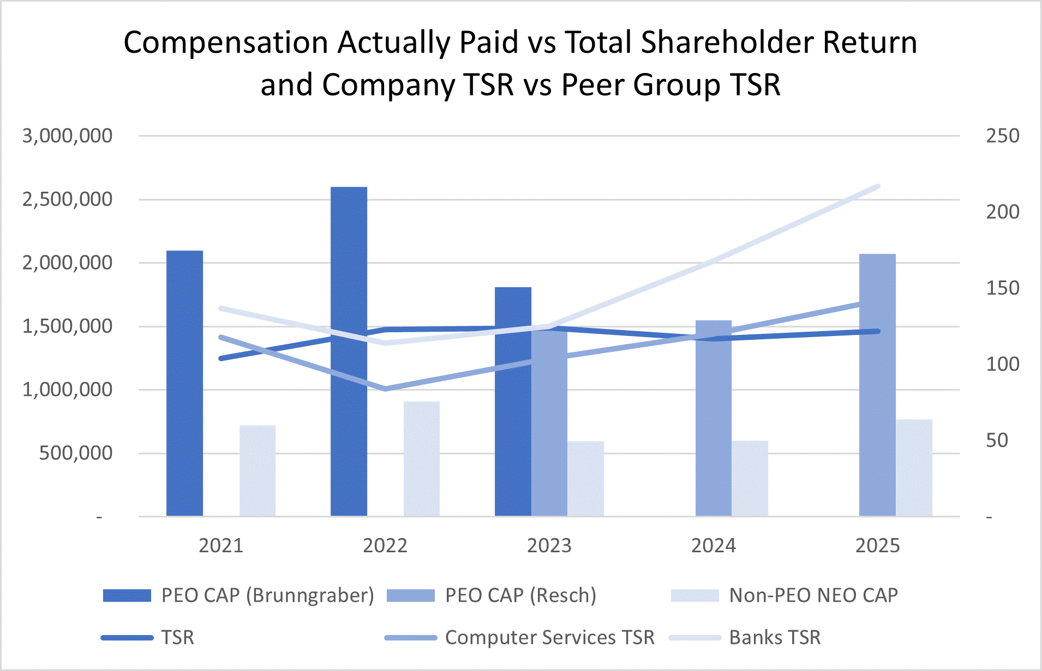
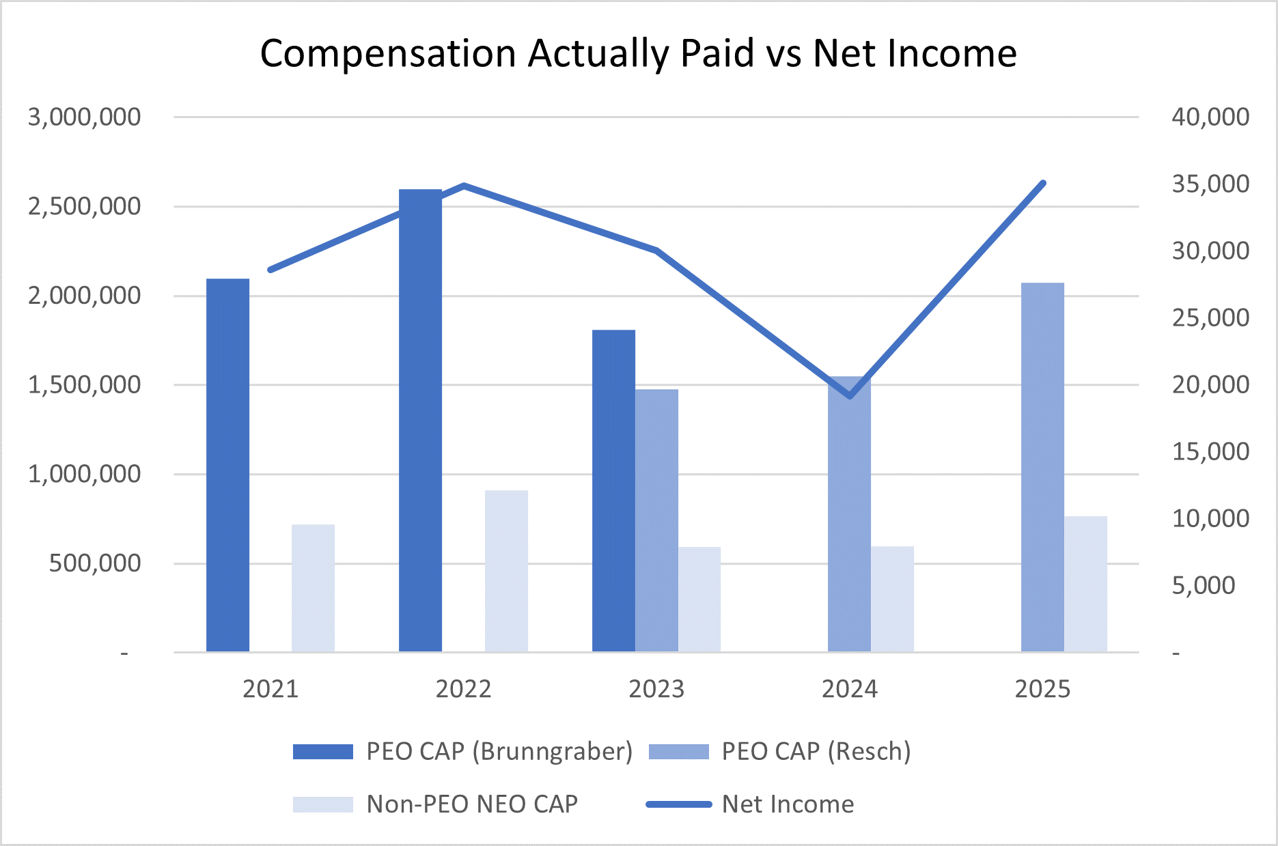

48
Executive Compensation
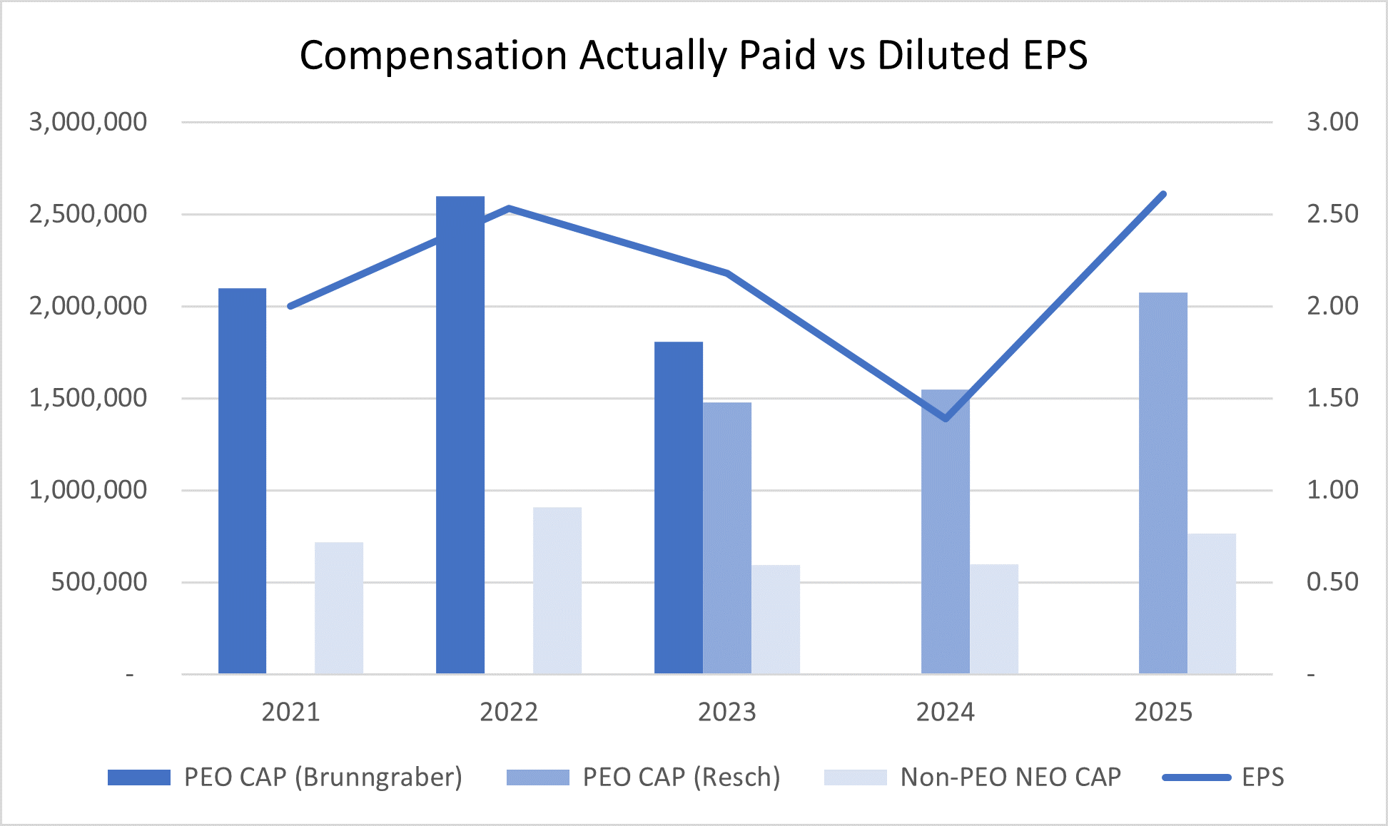

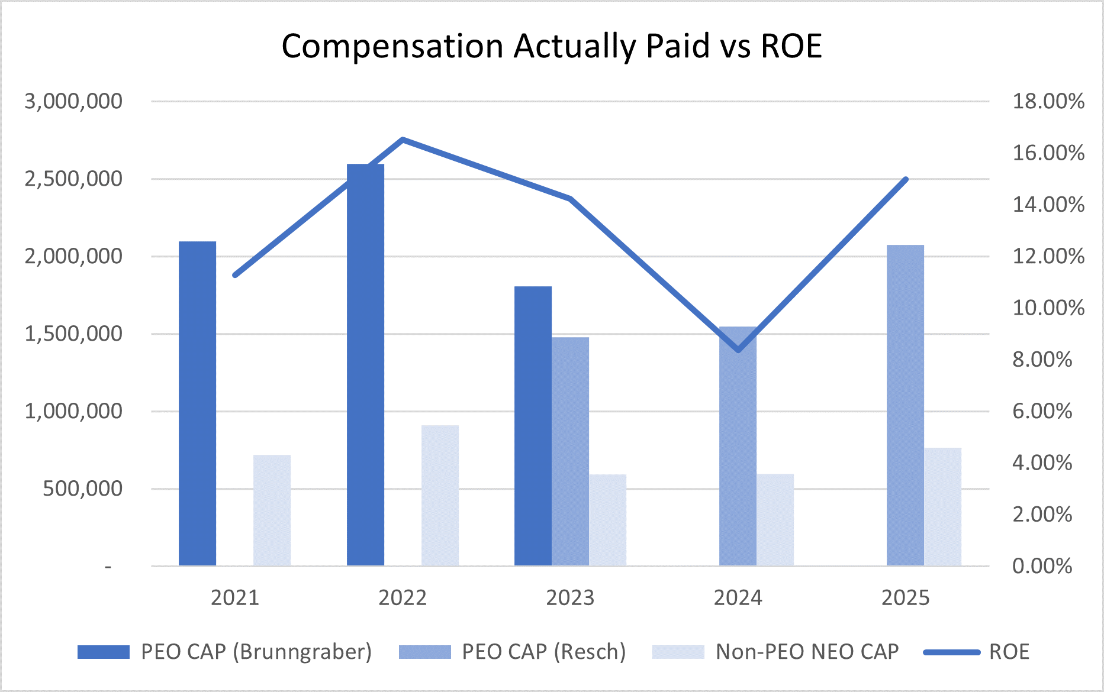

49
Executive Compensation
Stock Vested
The following table sets forth the vesting of restricted stock during 2025 for the named executive officers.
 |  |  | Stock Awards
Name |  |  | Number of Shares Acquired on Vesting (#) (1) |  |  | Value Realized on Vesting ($) (2)
Martin H. Resch |  |  | 12,062 |  |  | 499,367
Michael J. Normile |  |  | 5,629 |  |  | 233,041
James M. Cavellier |  |  | 5,365 |  |  | 222,111
Matthew S. Schuckman |  |  | 4,749 |  |  | 196,609
Dwight D. Erdbruegger |  |  | 5,585 |  |  | 231,219
(1)Represents gross amount of shares acquired upon vesting of time and performance-based restricted stock and RSUs, without netting any shares surrendered to pay taxes.
(2)Value is determined by applying the market value of the stock on the vesting date to the number of shares or units vested.

50

Beneficial Ownership of Securities

Stock Ownership of Directors, Executive Officers, and 5% Beneficial Owners
The following table contains information with respect to beneficial ownership of the Company's outstanding common stock as of February 16, 2026, unless otherwise noted, by: (i) each person known to the Company to be the beneficial owner of more than 5% of the Company’s common stock, (ii) each director and nominee for director, (iii) each named executive officer, and (iv) current directors and executive officers as a group. Unless otherwise indicated, the named person has sole voting and investment rights with respect to such shares. The percent of common stock owned by each person or group has been determined based on a total of 12,934,679 shares outstanding as of February 16, 2026. Except as indicated below, the address of each person listed is c/o Cass Information Systems, Inc., 12444 Powerscourt Drive, Suite 550, St. Louis, MO 63131.
51
Ownership of Common Stock
Name of Beneficial Owner (and address for Beneficial Owners over 5%) |  |  |  |  |  | Amount of Shares Beneficially Owned (1) |  |  |  |  |  | Percent of Class
AJH Investments LLC |  |  |  |  |  | 1,057,320 (2) |  |  |  |  |  | 8.17 |  | %
P.O. Box 680790
Park City, UT 84068
BlackRock, Inc. |  |  |  |  |  | 895,886 (3) |  |  |  |  |  | 6.93 |  | %
50 Hudson Yards
New York, NY 10001
The Vanguard Group |  |  |  |  |  | 790,913 (4) |  |  |  |  |  | 6.11 |  | %
100 Vanguard Blvd.
Malvern, PA 19355
Kim Kuehner Revocable Trust |  |  |  |  |  | 667,505 (5) |  |  |  |  |  | 5.16 |  | %
2533 South Warson Road
St. Louis, MO 63124
Eric H. Brunngraber |  |  |  |  |  | 157,538 (6) |  |  |  |  |  | 1.22%
James M. Cavellier |  |  |  |  |  | 16,713 (7) |  |  |  |  |  | *
Ralph W. Clermont |  |  |  |  |  | 21,610 (8) |  |  |  |  |  | *
John J. Drabik |  |  |  |  |  | — |  |  |  |  |  | *
Robert A. Ebel |  |  |  |  |  | 23,243 (9) |  |  |  |  |  | *
Benjamin F. Edwards, IV |  |  |  |  |  | 25,856 (10) |  |  |  |  |  | *
Dwight D. Erdbruegger |  |  |  |  |  | 16,113 |  |  |  |  |  | *
Wendy J. Henry |  |  |  |  |  | 4,655 (11) |  |  |  |  |  | *
James J. Lindemann |  |  |  |  |  | 30,382 (12) |  |  |  |  |  | *
Ann W. Marr |  |  |  |  |  | 4,730 (13) |  |  |  |  |  | *
Michael J. Normile |  |  |  |  |  | 13,529 (14) |  |  |  |  |  | *
Martin H. Resch |  |  |  |  |  | 33,971 (15) |  |  |  |  |  | *
Sally H. Roth |  |  |  |  |  | 9,399 (16) |  |  |  |  |  | *
Joseph D. Rupp |  |  |  |  |  | 18,485 (17) |  |  |  |  |  | *
Randall L. Schilling |  |  |  |  |  | 28,154 (18) |  |  |  |  |  | *
Matthew S. Schuckman |  |  |  |  |  | 8,963 (19) |  |  |  |  |  | *
Franklin D. Wicks, Jr. |  |  |  |  |  | 28,787 (20) |  |  |  |  |  | *
All directors (including nominees) and all executive officers as a group (17 persons) |  |  |  |  |  | 442,129 (21) |  |  |  |  |  | 3.42 |  | %
* Less than 1% of class.
1.The numbers reported do not include outstanding RSUs, as unvested RSUs do not carry voting rights and none will vest within 60 days of February 16, 2026.
2.Based on shareholder records as of December 31, 2025 obtained from Computershare Shareowner Services and Broadridge Financial Solutions.
3.Based on a Schedule 13G filed by the reporting person with the SEC on January 21, 2026. BlackRock, Inc. has sole voting power with respect to 883,211 shares and sole dispositive power with respect to 895,886 shares.
4.Based on a Schedule 13F filed by the reporting person with the SEC on January 29, 2026. The Vanguard Group has shared voting power with respect to 79,042 shares, sole dispositive power with respect to 707,476 shares and shared dispositive power with respect to 83,437 shares.
5.Based on shareholder records as of December 31, 2025 obtained from Computershare Shareowner Services and Broadridge Financial Solutions.
6.Includes 148,081 shares owned jointly with his spouse over which Mr. Brunngraber has shared voting and investment rights.
52
Ownership of Common Stock
7.Includes 14,662 shares held in a trust and 2,051 shares of restricted stock subject to forfeiture with respect to which Mr. Cavellier has voting but no investment rights.
8.Includes 1,200 shares held in trust and 20,410 shares of restricted stock subject to forfeiture with respect to which Mr. Clermont has voting but no investment rights.
9.Includes 3,354 shares owned jointly with his spouse over which Mr. Ebel has shared voting and investment rights and 14,401 shares of restricted stock subject to forfeiture with respect to which Mr. Ebel has voting but no investment rights.
10.Includes 21,877 shares held in trust.
11.Includes 4,655 shares of restricted stock subject to forfeiture with respect to which Ms. Henry has voting but no investment rights.
12.Includes 6,137 shares held in trust and 24,245 shares of restricted stock subject to forfeiture with respect to which Mr. Lindemann has voting but no investment rights.
13.Includes 3,128 shares of restricted stock subject to forfeiture with respect to which Ms. Marr has voting but no investment rights.
14.Includes 2,198 shares of restricted stock subject to forfeiture with respect to which Mr. Normile has voting but no investment rights.
15.Includes 24,224 shares held in trust and 9,747 shares of restricted stock subject to forfeiture with respect to which Mr. Resch has voting but no investment rights.
16.Includes 9,399 shares of restricted stock subject to forfeiture with respect to which Ms. Roth has voting but no investment rights.
17.Includes 18,485 shares of restricted stock subject to forfeiture with respect to which Mr. Rupp has voting but no investment rights.
18.Includes 24,245 shares of restricted stock subject to forfeiture with respect to which Mr. Schilling has voting but no investment rights.
19.Includes 1,821 shares of restricted stock subject to forfeiture with respect to which Mr. Schuckman has voting but no investment rights.
20.Includes 6,687 shares held in trust and 22,100 shares of restricted stock subject to forfeiture with respect to which Mr. Wicks has voting but no investment rights.
21.Includes 156,885 shares of restricted stock subject to forfeiture with respect to which the holders have voting but no investment rights.

53

Proposal No. 3
Ratification of Appointment of Independent Registered Public Accounting Firm
The Audit and Risk Committee of the Board has appointed KPMG LLP to serve as the Company's independent registered public accounting firm for 2026. KPMG LLP has served as the Company’s independent registered public accounting firm since 1983. The Audit and Risk Committee recognizes the importance of maintaining the independence of the Company's independent registered public accounting firm. To help ensure independence, the Audit and Risk Committee evaluates the qualifications, performance, and independence of KPMG LLP and its lead audit partner and periodically considers the rotation of the independent registered public accounting firm. In the course of these reviews, the Audit and Risk Committee considers, among other things:
•The quality and effectiveness of services provided by the auditors;
•The auditors' technical expertise and knowledge of the Company's operations and industry;
•Any issues raised by the PCAOB's most recent quality control review of KPMG LLP; and
•The potential impact of appointing a different public accounting firm.
A representative of KPMG LLP is expected to be present at the Annual Meeting, will have an opportunity to make a statement and will be available to respond to appropriate questions of shareholders.
Fees Incurred for Services Performed by the Independent Registered Public Accountant
For the years ended December 31, 2025 and 2024, the Company incurred the following fees for services performed by KPMG LLP, all of which were pre-approved by the Audit and Risk Committee:
 |  |  |  |  |  | 2025 |  |  |  |  |  | 2024
Audit Fees (1) |  |  |  |  |  | $975,000 |  |  |  |  |  | $905,000
Audit-Related Fees |  |  |  |  |  | — |  |  |  |  |  | —
Total Fees |  |  |  |  |  | $975,000 |  |  |  |  |  | $905,000
(1)Represents fees for the quarterly review of financial statements and annual audit of the Company’s consolidated financial statements and internal controls over financial reporting. Also includes fees for the audit of the Company’s subsidiary bank financial statements, pursuant to the requirements of 12 CFR Part 363, Annual Independent Audits and Reporting Requirements. Such fees were $60,000 for both 2025 and 2024, respectively. All such fees were pre-approved by the Audit and Risk Committee.
The Audit and Risk Committee pre-approves all auditing services, internal control-related services, and permitted non-audit services (including the fees and terms thereof) to be performed for the Company by its independent auditors, subject to the de minimis exception for non-audit services that are approved by the Audit and Risk Committee prior to the completion of the audit. The Audit and Risk Committee has delegated the authority to grant pre-approvals of audit and permitted non-audit services to the Chair, provided such decisions to grant pre-approvals are presented to the full Audit and Risk Committee at its next scheduled meeting.
54

The Company's Board recommends a vote "FOR" the ratification of the appointment of KPMG LLP as the Company's independent registered public accounting firm for 2026.

Shareholder Proposals for the 2027 Annual Meeting
In order for a shareholder to bring any business before a meeting of shareholders or nominate a candidate for election as a director at an Annual Meeting of Shareholders, the shareholder must have given timely notice thereof in writing to the Company's Secretary and comply with the other notice requirements set forth in the Bylaws. To be timely, a shareholder’s notice must be delivered to or mailed and received at the Company’s principal executive offices not less than 60 days nor more than 90 days prior to the first anniversary of the preceding year’s Annual Meeting. For the 2027 Annual Meeting, shareholders must submit proposals or nominations no earlier than January 21, 2027 and no later than February 20, 2027. If, however, the date of the meeting is changed by more than 30 days before or after such anniversary date, the notice must be received not later than the tenth day following the day on which such notice of the date of the Annual Meeting was mailed or such public disclosure was made.

Shareholder Proposals:

A shareholder’s notice to the Secretary must set forth as to each matter the shareholder proposes to bring before the Annual Meeting the following, among other information:

•a brief description of the business desired to be brought before the Annual Meeting and the reasons for conducting the business at the Annual Meeting;
•the name and address, as they appear on the Company's books, of the proposing shareholder and any beneficial owner on whose behalf the business is submitted;
•the text of the proposal or business;
•the class and number of shares which are beneficially owned by the shareholder and beneficial owner;
•any material interest of the shareholder or beneficial owner in such business; and
•any other information that would be required to be provided under Regulation 14A under the Exchange Act.

Shareholder Nominees for Director:

A shareholder’s notice to the Secretary of a director nominee must set forth, among other matters:

•as to each nominee, all information relating to the nominee that is required to be disclosed pursuant to Regulation 14A under the Exchange Act; the name, age, address, and occupation of the nominee; the class and number of shares of the Company that are beneficially owned by the nominee; and a description of all arrangements or understandings between the shareholder and each nominee and any other person or persons pursuant to which the nominations are to be made; and
•as to the nominating shareholder, the name and address of such shareholder and the beneficial owner, if any, on whose behalf the nomination is made; the class and number of shares of the Company that are beneficially owned by such shareholder and any beneficial owner on whose behalf the nomination is made; and any material interest of such shareholder and owner.

The Secretary will promptly forward such materials to the Nominating and Corporate Governance Committee Chair. The same criteria apply with respect to the Nominating and Corporate Governance Committee’s evaluation of all candidates for membership to the Board. However, separate procedures will apply if a shareholder wishes to submit at an Annual Meeting a director candidate who is not approved by the Nominating and Corporate Governance Committee or the full Board. In order for a shareholder to give timely notice of nominations for directors for inclusion on a universal proxy card in connection with
55

the 2027 Annual Meeting, notice must be submitted no later than February 20, 2027 (which is 60 days before the first anniversary of the preceding year’s Annual Meeting) and must include the information required by the Bylaws and by Rule 14a-19 under the Exchange Act.
The requirements contained in the Bylaws and summarized above are separate from and in addition to the SEC requirements that a shareholder must meet to have a proposal included in the Company’s Proxy Statement. Any shareholder proposal to be considered for inclusion in the Company’s Proxy Statement and form of proxy for its next Annual Meeting must be received by the Company no later than November 6, 2026.
All notices described in this section should be sent to the following address:
Cass Information Systems, Inc. Attn: Matthew S. Schuckman, Secretary, 12444 Powerscourt Drive, Suite 550, St. Louis, Missouri 63131.

56

Other Matters; Householding; Availability of Proxy Materials
Management does not intend to present to the Annual Meeting any business other than the items stated in the Notice of Annual Meeting of Shareholders and does not know of any matters to be brought before the Annual Meeting other than those referred to above. If, however, any other matters properly come before the Annual Meeting, the persons designated as proxies will vote on each such matter in accordance with their best judgment.
The Company and some banks, brokers, and other nominee record holders may be participating in the practice of householding proxy materials, including Notices of Internet Availability of Proxy Materials, proxy statements and annual reports. This means only a single copy of these proxy materials may be sent to multiple shareholders in your household unless you provide us with contrary instructions. The Company will deliver, promptly upon request, a separate copy of the proxy materials to any shareholder who is subject to householding. You can request a separate copy of the proxy materials by writing to the Company at Cass Information Systems, Inc., Attn: Matthew S. Schuckman, Secretary, 12444 Powerscourt Drive, Suite 550, St. Louis, MO 63131 or by calling the Company at 314 506-5500. Once you have received notice from your broker or the Company that the broker or the Company will be householding materials to your address, householding will continue until you are notified otherwise or until you revoke your consent. If, at any time, you no longer wish to participate in householding and would prefer to receive a separate copy of the proxy materials in the future, or if you currently receive multiple sets of proxy materials and would prefer to participate in householding, please notify your broker if your shares are held in a brokerage account or the Company if you hold registered shares. You can notify the Company as noted above.
The Company has elected to furnish proxy materials to shareholders online. The Company believes that doing so expedites your receipt of these materials while lowering costs and reducing the environmental impact of the Annual Meeting. The Company mailed the Notice of Internet Availability of Proxy Materials containing instructions on how to access this Proxy Statement and the Annual Report on Form 10-K for fiscal 2025 online on or about March 6, 2026. If you would like to receive printed copies of these proxy materials, the Company will provide them free of charge upon your request to the Company as noted above.
By Order of the Board of Directors
Matthew S. Schuckman, Secretary

57

Annex A
As previously described, for the purposes of certifying the Company’s performance under the Company’s compensation plans, the Compensation Committee at times makes adjustments to the Company’s GAAP results to ensure that the participants are compensated for the Company’s adjusted financial performance. These adjustments mainly include merger-related and restructuring charges or specific Board identified and approved performance items. These adjustments are made so that participants are compensated for the Company’s organic performance and are neither penalized nor rewarded for one-time charges, unusual gains, or similar non-recurring events.
For 2025, the Compensation Committee adjusted the Profit-Sharing Bonus performance metric of target net income based on certain adjustments and charges in 2024, thereby, increasing the base metric for the determination of change in NIAT for the CEO and NEOs.
During 2024, certain adjustments impacted the Profit-Sharing Bonus performance metric of net income and the LTIC performance metrics of EPS and ROE. The Company derives each of these non-GAAP performance metrics from its adjusted net income, which, as described below, is a non-GAAP financial measure, and accordingly, each of these adjusted financial measures is determined by methods other than in accordance with GAAP. See the below reconciliation of the Company’s non-GAAP financial measures within the meaning of Regulation G adopted by the SEC.

Reconciliation of Non-GAAP Financial Information
2024 Adjusted Net Income for 2025 Annual Incentive Awards
Income from continuing operations, before income tax expense |  |  | $ | 23,445
Income tax expense |  |  | 4,887
Net income from continuing operations |  |  | 18,558
Income from discontinued operations, net of tax |  |  | 610
GAAP net income as reported |  |  | $ | 19,168
Adjustments:
Pension termination expense |  |  | $ | 3,458
Bad debt expense |  |  | 6,559
Adjusted income from continuing operations, before income tax expense |  |  | 33,462
Adjusted income tax expense |  |  | 7,391
Adjusted net income (non-GAAP) |  |  | $ | 26,681
58

2024 Adjusted Net Income for 2024 Annual Incentive Awards
 |  |  | 2024
Income from continuing operations, before income tax expense |  |  | $ | 23,445
Income tax expense |  |  | 4,887
Net income from continuing operations |  |  | 18,558
Income from discontinued operations, net of tax |  |  | 610
GAAP net income as reported |  |  | $ | 19,168
Adjustments:
Pension termination expense |  |  | $ | 3,458
Adjusted income from continuing operations, before income tax expense |  |  | 26,903
Adjusted income tax expense |  |  | 5,752
Adjusted net income (non-GAAP) |  |  | $ | 21,761

2024 Annual Incentive Award Performance Metrics
 |  |  | GAAP |  |  | Performance Metric Calculated
Performance Metric |  |  | Performance Metric |  |  | Using Adjusted Net Income
Net income |  |  | $19,168 |  |  | $21,761
EPS (1) |  |  | $1.39 |  |  | $1.58
Average ROE (2) |  |  | 8.37% |  |  | 9.51%
(1)Represents adjusted earnings per common share calculated using weighted average diluted common shares.
(2)Represents the adjusted return on average equity calculated using average total equity.

59

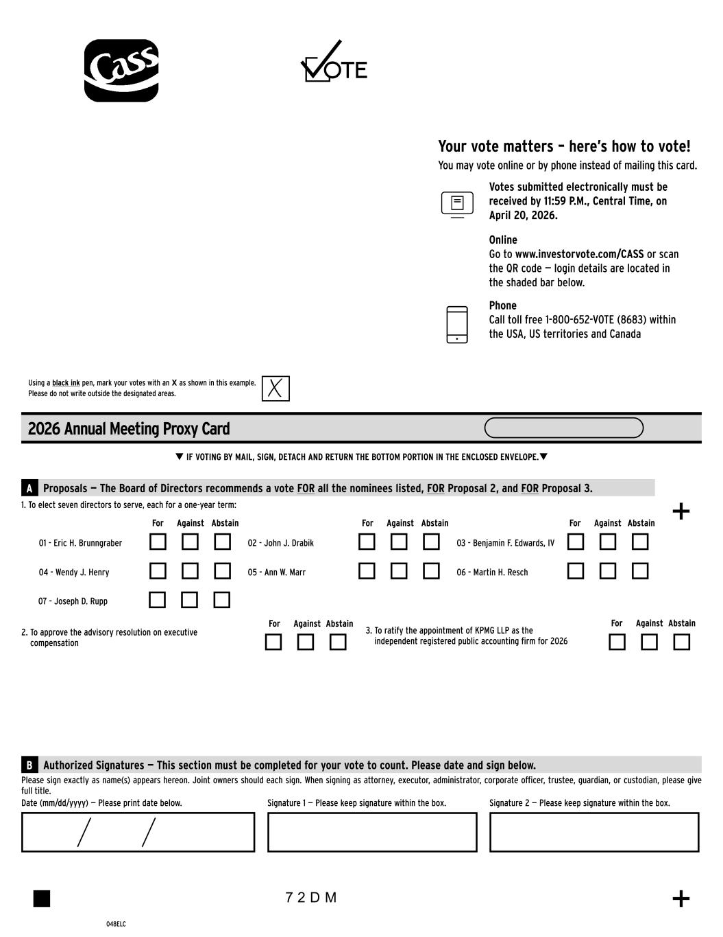
60

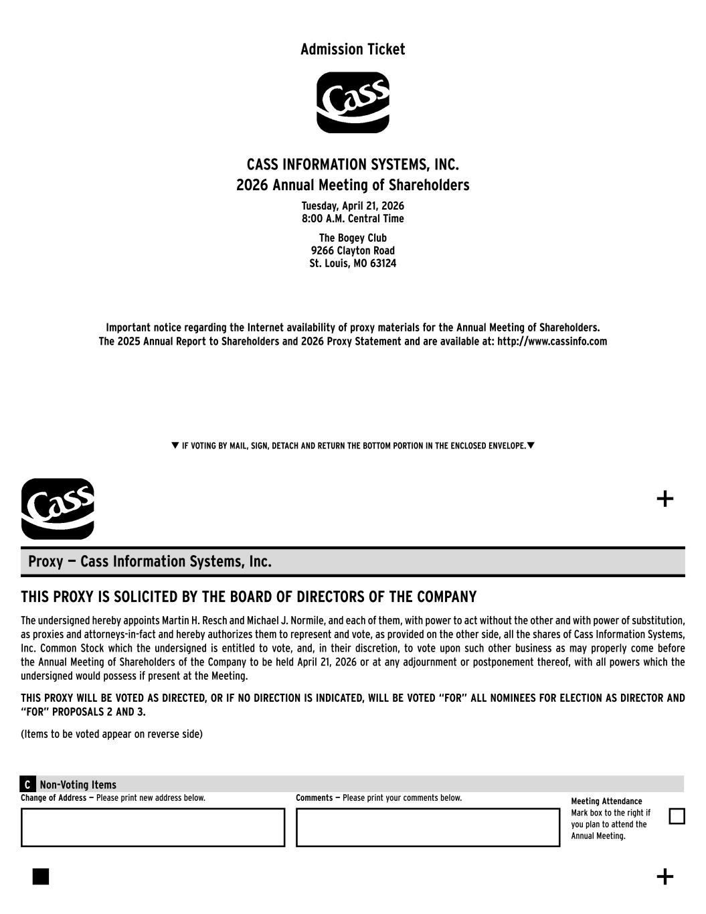
61

