UNITED STATES
SECURITIES AND EXCHANGE COMMISSION
Washington, D.C. 20549
______________________
FORM 8-K
______________________
CURRENT REPORT
PURSUANT TO SECTION 13 OR 15(d)
OF THE SECURITIES EXCHANGE ACT OF 1934
Date of Report (date of earliest event reported): July 21, 2026
______________________
CASS INFORMATION SYSTEMS, INC.
(Exact name of registrant as specified in its charter)
______________________
Missouri |  |  | 000-20827 |  |  | 43-1265338
(State or other jurisdiction of  incorporation or organization) |  |  | (Commission  File Number) |  |  | (I.R.S. Employer  Identification No.)
12444 Powerscourt Drive, Suite 550  St. Louis, Missouri |  |  | 63131
(Address of principal executive offices) |  |  | (Zip Code)
(314) 506-5500
(Registrant’s telephone number, including area code)
______________________
Check the appropriate box below if the Form 8-K filing is intended to simultaneously satisfy the filing obligation of the registrant under any of the following provisions:
☐ |  |  | Written communications pursuant to Rule 425 under the Securities Act.
☐ |  |  | Soliciting material pursuant to Rule 14a-12 under the Exchange Act.
☐ |  |  | Pre-commencement communications pursuant to Rule 14d-2(b) under the Exchange Act.
☐ |  |  | Pre-commencement communications pursuant to Rule 13e-4(c) under the Exchange Act.
Securities registered pursuant to Section 12(b) of the Act:
Title of each class |  |  |  |  |  | Trading  Symbol |  |  |  |  |  | Name of each exchange  on which registered
Common Stock, par value $0.50 per share |  |  |  |  |  | CASS |  |  |  |  |  | Nasdaq Global Select Market
Indicate by check mark whether the registrant is an emerging growth company as defined in Rule 405 of the Securities Act of 1933 (§230.405 of this chapter) or Rule 12b-2 of the Securities Exchange Act of 1934 (§240.12b-2 of this chapter).
Emerging growth company ☐
If an emerging growth company, indicate by check mark if the registrant has elected not to use the extended transition period for complying with any new or revised financial accounting standards provided pursuant to Section 13(a) of the Exchange Act. ☐

Item 2.02. Results of Operations and Financial Condition.
On July 23, 2026, Cass Information Systems, Inc. (the “Company”) issued a press release announcing its financial results for the second quarter of fiscal 2026. A copy of this press release is attached hereto as Exhibit 99.1 and incorporated herein by reference.

Also on July 23, 2026, the Company made available on the Investors section of the Company’s website at www.cassinfo.com, an earnings supplement that includes information about the Company’s business and developments and certain financial information relating to the second quarter of fiscal 2026. The information contained in this presentation is summary information that is intended to be considered in the context of the Company’s Securities and Exchange Commission filings and other public announcements that the Company may make, by press release or otherwise, from time to time. A copy of the earnings supplement is attached hereto as Exhibit 99.2 and incorporated herein by reference.

The Company has used, and intends to continue using, the Investors portion of its website to disclose material non-public information and to comply with its disclosure obligations under Regulation FD. Accordingly, investors are encouraged to monitor the Company’s website in addition to following press releases, SEC filings, and public conference calls and webcasts.

The information reported under this Item 2.02 of Form 8-K, including Exhibit 99.1 and Exhibit 99.2 is being furnished and shall not be deemed to be “filed” for the purposes of Section 18 of the Securities Exchange Act of 1934, as amended (the “Exchange Act”), or otherwise subject to the liabilities of such section, nor shall such information be deemed incorporated by reference in any filing under the Securities Act of 1933, as amended, or the Exchange Act, except as shall be expressly set forth by specific reference in such filing.

Item 8.01. Other Events.
On July 21, 2026, the Company’s Board of Directors declared a third quarter dividend of $0.32 per share payable on September 14, 2026 to shareholders of record on September 4, 2026.

Item 9.01. Financial Statements and Exhibits.
(d) Exhibits.
Exhibit Number |  |  |  |  |  | Description
99.1 |  |  |  |  |  | Press release issued by Cass Information Systems, Inc. dated July 23, 2026.
99.2 |  |  |  |  |  | Earnings supplement made available on the Investors section of the Company’s website.
104 |  |  |  |  |  | Cover Page Interactive Data File (embedded within the Inline XBRL document).

2

SIGNATURES
Pursuant to the requirements of the Securities Exchange Act of 1934, the registrant has duly caused this report to be signed on its behalf by the undersigned hereunto duly authorized.
Dated: July 23, 2026
 |  |  | CASS INFORMATION SYSTEMS, INC.
 |  |  | By: |  |  | /s/ Martin H. Resch
 |  |  | Name: |  |  | Martin H. Resch
 |  |  | Title: |  |  | President and Chief Executive Officer
 |  |  | By: |  |  | /s/ Michael J. Normile
 |  |  | Name: |  |  | Michael J. Normile
 |  |  | Title: |  |  | Executive Vice President and Chief Financial Officer

2

Exhibit 99.1

Contact: Cass Investor Relations
ir@cassinfo.com
July 23, 2026
Cass Information Systems reports Second Quarter 2026 Results

Record level of quarterly net income and EPS

Continued net interest margin expansion

Strong expense control
ST. LOUIS – Cass Information Systems, Inc. (Nasdaq: CASS) (the Company or Cass) today reported its second quarter 2026 earnings.

Second Quarter Financial Highlights

•Record net income and diluted earnings per share of $10.6 million and $0.81, respectively.
•Adjusted net income and adjusted diluted earnings per share from continuing operations (non-GAAP) of $9.2 million and $0.71, respectively, increases of 18.1% and 22.4%, respectively, compared to the second quarter of 2025.
•Increase in net interest margin to 4.00% compared to 3.78% in the second quarter of 2025.
•Increase in transportation dollar volumes of 7.4% compared to the second quarter of 2025.
•Decrease in personnel expenses of 2.4% compared to the second quarter of 2025.
•Continued strong asset quality with no loan charge-offs and an allowance for credit losses to loans ratio of 1.30%. In addition, reduced non-performing loans by $5.3 million, or 76.4%, as compared to December 31, 2025.
•Received a bad debt recovery of $1.8 million.
•Repurchased 65,557 shares of Company stock at a weighted average price of $46.23.

Martin Resch, the Company’s President and Chief Executive Officer, noted, “Our record quarterly earnings reflect continued successful execution against our financial objectives.” Resch added, “The current market conditions, including higher freight rates and a sustained higher interest rate environment, present meaningful support to our earnings outlook. These tailwinds, combined with new business wins and expense discipline, should position Cass well for continued core earnings growth in coming quarters."

Earnings for the second quarter of 2026 are summarized as follows:

($ in thousands, except per share data) |  |  | Three Months Ended |  |  |  |  |  |  |  |  |  |  |  |  |  |  |  |  |  |  |  |  |  |  |  |  |  |  |  |  |  | Six Months Ended
 |  |  | 6/30/26 |  |  |  |  |  | 3/31/26 |  |  |  |  |  | 12/31/25 |  |  |  |  |  | 9/30/25 |  |  |  |  |  | 6/30/25 |  |  |  |  |  | 6/30/26 |  |  |  |  |  | 6/30/25
Net income from continuing operations |  |  | $ | 10,575 |  |  |  |  | $ | 8,739 |  |  |  |  | $ | 8,189 |  |  |  |  | $ | 9,212 |  |  |  |  | $ | 5,160 |  |  |  |  | $ | 19,314 |  |  |  |  | $ | 13,710
Net income |  |  | $ | 10,587 |  |  |  |  | $ | 8,832 |  |  |  |  | $ | 8,189 |  |  |  |  | $ | 9,106 |  |  |  |  | $ | 8,855 |  |  |  |  | $ | 19,419 |  |  |  |  | $ | 17,821
Diluted earnings per share from continuing operations |  |  | $ | 0.81 |  |  |  |  | $ | 0.66 |  |  |  |  | $ | 0.62 |  |  |  |  | $ | 0.69 |  |  |  |  | $ | 0.38 |  |  |  |  | $ | 1.47 |  |  |  |  | $ | 1.01
Diluted earnings per share |  |  | $ | 0.81 |  |  |  |  | $ | 0.67 |  |  |  |  | $ | 0.62 |  |  |  |  | $ | 0.68 |  |  |  |  | $ | 0.66 |  |  |  |  | $ | 1.48 |  |  |  |  | $ | 1.31
Return on average equity |  |  | 17.72% |  |  |  |  |  | 14.63% |  |  |  |  |  | 13.45% |  |  |  |  |  | 15.29% |  |  |  |  |  | 15.35% |  |  |  |  |  | 16.17% |  |  |  |  |  | 15.62%
Return on average assets |  |  | 1.67% |  |  |  |  |  | 1.42% |  |  |  |  |  | 1.28% |  |  |  |  |  | 1.44% |  |  |  |  |  | 1.48% |  |  |  |  |  | 1.54% |  |  |  |  |  | 1.49%
Net interest margin |  |  | 4.00% |  |  |  |  |  | 3.95% |  |  |  |  |  | 3.93% |  |  |  |  |  | 3.87% |  |  |  |  |  | 3.78% |  |  |  |  |  | 3.97% |  |  |  |  |  | 3.76%

($ in thousands, except per share data) |  |  | Three Months Ended |  |  |  |  |  |  |  |  |  |  |  |  |  |  |  |  |  |  |  |  |  |  |  |  |  |  |  |  |  | Six Months Ended
 |  |  | 6/30/26 |  |  |  |  |  | 3/31/26 |  |  |  |  |  | 12/31/25 |  |  |  |  |  | 9/30/25 |  |  |  |  |  | 6/30/25 |  |  |  |  |  | 6/30/26 |  |  |  |  |  | 6/30/25
Net income from continuing operations (GAAP) |  |  | $ | 10,575 |  |  |  |  | $ | 8,739 |  |  |  |  | $ | 8,189 |  |  |  |  | $ | 9,212 |  |  |  |  | $ | 5,160 |  |  |  |  | $ | 19,314 |  |  |  |  | $ | 13,710
Net income adjustments(1) |  |  | (1,326) |  |  |  |  |  | (4) |  |  |  |  |  | 821 |  |  |  |  |  | (3) |  |  |  |  |  | 2,674 |  |  |  |  |  | (1,330) |  |  |  |  |  | 1,185
Adjusted net income from continuing operations (Non-GAAP) (1) |  |  | $ | 9,249 |  |  |  |  | $ | 8,735 |  |  |  |  | $ | 9,010 |  |  |  |  | $ | 9,209 |  |  |  |  | $ | 7,834 |  |  |  |  | $ | 17,984 |  |  |  |  | $ | 14,895
Diluted earnings per share from continuing operations (GAAP) |  |  | $ | 0.81 |  |  |  |  | $ | 0.66 |  |  |  |  | $ | 0.62 |  |  |  |  | $ | 0.69 |  |  |  |  | $ | 0.38 |  |  |  |  | $ | 1.47 |  |  |  |  | $ | 1.01
Adjusted diluted earnings per share from continuing operations (Non-GAAP) (1) |  |  | $ | 0.71 |  |  |  |  | $ | 0.66 |  |  |  |  | $ | 0.68 |  |  |  |  | $ | 0.69 |  |  |  |  | $ | 0.58 |  |  |  |  | $ | 1.37 |  |  |  |  | $ | 1.09
(1)Refer to explanation of use of non-GAAP financial measures and reconciliation of adjusted net income from continuing operations and adjusted diluted earnings per share from continuing operations as presented later in this earnings release.

Second Quarter 2026 Financial Commentary
(All comparisons refer to the second quarter of 2025, except as noted)

Transportation Invoice and Dollar Volumes – Despite transportation invoice volumes of 8.7 million decreasing 1.9%, transportation dollar volumes of $10.1 billion increased 7.4%. The average dollars per invoice were $1,161 in the second quarter of 2026, compared to $1,115 in the first quarter of 2026 and $1,060 in the second quarter of 2025. Dollars per invoice increased due to an increase in overall freight rates, as well as the impact of fuel surcharges. The Company expects average dollars per invoice to continue increasing in future quarters due to the anticipated upward repricing of contract freight rates. A more detailed analysis of Cass Freight Index® changes can be found at www.cassinfo.com.

Facility Expense Invoice and Dollar Volumes – Facility expense invoice volumes of 4.0 million decreased 3.0%, and dollar volumes of $5.7 billion, increased 2.6%. The Company expects invoice volumes to increase on a quarter over prior year quarter basis beginning in the fourth quarter of 2026 as new clients are onboarded. Dollar volumes are expected to continue increasing compared to prior year quarters due to rising electricity and gas prices.

Processing Fees – Processing fees decreased $614,000, or 3.7%, due to lower transportation and facility invoice volumes.

Financial Fees – Financial fees, earned on a transactional level basis for invoice payment services when making customer payments, increased $790,000, or 7.8%. The increase in financial fees was primarily due to an increase in average payments in advance of funding of 19.4%. Rising freight rates, combined with higher demand for the Company’s early payment and other financial solutions, are expected to continue to drive an increase in payments in advance of funding and resulting financial fees in future quarters.

Net Interest Income – Net interest income increased $2.1 million, or 10.6%. The increase in net interest income was attributable to the net interest margin improving to 4.00% as compared to 3.78%, in addition to an increase in average interest-earning assets of $108.7 million, or 5.2%.

The Company’s net interest margin improvement was driven by increases in the average yield on loans and investment securities of 23 and 70 basis points, respectively, combined with a decrease in the average cost of total deposits of 20 basis points, partially offset by a decrease in the yield on short-term investments of 66 basis points. The increase in loan yield was driven by the continued maturity and subsequent re-pricing of fixed rate loans originated in the years 2021 and 2022 to current market interest rates. The increase in the investment securities yield was driven by the partial repositioning of the portfolio at the end of the second quarter of 2025 as well as purchases of investments at current market rates. The decline in the cost of total deposits and yield on short-term investments was driven by the reduction in the federal funds rate.

The Company expects continued expansion in its net interest margin in future quarters to the extent 3-5 year U.S. Treasury interest rates stay relatively consistent or increase as compared to current levels.

Provision for Credit Losses - The Company recorded a provision for credit losses of $531,000 during the second quarter of 2026 as compared to $25,000 in the second quarter of 2025. The provision for credit losses for the second quarter of 2026 was driven by loan growth as well as a specific reserve on a nonperforming commercial real estate loan.

Personnel Expenses - Personnel expenses decreased $667,000, or 2.4%, as compared to the second quarter of 2025. Salaries and commissions decreased $397,000, or 1.9%, as a result of the decrease in average full-time equivalent employees (“FTEs”) of 9.0% due to automation and the ongoing consolidation within our Facilities division, partially offset by merit increases. Share-based compensation and employee profit sharing increased $212,000 and $376,000, respectively, due to the improvement in net income from continuing operations. Other benefits decreased $858,000, or 18.6%, due to the decrease in FTEs in addition to lower health insurance claims and related expenses.

Salaries and commissions increased $973,000, or 5.0%, as compared to the first quarter of 2026 due to merit increases effective April 1, 2026, an increase in severance costs of $160,000 and one additional payroll day, partially offset by a 2.9% decrease in average FTEs.

Equipment Expense - Equipment expense increased $214,000 primarily due to an increase in depreciation and licensing and maintenance expense on software related to technology initiatives.

Bad Debt Recovery - The Company recorded a bad debt recovery of $1.8 million related to the second annual payment in a litigation settlement. There are three annual payments remaining of $1.25 million each, plus interest.

Other Expense - Other expense increased $828,000, or 12.1%. The increase is primarily due to higher business development costs and professional fees.

Loans - When compared to December 31, 2025, loans increased $41.8 million, or 3.9%. Other commercial and industrial loans have increased $38.0 million year-to-date due to organic growth and higher line utilization. The Company continues to expect loan growth of 6-8% for full year 2026.

Payments in Advance of Funding – Average payments in advance of funding increased $34.2 million, or 19.4%, primarily due to a 7.4% increase in transportation dollar volumes and a higher level of demand for the Company’s early payment and other financial solutions.

Deposits – Average deposits increased $66.1 million, or 6.6%. The Company experienced growth in average CassPay deposits of $43.4 million, or 18.0%, as compared to the second quarter of 2025.

Accounts and Drafts Payable - Average accounts and drafts payable increased $56.0 million, or 5.0%, as compared to the second quarter of 2025. The increase in these balances, which are non-interest bearing, is primarily reflective of the increase in transportation and facility dollar volumes of 7.4% and 2.6%, respectively.

Short-term Borrowings - The Company had outstanding borrowings of $80.0 million on its lines of credit at June 30, 2026 to provide funding for higher balances of payments in advance of funding and accounts and drafts receivable from customers at quarter end. Average short-term borrowings during the second quarter of 2026 were $10.0 million.

Shareholders’ Equity - Total shareholders’ equity increased $2.9 million as compared to March 31, 2026 as a result of net income of $10.6 million, partially offset by the repurchase of Company stock of $3.0 million and dividends of $4.1 million.

Dividend - On July 21, 2026, the Company’s Board of Directors approved a quarterly dividend of $0.32 per share with the dividend payable on September 14, 2026 to shareholders of record on September 4, 2026.

Repurchase of Common Stock - The Company repurchased 65,557 shares of common stock during the current quarter. The Company manages capital with an overall objective of maintaining a leverage ratio of approximately 10.00%. Future levels of repurchases will depend on market conditions, earnings, balance sheet growth and potential acquisition opportunities.

Asset Quality - Non-performing loans totaled $1.6 million at June 30, 2026, a decrease of $1.5 million as compared to March 31, 2026. The Company has two non-performing loan relationships remaining at June 30, 2026.

Outlook - The Company is optimistic regarding its revenue outlook as a result of i) the likelihood of sustained higher interest rates which would be expected to positively impact net interest margin; ii) the impact of higher contract freight rates and fuel surcharges which should lead to higher levels of accounts and drafts payable, net interest income and financial fees; iii) increased sales activity around early payment solutions within Transportation which generates financial fees: iv) organic loan growth opportunities; and v) increased sales activity around non-interest bearing CassPay deposits. In addition, the Company expects to be able to hold quarter over prior year quarter core expense growth to under 2% as a result of the continued focus on AI-enabled systems and other operational efficiency opportunities. While transaction growth in its Transportation and Facility businesses remains a challenge, the Company believes that recent technology investments into AI-enabled systems and a higher level of focus on business development positions the Company for better success in client growth in the mid-term.
About Cass Information Systems
Cass Information Systems, Inc. is a leading provider of integrated information and payment management solutions. Cass enables enterprises to achieve visibility, control and efficiency in their supply chains, communications networks, facilities and other operations. Disbursing over $94 billion annually on behalf of clients, and with total assets of $2.5 billion, Cass is uniquely supported by Cass Commercial Bank. Founded in 1906 and a wholly owned subsidiary, Cass Commercial Bank provides sophisticated financial exchange services to the parent organization and its clients. Cass is part of the Russell 2000®. More information is available at www.cassinfo.com.

On April 7, 2025, the Company signed an Asset Purchase Agreement providing for the sale of its Telecom Expense Management & Managed Mobility Services (“TEM”) business to Asignet USA Inc. The sale closed on June 30, 2025. The Company has applied discontinued operations accounting in accordance with FASB Accounting Standards Codification (“ASC”), Topic 205-20, “Presentation of Financial Statements – Discontinued Operations,” to the assets and liabilities sold related to the Company's TEM Business Unit as of and for the periods ended June 30, 2026, March 31, 2026, December 31, 2025, September 30, 2025, and June 30, 2025, as applicable. All financial information in this earnings release is reported on a continuing operations basis, unless otherwise noted.

About Non-GAAP Financial Measures

Certain of the financial measures and ratios the Company presents, including “adjusted net income from continuing operations,” and “adjusted diluted earnings per share from continuing operations,” are supplemental measures that are not required by, or are not presented in accordance with, U.S. generally accepted accounting principles (GAAP). The Company refers to these financial measures and ratios as “non-GAAP financial measures.” The Company considers the use of select non-GAAP financial measures and ratios to be useful for financial and operational decision making and useful in evaluating period-to-period comparisons. The Company believes that these non-GAAP financial measures provide meaningful supplemental information regarding its performance by excluding certain revenue and expense items that the Company believes are not indicative of its primary business operating results or by presenting certain metrics on a fully taxable equivalent basis. The Company believes that management and investors benefit from referring to these non-GAAP financial measures in assessing the Company’s performance and when planning, forecasting, analyzing and comparing past, present and future periods.

These non-GAAP financial measures should not be considered a substitute for financial information presented in accordance with GAAP and you should not rely on non-GAAP financial measures alone as measures of the Company’s

performance. The non-GAAP financial measures the Company presents may differ from non-GAAP financial measures used by the Company’s peers or other companies. The Company compensates for these differences by providing the equivalent GAAP measures whenever the Company presents the non-GAAP financial measures and by including a reconciliation of the impact of the components adjusted for in the non-GAAP financial measure so that both measures and the individual components may be considered when analyzing the Company’s performance. A reconciliation of non-GAAP financial measures to the comparable GAAP financial measures is included at the end of the financial statement tables.
Forward Looking Information

All statements other than statements of historical fact included in this release, including without limitation the Company’s future prospects and performance, the business strategy and the plans and objectives of the Company's management for future operations, are forward-looking statements within the meaning of the Private Securities Litigation Reform Act of 1995. When used in this release, words such as “estimate,” “could,” “should,” “would,” “likely,” “may,” “will,” “plan,” “intend,” “believes,” “expects,” “anticipates,” “projected,” and variations of these terms and similar expressions. Although the Company believes that the expectations reflected in the forward-looking statements are reasonable, the Company cannot guarantee future results, levels of activity, performance, or achievements. Actual results or business conditions may differ materially from those projected or suggested in forward-looking statements as a result of various factors including, but not limited to, those described below and in Part I, Item 1A, “Risk Factors” of our most recent Annual Report.

Actual results could differ materially from those contemplated by the forward-looking statements as a result of certain factors, including but not limited to general economic, market or business conditions unrelated to the Company’s operating performance, including inflation, changes in interest rates, changes in energy prices, supply chain disruptions, financial institution disruptions, geopolitical conflicts, public health emergencies and declines in consumer confidence and discretionary spending; the Company’s ability to compete with its competitors and increase market share; the Company’s ability to maintain compliance with rules and regulations applicable to our business operations and industry; increased regulatory examination scrutiny or new regulatory requirements; whether the Company’s customers continue to utilize its payment processing and related services; unfavorable developments concerning customer credit quality; risk associated with lending concentrations including, but not limited to, faith-based ministries and franchise restaurants; liquidity risk; and risks associated with cyber-attacks and data breaches.

Readers are cautioned not to place undue reliance on these forward-looking statements. Any forward-looking statement made by the Company in this release speaks only as of the date of this release. Unless required by law, the Company does not undertake to release publicly any revisions to these forward-looking statements to reflect future events or circumstances or to reflect the occurrence of unanticipated events. If the Company updates one or more forward-looking statements, no inference should be drawn that the Company will make additional updates with respect to those or other forward-looking statements.

Consolidated Statements of Income (unaudited)

($ and numbers in thousands, except per share data)
 |  |  | Three Months Ended |  |  |  |  |  |  |  |  |  |  |  |  |  |  |  |  |  |  |  |  |  |  |  |  |  |  |  |  |  | Six Months Ended
 |  |  | 6/30/26 |  |  |  |  |  | 3/31/26 |  |  |  |  |  | 12/31/25 |  |  |  |  |  | 9/30/25 |  |  |  |  |  | 6/30/25 |  |  |  |  |  | 6/30/26 |  |  |  |  |  | 6/30/25
Processing fees |  |  | $ | 16,086 |  |  |  |  | $ | 15,728 |  |  |  |  | $ | 16,304 |  |  |  |  | $ | 16,655 |  |  |  |  | $ | 16,700 |  |  |  |  | $ | 31,814 |  |  |  |  | $ | 33,169
Financial fees |  |  | 10,951 |  |  |  |  |  | 10,431 |  |  |  |  |  | 9,860 |  |  |  |  |  | 10,416 |  |  |  |  |  | 10,161 |  |  |  |  |  | 21,382 |  |  |  |  |  | 20,122
Total fee revenue |  |  | $ | 27,037 |  |  |  |  | $ | 26,159 |  |  |  |  | $ | 26,164 |  |  |  |  | $ | 27,071 |  |  |  |  | $ | 26,861 |  |  |  |  | $ | 53,196 |  |  |  |  | $ | 53,291
Interest and fees on loans |  |  | 15,956 |  |  |  |  |  | 15,277 |  |  |  |  |  | 15,521 |  |  |  |  |  | 15,632 |  |  |  |  |  | 15,837 |  |  |  |  |  | 31,233 |  |  |  |  |  | 31,187
Interest and dividends on investment securities |  |  | 7,079 |  |  |  |  |  | 6,995 |  |  |  |  |  | 6,767 |  |  |  |  |  | 5,679 |  |  |  |  |  | 4,799 |  |  |  |  |  | 14,074 |  |  |  |  |  | 8,946
Interest on short-term investments |  |  | 2,570 |  |  |  |  |  | 2,832 |  |  |  |  |  | 3,078 |  |  |  |  |  | 3,860 |  |  |  |  |  | 3,003 |  |  |  |  |  | 5,402 |  |  |  |  |  | 6,895
Total interest income |  |  | $ | 25,605 |  |  |  |  | $ | 25,104 |  |  |  |  | $ | 25,366 |  |  |  |  | $ | 25,171 |  |  |  |  | $ | 23,639 |  |  |  |  | $ | 50,709 |  |  |  |  | $ | 47,028
Interest expense |  |  | 4,058 |  |  |  |  |  | 3,888 |  |  |  |  |  | 3,895 |  |  |  |  |  | 4,151 |  |  |  |  |  | 4,164 |  |  |  |  |  | 7,946 |  |  |  |  |  | 8,280
Net interest income |  |  | $ | 21,547 |  |  |  |  | $ | 21,216 |  |  |  |  | $ | 21,471 |  |  |  |  | $ | 21,020 |  |  |  |  | $ | 19,475 |  |  |  |  | $ | 42,763 |  |  |  |  | $ | 38,748
(Provision for) release of credit losses |  |  | (531) |  |  |  |  |  | (61) |  |  |  |  |  | 389 |  |  |  |  |  | 193 |  |  |  |  |  | (25) |  |  |  |  |  | (592) |  |  |  |  |  | (930)
Gain (loss) on sale of investment securities |  |  | 5 |  |  |  |  |  | 5 |  |  |  |  |  | 38 |  |  |  |  |  | 4 |  |  |  |  |  | (3,558) |  |  |  |  |  | 10 |  |  |  |  |  | (3,576)
Other |  |  | 1,885 |  |  |  |  |  | 1,782 |  |  |  |  |  | 1,827 |  |  |  |  |  | 1,768 |  |  |  |  |  | 1,645 |  |  |  |  |  | 3,667 |  |  |  |  |  | 3,271
Total revenues |  |  | $ | 49,943 |  |  |  |  | $ | 49,101 |  |  |  |  | $ | 49,889 |  |  |  |  | $ | 50,056 |  |  |  |  | $ | 44,398 |  |  |  |  | $ | 99,044 |  |  |  |  | $ | 90,804
Salaries and commissions |  |  | 20,241 |  |  |  |  |  | 19,268 |  |  |  |  |  | 20,304 |  |  |  |  |  | 20,105 |  |  |  |  |  | 20,638 |  |  |  |  |  | 39,509 |  |  |  |  |  | 40,301
Share-based compensation |  |  | 1,130 |  |  |  |  |  | 1,439 |  |  |  |  |  | 1,009 |  |  |  |  |  | 1,018 |  |  |  |  |  | 918 |  |  |  |  |  | 2,569 |  |  |  |  |  | 2,159
Employee profit sharing |  |  | 1,959 |  |  |  |  |  | 1,634 |  |  |  |  |  | 1,514 |  |  |  |  |  | 1,685 |  |  |  |  |  | 1,583 |  |  |  |  |  | 3,593 |  |  |  |  |  | 3,085
Other benefits |  |  | 3,755 |  |  |  |  |  | 4,938 |  |  |  |  |  | 4,602 |  |  |  |  |  | 4,798 |  |  |  |  |  | 4,613 |  |  |  |  |  | 8,693 |  |  |  |  |  | 9,486
Total personnel expenses |  |  | $ | 27,085 |  |  |  |  | $ | 27,279 |  |  |  |  | $ | 27,429 |  |  |  |  | $ | 27,606 |  |  |  |  | $ | 27,752 |  |  |  |  | $ | 54,364 |  |  |  |  | $ | 55,031
Occupancy |  |  | 703 |  |  |  |  |  | 681 |  |  |  |  |  | 643 |  |  |  |  |  | 734 |  |  |  |  |  | 669 |  |  |  |  |  | 1,384 |  |  |  |  |  | 1,390
Equipment |  |  | 2,776 |  |  |  |  |  | 2,432 |  |  |  |  |  | 2,548 |  |  |  |  |  | 2,513 |  |  |  |  |  | 2,562 |  |  |  |  |  | 5,208 |  |  |  |  |  | 4,856
Amortization of intangible assets |  |  | 293 |  |  |  |  |  | 293 |  |  |  |  |  | 293 |  |  |  |  |  | 293 |  |  |  |  |  | 293 |  |  |  |  |  | 586 |  |  |  |  |  | 586
Bad debt recovery |  |  | (1,759) |  |  |  |  |  | — |  |  |  |  |  | — |  |  |  |  |  | — |  |  |  |  |  | — |  |  |  |  |  | (1,759) |  |  |  |  |  | (2,000)
Other |  |  | 7,671 |  |  |  |  |  | 7,533 |  |  |  |  |  | 8,988 |  |  |  |  |  | 7,295 |  |  |  |  |  | 6,843 |  |  |  |  |  | 15,204 |  |  |  |  |  | 13,786
Total operating expenses |  |  | $ | 36,769 |  |  |  |  | $ | 38,218 |  |  |  |  | $ | 39,901 |  |  |  |  | $ | 38,441 |  |  |  |  | $ | 38,119 |  |  |  |  | $ | 74,987 |  |  |  |  | $ | 73,649
Income from continuing operations, before income tax expense |  |  | $ | 13,174 |  |  |  |  | $ | 10,883 |  |  |  |  | $ | 9,988 |  |  |  |  | $ | 11,615 |  |  |  |  | $ | 6,279 |  |  |  |  | $ | 24,057 |  |  |  |  | $ | 17,155
Income tax expense |  |  | 2,599 |  |  |  |  |  | 2,144 |  |  |  |  |  | 1,799 |  |  |  |  |  | 2,403 |  |  |  |  |  | 1,119 |  |  |  |  |  | 4,743 |  |  |  |  |  | 3,445
Net income from continuing operations |  |  | $ | 10,575 |  |  |  |  | $ | 8,739 |  |  |  |  | $ | 8,189 |  |  |  |  | $ | 9,212 |  |  |  |  | $ | 5,160 |  |  |  |  | $ | 19,314 |  |  |  |  | $ | 13,710
Income (loss) from discontinued operations, net of tax |  |  | 12 |  |  |  |  |  | 93 |  |  |  |  |  | — |  |  |  |  |  | (106) |  |  |  |  |  | 3,695 |  |  |  |  |  | 105 |  |  |  |  |  | 4,111
Net income |  |  | $ | 10,587 |  |  |  |  | $ | 8,832 |  |  |  |  | $ | 8,189 |  |  |  |  | $ | 9,106 |  |  |  |  | $ | 8,855 |  |  |  |  | $ | 19,419 |  |  |  |  | $ | 17,821
Basic earnings per share from continuing operations |  |  | $ | .83 |  |  |  |  | $ | .68 |  |  |  |  | $ | .63 |  |  |  |  | $ | .70 |  |  |  |  | $ | .39 |  |  |  |  | $ | 1.50 |  |  |  |  | $ | 1.03
Basic earnings (loss) per share from discontinued operations |  |  | — |  |  |  |  |  | .01 |  |  |  |  |  | — |  |  |  |  |  | (.01) |  |  |  |  |  | .28 |  |  |  |  |  | .01 |  |  |  |  |  | .31
Basic earnings per share |  |  | $ | .83 |  |  |  |  | $ | .69 |  |  |  |  | $ | .63 |  |  |  |  | $ | .69 |  |  |  |  | $ | .67 |  |  |  |  | $ | 1.51 |  |  |  |  | $ | 1.34
Diluted earnings per share from continuing operations |  |  | $ | .81 |  |  |  |  | $ | .66 |  |  |  |  | $ | .62 |  |  |  |  | $ | .69 |  |  |  |  | $ | .38 |  |  |  |  | $ | 1.47 |  |  |  |  | $ | 1.01
Diluted earnings (loss) per share from discontinued operations |  |  | — |  |  |  |  |  | .01 |  |  |  |  |  | — |  |  |  |  |  | (.01) |  |  |  |  |  | .28 |  |  |  |  |  | .01 |  |  |  |  |  | .30
Diluted earnings per share |  |  | $ | .81 |  |  |  |  | $ | .67 |  |  |  |  | $ | .62 |  |  |  |  | $ | .68 |  |  |  |  | $ | .66 |  |  |  |  | $ | 1.48 |  |  |  |  | $ | 1.31

Consolidated Balance Sheets (unaudited)

($ in thousands)
 |  |  | As of
 |  |  | 6/30/26 |  |  |  |  |  | 3/31/26 |  |  |  |  |  | 12/31/25 |  |  |  |  |  | 9/30/25 |  |  |  |  |  | 6/30/25
Assets:
Cash and cash equivalents |  |  | $ | 228,473 |  |  |  |  | $ | 244,343 |  |  |  |  | $ | 392,268 |  |  |  |  | $ | 258,634 |  |  |  |  | $ | 218,165
Investment securities available-for-sale, at fair value |  |  | 736,790 |  |  |  |  |  | 785,343 |  |  |  |  |  | 770,772 |  |  |  |  |  | 717,369 |  |  |  |  |  | 599,541
Loans |  |  | 1,103,039 |  |  |  |  |  | 1,088,730 |  |  |  |  |  | 1,061,217 |  |  |  |  |  | 1,088,347 |  |  |  |  |  | 1,117,004
Less: Allowance for credit losses |  |  | (14,374) |  |  |  |  |  | (13,861) |  |  |  |  |  | (13,597) |  |  |  |  |  | (14,066) |  |  |  |  |  | (14,296)
Loans, net |  |  | $ | 1,088,665 |  |  |  |  | $ | 1,074,869 |  |  |  |  | $ | 1,047,620 |  |  |  |  | $ | 1,074,281 |  |  |  |  | $ | 1,102,708
Payments in advance of funding |  |  | 249,614 |  |  |  |  |  | 260,624 |  |  |  |  |  | 164,514 |  |  |  |  |  | 188,040 |  |  |  |  |  | 177,601
Premises and equipment, net |  |  | 29,848 |  |  |  |  |  | 29,903 |  |  |  |  |  | 29,449 |  |  |  |  |  | 30,287 |  |  |  |  |  | 30,700
Investments in bank-owned life insurance |  |  | 53,161 |  |  |  |  |  | 52,670 |  |  |  |  |  | 52,195 |  |  |  |  |  | 51,700 |  |  |  |  |  | 51,224
Goodwill and other intangible assets |  |  | 19,306 |  |  |  |  |  | 19,599 |  |  |  |  |  | 19,892 |  |  |  |  |  | 20,200 |  |  |  |  |  | 20,493
Accounts and drafts receivable from customers |  |  | 44,690 |  |  |  |  |  | 4,950 |  |  |  |  |  | 69,425 |  |  |  |  |  | 49,798 |  |  |  |  |  | 60,276
Other assets |  |  | 65,665 |  |  |  |  |  | 61,490 |  |  |  |  |  | 59,889 |  |  |  |  |  | 63,313 |  |  |  |  |  | 55,310
Total assets |  |  | $ | 2,516,212 |  |  |  |  | $ | 2,533,791 |  |  |  |  | $ | 2,606,024 |  |  |  |  | $ | 2,453,622 |  |  |  |  | $ | 2,316,018
Liabilities and shareholders’ equity:
Deposits
Non-interest bearing |  |  | $ | 481,852 |  |  |  |  | $ | 406,113 |  |  |  |  | $ | 513,434 |  |  |  |  | $ | 407,169 |  |  |  |  | $ | 370,606
Interest-bearing |  |  | 634,716 |  |  |  |  |  | 699,570 |  |  |  |  |  | 686,599 |  |  |  |  |  | 627,491 |  |  |  |  |  | 633,189
Total deposits |  |  | $ | 1,116,568 |  |  |  |  | $ | 1,105,683 |  |  |  |  | $ | 1,200,033 |  |  |  |  | $ | 1,034,660 |  |  |  |  | $ | 1,003,795
Accounts and drafts payable |  |  | 1,028,098 |  |  |  |  |  | 1,000,154 |  |  |  |  |  | 1,124,858 |  |  |  |  |  | 1,130,371 |  |  |  |  |  | 1,036,795
Short-term borrowings |  |  | 80,000 |  |  |  |  |  | 145,000 |  |  |  |  |  | — |  |  |  |  |  | — |  |  |  |  |  | —
Other liabilities |  |  | 46,882 |  |  |  |  |  | 41,162 |  |  |  |  |  | 38,135 |  |  |  |  |  | 45,142 |  |  |  |  |  | 34,606
Total liabilities |  |  | $ | 2,271,548 |  |  |  |  | $ | 2,291,999 |  |  |  |  | $ | 2,363,026 |  |  |  |  | $ | 2,210,173 |  |  |  |  | $ | 2,075,196
Shareholders’ equity:
Common stock |  |  | $ | 7,753 |  |  |  |  | $ | 7,753 |  |  |  |  | $ | 7,753 |  |  |  |  | $ | 7,753 |  |  |  |  | $ | 7,753
Additional paid-in capital |  |  | 206,971 |  |  |  |  |  | 206,807 |  |  |  |  |  | 207,052 |  |  |  |  |  | 205,925 |  |  |  |  |  | 204,842
Retained earnings |  |  | 178,287 |  |  |  |  |  | 171,797 |  |  |  |  |  | 167,092 |  |  |  |  |  | 163,038 |  |  |  |  |  | 158,005
Common shares in treasury, at cost |  |  | (117,437) |  |  |  |  |  | (114,366) |  |  |  |  |  | (112,148) |  |  |  |  |  | (103,835) |  |  |  |  |  | (97,103)
Accumulated other comprehensive loss |  |  | (30,910) |  |  |  |  |  | (30,199) |  |  |  |  |  | (26,751) |  |  |  |  |  | (29,432) |  |  |  |  |  | (32,675)
Total shareholders’ equity |  |  | $ | 244,664 |  |  |  |  | $ | 241,792 |  |  |  |  | $ | 242,998 |  |  |  |  | $ | 243,449 |  |  |  |  | $ | 240,822
Total liabilities and shareholders’ equity |  |  | $ | 2,516,212 |  |  |  |  | $ | 2,533,791 |  |  |  |  | $ | 2,606,024 |  |  |  |  | $ | 2,453,622 |  |  |  |  | $ | 2,316,018

Consolidated Financial Summary (unaudited)

($ in thousands)
 |  |  | As of or for Three Months Ended |  |  |  |  |  |  |  |  |  |  |  |  |  |  |  |  |  |  |  |  |  |  |  |  |  |  |  |  |  | As of or for Six Months Ended
 |  |  | 6/30/26 |  |  |  |  |  | 3/31/26 |  |  |  |  |  | 12/31/25 |  |  |  |  |  | 9/30/25 |  |  |  |  |  | 6/30/25 |  |  |  |  |  | 6/30/26 |  |  |  |  |  | 6/30/25
LOAN PORTFOLIO
Commercial & Industrial:
Franchise |  |  | $ | 231,520 |  |  |  |  | $ | 233,088 |  |  |  |  | $ | 235,718 |  |  |  |  | $ | 249,855 |  |  |  |  | $ | 260,283 |  |  |  |  | $ | 231,520 |  |  |  |  | $ | 260,283
Leases |  |  | 128,531 |  |  |  |  |  | 123,914 |  |  |  |  |  | 119,186 |  |  |  |  |  | 123,601 |  |  |  |  |  | 111,657 |  |  |  |  |  | 128,531 |  |  |  |  |  | 111,657
Other |  |  | 235,031 |  |  |  |  |  | 220,863 |  |  |  |  |  | 198,194 |  |  |  |  |  | 196,273 |  |  |  |  |  | 211,629 |  |  |  |  |  | 235,031 |  |  |  |  |  | 211,629
Commercial Real Estate:
Faith-Based |  |  | 395,521 |  |  |  |  |  | 396,758 |  |  |  |  |  | 397,608 |  |  |  |  |  | 407,074 |  |  |  |  |  | 410,917 |  |  |  |  |  | 395,521 |  |  |  |  |  | 410,917
Other |  |  | 112,436 |  |  |  |  |  | 114,107 |  |  |  |  |  | 110,511 |  |  |  |  |  | 111,544 |  |  |  |  |  | 122,518 |  |  |  |  |  | 112,436 |  |  |  |  |  | 122,518
Total loans |  |  | $ | 1,103,039 |  |  |  |  | $ | 1,088,730 |  |  |  |  | $ | 1,061,217 |  |  |  |  | $ | 1,088,347 |  |  |  |  | $ | 1,117,004 |  |  |  |  | $ | 1,103,039 |  |  |  |  | $ | 1,117,004
AVERAGE BALANCES
Interest-earning assets |  |  | $ | 2,199,091 |  |  |  |  | $ | 2,214,838 |  |  |  |  | $ | 2,207,672 |  |  |  |  | $ | 2,189,384 |  |  |  |  | $ | 2,090,366 |  |  |  |  | $ | 2,206,922 |  |  |  |  | $ | 2,097,445
Loans |  |  | 1,090,796 |  |  |  |  |  | 1,066,371 |  |  |  |  |  | 1,081,819 |  |  |  |  |  | 1,095,412 |  |  |  |  |  | 1,125,899 |  |  |  |  |  | 1,078,651 |  |  |  |  |  | 1,117,758
Investment securities |  |  | 761,707 |  |  |  |  |  | 777,777 |  |  |  |  |  | 755,004 |  |  |  |  |  | 667,271 |  |  |  |  |  | 613,782 |  |  |  |  |  | 769,698 |  |  |  |  |  | 584,506
Short-term investments |  |  | 305,759 |  |  |  |  |  | 339,667 |  |  |  |  |  | 334,824 |  |  |  |  |  | 382,250 |  |  |  |  |  | 298,875 |  |  |  |  |  | 322,619 |  |  |  |  |  | 341,121
Payments in advance of funding |  |  | 210,387 |  |  |  |  |  | 176,987 |  |  |  |  |  | 175,009 |  |  |  |  |  | 175,705 |  |  |  |  |  | 176,191 |  |  |  |  |  | 193,779 |  |  |  |  |  | 174,898
Assets |  |  | 2,546,593 |  |  |  |  |  | 2,523,860 |  |  |  |  |  | 2,529,068 |  |  |  |  |  | 2,499,914 |  |  |  |  |  | 2,402,508 |  |  |  |  |  | 2,535,289 |  |  |  |  |  | 2,405,441
Non-interest bearing deposits |  |  | 432,183 |  |  |  |  |  | 421,702 |  |  |  |  |  | 421,548 |  |  |  |  |  | 406,241 |  |  |  |  |  | 393,054 |  |  |  |  |  | 426,971 |  |  |  |  |  | 399,085
Interest-bearing deposits |  |  | 642,892 |  |  |  |  |  | 648,261 |  |  |  |  |  | 614,165 |  |  |  |  |  | 610,403 |  |  |  |  |  | 615,921 |  |  |  |  |  | 645,562 |  |  |  |  |  | 622,034
Short-term borrowings |  |  | 9,967 |  |  |  |  |  | 4,067 |  |  |  |  |  | 609 |  |  |  |  |  | 11 |  |  |  |  |  | 11 |  |  |  |  |  | 7,033 |  |  |  |  |  | 11
Accounts and drafts payable |  |  | 1,178,774 |  |  |  |  |  | 1,172,102 |  |  |  |  |  | 1,214,865 |  |  |  |  |  | 1,209,416 |  |  |  |  |  | 1,122,739 |  |  |  |  |  | 1,175,456 |  |  |  |  |  | 1,107,031
Shareholders’ equity |  |  | $ | 239,614 |  |  |  |  | $ | 244,850 |  |  |  |  | $ | 241,525 |  |  |  |  | $ | 236,208 |  |  |  |  | $ | 231,414 |  |  |  |  | $ | 242,217 |  |  |  |  | $ | 230,022
YIELDS (tax equivalent)1
Net interest margin |  |  | 4.00% |  |  |  |  |  | 3.95% |  |  |  |  |  | 3.93% |  |  |  |  |  | 3.87% |  |  |  |  |  | 3.78% |  |  |  |  |  | 3.97% |  |  |  |  |  | 3.76%
Interest-earning assets |  |  | 4.74% |  |  |  |  |  | 4.67% |  |  |  |  |  | 4.63% |  |  |  |  |  | 4.62% |  |  |  |  |  | 4.58% |  |  |  |  |  | 4.70% |  |  |  |  |  | 4.56%
Loans |  |  | 5.87% |  |  |  |  |  | 5.81% |  |  |  |  |  | 5.69% |  |  |  |  |  | 5.66% |  |  |  |  |  | 5.64% |  |  |  |  |  | 5.84% |  |  |  |  |  | 5.63%
Investment securities |  |  | 3.72% |  |  |  |  |  | 3.69% |  |  |  |  |  | 3.59% |  |  |  |  |  | 3.34% |  |  |  |  |  | 3.02% |  |  |  |  |  | 3.71% |  |  |  |  |  | 2.95%
Short-term investments |  |  | 3.37% |  |  |  |  |  | 3.38% |  |  |  |  |  | 3.65% |  |  |  |  |  | 4.01% |  |  |  |  |  | 4.03% |  |  |  |  |  | 3.38% |  |  |  |  |  | 4.08%
Total deposits |  |  | 1.46% |  |  |  |  |  | 1.45% |  |  |  |  |  | 1.49% |  |  |  |  |  | 1.62% |  |  |  |  |  | 1.66% |  |  |  |  |  | 1.46% |  |  |  |  |  | 1.64%
Interest-bearing deposits |  |  | 2.44% |  |  |  |  |  | 2.39% |  |  |  |  |  | 2.51% |  |  |  |  |  | 2.70% |  |  |  |  |  | 2.71% |  |  |  |  |  | 2.42% |  |  |  |  |  | 2.68%
Interest-bearing liabilities |  |  | 2.49% |  |  |  |  |  | 2.42% |  |  |  |  |  | 2.51% |  |  |  |  |  | 2.70% |  |  |  |  |  | 2.71% |  |  |  |  |  | 2.46% |  |  |  |  |  | 2.68%
ASSET QUALITY
Allowance for credit losses to loans |  |  | 1.30% |  |  |  |  |  | 1.27% |  |  |  |  |  | 1.28% |  |  |  |  |  | 1.29% |  |  |  |  |  | 1.28% |  |  |  |  |  | 1.30% |  |  |  |  |  | 1.28%
Non-performing loans |  |  | $ | 1,648 |  |  |  |  | $ | 3,139 |  |  |  |  | $ | 6,992 |  |  |  |  | $ | 7,074 |  |  |  |  | $ | 3,380 |  |  |  |  | $ | 1,648 |  |  |  |  | $ | 3,380
Non-performing loans to total loans |  |  | 0.15% |  |  |  |  |  | 0.29% |  |  |  |  |  | 0.66% |  |  |  |  |  | 0.65% |  |  |  |  |  | 0.30% |  |  |  |  |  | 0.15% |  |  |  |  |  | 0.30%
Net loan charge-offs to loans |  |  | —% |  |  |  |  |  | —% |  |  |  |  |  | —% |  |  |  |  |  | —% |  |  |  |  |  | —% |  |  |  |  |  | —% |  |  |  |  |  | —%
1 Yields are presented on a tax-equivalent basis assuming a tax rate of 21%.

Consolidated Financial Summary (unaudited) (continued)

($ and numbers in thousands, except average full-time equivalent employees)
 |  |  | As of or for Three Months Ended |  |  |  |  |  |  |  |  |  |  |  |  |  |  |  |  |  |  |  |  |  |  |  |  |  |  |  |  |  | As of or for Six Months Ended
 |  |  | 6/30/26 |  |  |  |  |  | 3/31/26 |  |  |  |  |  | 12/31/25 |  |  |  |  |  | 9/30/25 |  |  |  |  |  | 6/30/25 |  |  |  |  |  | 6/30/26 |  |  |  |  |  | 6/30/25
SHARE DATA
Weighted average common shares outstanding |  |  | 12,805 |  |  |  |  |  | 12,875 |  |  |  |  |  | 12,939 |  |  |  |  |  | 13,116 |  |  |  |  |  | 13,269 |  |  |  |  |  | 12,839 |  |  |  |  |  | 13,339
Weighted average common shares outstanding assuming dilution |  |  | 13,069 |  |  |  |  |  | 13,152 |  |  |  |  |  | 13,219 |  |  |  |  |  | 13,399 |  |  |  |  |  | 13,562 |  |  |  |  |  | 13,110 |  |  |  |  |  | 13,620
Period end common shares outstanding |  |  | 12,776 |  |  |  |  |  | 12,843 |  |  |  |  |  | 12,871 |  |  |  |  |  | 13,073 |  |  |  |  |  | 13,233 |  |  |  |  |  | 12,776 |  |  |  |  |  | 13,233
CAPITAL
Common equity tier 1 ratio |  |  | 14.68% |  |  |  |  |  | 14.80% |  |  |  |  |  | 15.10% |  |  |  |  |  | 15.04% |  |  |  |  |  | 14.82% |  |  |  |  |  | 14.68% |  |  |  |  |  | 14.82%
Total risk-based capital ratio |  |  | 15.52% |  |  |  |  |  | 15.63% |  |  |  |  |  | 15.95% |  |  |  |  |  | 15.90% |  |  |  |  |  | 15.67% |  |  |  |  |  | 15.52% |  |  |  |  |  | 15.67%
Leverage ratio |  |  | 10.13% |  |  |  |  |  | 10.05% |  |  |  |  |  | 9.91% |  |  |  |  |  | 10.17% |  |  |  |  |  | 10.62% |  |  |  |  |  | 10.13% |  |  |  |  |  | 10.62%
OTHER INFORMATION
Transportation invoice volume |  |  | 8,670 |  |  |  |  |  | 8,098 |  |  |  |  |  | 8,376 |  |  |  |  |  | 8,884 |  |  |  |  |  | 8,837 |  |  |  |  |  | 16,768 |  |  |  |  |  | 17,192
Transportation dollar volume |  |  | $ | 10,062,357 |  |  |  |  | $ | 9,032,515 |  |  |  |  | $ | 9,156,077 |  |  |  |  | $ | 9,277,722 |  |  |  |  | $ | 9,370,535 |  |  |  |  | $ | 19,094,872 |  |  |  |  | $ | 18,013,673
Facility expense invoice volume |  |  | 4,018 |  |  |  |  |  | 4,038 |  |  |  |  |  | 4,058 |  |  |  |  |  | 4,084 |  |  |  |  |  | 4,141 |  |  |  |  |  | 8,056 |  |  |  |  |  | 8,366
Facility expense dollar volume |  |  | $ | 5,656,647 |  |  |  |  | $ | 6,253,208 |  |  |  |  | $ | 5,686,642 |  |  |  |  | $ | 6,233,369 |  |  |  |  | $ | 5,513,143 |  |  |  |  | $ | 11,909,855 |  |  |  |  | $ | 11,336,078
Average full-time equivalent employees |  |  | 896 |  |  |  |  |  | 923 |  |  |  |  |  | 939 |  |  |  |  |  | 958 |  |  |  |  |  | 985 |  |  |  |  |  | 910 |  |  |  |  |  | 993

Income from Discontinued Operations (unaudited)
($ in thousands)
 |  |  | Three Months Ended |  |  |  |  |  |  |  |  |  |  |  |  |  |  |  |  |  |  |  |  |  |  |  |  |  |  |  |  |  | Six Months Ended
 |  |  | 6/30/26 |  |  |  |  |  | 3/31/26 |  |  |  |  |  | 12/31/25 |  |  |  |  |  | 9/30/25 |  |  |  |  |  | 6/30/25 |  |  |  |  |  | 6/30/26 |  |  |  |  |  | 6/30/25
Revenue:
Processing fees |  |  | $ | — |  |  |  |  | $ | — |  |  |  |  | $ | — |  |  |  |  | $ | — |  |  |  |  | $ | 3,807 |  |  |  |  | $ | — |  |  |  |  | $ | 7,630
Financial fees |  |  | — |  |  |  |  |  | — |  |  |  |  |  | — |  |  |  |  |  | — |  |  |  |  |  | 475 |  |  |  |  |  | — |  |  |  |  |  | 888
Other fees |  |  | 736 |  |  |  |  |  | 733 |  |  |  |  |  | 794 |  |  |  |  |  | 772 |  |  |  |  |  | 1,454 |  |  |  |  |  | 1,469 |  |  |  |  |  | 1,836
Gain on sale of TEM business |  |  | — |  |  |  |  |  | — |  |  |  |  |  | — |  |  |  |  |  | — |  |  |  |  |  | 3,550 |  |  |  |  |  | — |  |  |  |  |  | 3,550
Total revenue |  |  | $ | 736 |  |  |  |  | $ | 733 |  |  |  |  | $ | 794 |  |  |  |  | $ | 772 |  |  |  |  | $ | 9,286 |  |  |  |  | 1,469 |  |  |  |  |  | 13,904
Operating expense:
Salaries and commissions |  |  | 401 |  |  |  |  |  | 433 |  |  |  |  |  | 487 |  |  |  |  |  | 536 |  |  |  |  |  | 2,858 |  |  |  |  |  | 834 |  |  |  |  |  | 5,614
Share-based compensation |  |  | — |  |  |  |  |  | — |  |  |  |  |  | — |  |  |  |  |  | — |  |  |  |  |  | (16) |  |  |  |  |  | — |  |  |  |  |  | 28
Other benefits |  |  | 72 |  |  |  |  |  | 72 |  |  |  |  |  | 90 |  |  |  |  |  | 183 |  |  |  |  |  | 525 |  |  |  |  |  | 144 |  |  |  |  |  | 1,141
Total personnel expenses |  |  | $ | 473 |  |  |  |  | $ | 505 |  |  |  |  | $ | 577 |  |  |  |  | $ | 719 |  |  |  |  | $ | 3,367 |  |  |  |  | 978 |  |  |  |  |  | 6,783
Occupancy |  |  | 21 |  |  |  |  |  | 23 |  |  |  |  |  | 24 |  |  |  |  |  | 23 |  |  |  |  |  | 180 |  |  |  |  |  | 44 |  |  |  |  |  | 361
Equipment |  |  | — |  |  |  |  |  | — |  |  |  |  |  | 9 |  |  |  |  |  | 1 |  |  |  |  |  | 49 |  |  |  |  |  | — |  |  |  |  |  | 100
Amortization of intangible assets |  |  | — |  |  |  |  |  | — |  |  |  |  |  | — |  |  |  |  |  | — |  |  |  |  |  | 9 |  |  |  |  |  | — |  |  |  |  |  | 18
Other |  |  | 226 |  |  |  |  |  | 81 |  |  |  |  |  | 184 |  |  |  |  |  | 170 |  |  |  |  |  | 754 |  |  |  |  |  | 307 |  |  |  |  |  | 1,186
Total operating expense |  |  | $ | 720 |  |  |  |  | $ | 609 |  |  |  |  | $ | 794 |  |  |  |  | $ | 913 |  |  |  |  | $ | 4,359 |  |  |  |  | 1,329 |  |  |  |  |  | 8,448
Income (loss) from discontinued operations, before income tax expense (benefit) |  |  | $ | 16 |  |  |  |  | $ | 124 |  |  |  |  | $ | — |  |  |  |  | $ | (141) |  |  |  |  | $ | 4,927 |  |  |  |  | 140 |  |  |  |  |  | 5,456
Income tax expense (benefit) |  |  | 4 |  |  |  |  |  | 31 |  |  |  |  |  | — |  |  |  |  |  | (35) |  |  |  |  |  | 1,232 |  |  |  |  |  | 35 |  |  |  |  |  | 1,345
Net income (loss) from discontinued operations |  |  | $ | 12 |  |  |  |  | $ | 93 |  |  |  |  | $ | — |  |  |  |  | $ | (106) |  |  |  |  | $ | 3,695 |  |  |  |  | $ | 105 |  |  |  |  | $ | 4,111

Reconciliation of GAAP to Non-GAAP Financial Information (unaudited)

($ in thousands, except per share data)
 |  |  | Three Months Ended |  |  |  |  |  |  |  |  |  |  |  |  |  |  |  |  |  |  |  |  |  |  |  |  |  |  |  |  |  | Six Months Ended
 |  |  | 6/30/26 |  |  |  |  |  | 3/31/26 |  |  |  |  |  | 12/31/25 |  |  |  |  |  | 9/30/25 |  |  |  |  |  | 6/30/25 |  |  |  |  |  | 6/30/26 |  |  |  |  |  | 6/30/25
Net income from continuing operations (GAAP) |  |  | $ | 10,575 |  |  |  |  | $ | 8,739 |  |  |  |  | $ | 8,189 |  |  |  |  | $ | 9,212 |  |  |  |  | $ | 5,160 |  |  |  |  | $ | 19,314 |  |  |  |  | $ | 13,710
Adjustments:
(Gain) loss on sale of investment securities |  |  | (5) |  |  |  |  |  | (5) |  |  |  |  |  | (38) |  |  |  |  |  | (4) |  |  |  |  |  | 3,558 |  |  |  |  |  | (10) |  |  |  |  |  | 3,576
Bad debt recovery |  |  | (1,759) |  |  |  |  |  | — |  |  |  |  |  | — |  |  |  |  |  | — |  |  |  |  |  | — |  |  |  |  |  | (1,759) |  |  |  |  |  | (2,000)
Restructuring expense |  |  | — |  |  |  |  |  | — |  |  |  |  |  | 1,131 |  |  |  |  |  | — |  |  |  |  |  | — |  |  |  |  |  | — |  |  |  |  |  | —
Tax effect1 |  |  | 438 |  |  |  |  |  | 1 |  |  |  |  |  | (272) |  |  |  |  |  | 1 |  |  |  |  |  | (884) |  |  |  |  |  | 439 |  |  |  |  |  | (391)
Adjusted net income from continuing operations (Non-GAAP) |  |  | $ | 9,249 |  |  |  |  | $ | 8,735 |  |  |  |  | $ | 9,010 |  |  |  |  | $ | 9,209 |  |  |  |  | $ | 7,834 |  |  |  |  | $ | 17,984 |  |  |  |  | $ | 14,895
Diluted earnings per share from continuing operations (GAAP) |  |  | $ | 0.81 |  |  |  |  | $ | 0.66 |  |  |  |  | $ | 0.62 |  |  |  |  | $ | 0.69 |  |  |  |  | $ | 0.38 |  |  |  |  | $ | 1.47 |  |  |  |  | $ | 1.01
Adjusted diluted earnings per share from continuing operations (Non-GAAP) |  |  | $ | 0.71 |  |  |  |  | $ | 0.66 |  |  |  |  | $ | 0.68 |  |  |  |  | $ | 0.69 |  |  |  |  | $ | 0.58 |  |  |  |  | $ | 1.37 |  |  |  |  | $ | 1.09
1 The tax effect is calculated using the Company’s effective statutory rate of 21% plus the state tax effect.

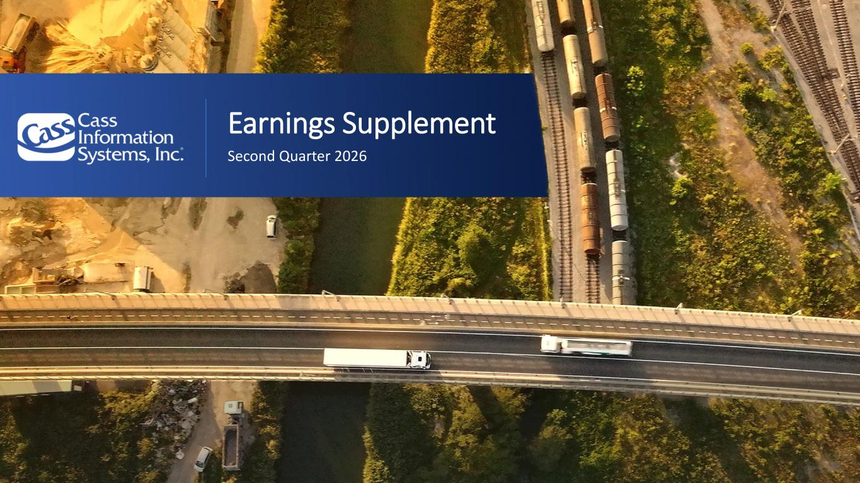

www.cassinfo.com | ©2026 Cass Information Systems | Earnings Supplement Second Quarter 2026

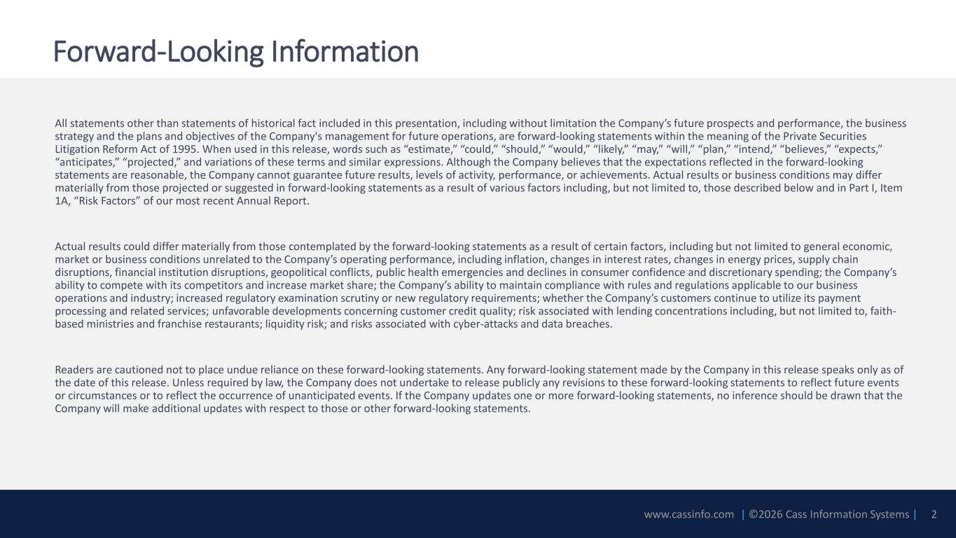
www.cassinfo.com | ©2026 Cass Information Systems | Forward-Looking Information All statements other than statements of historical fact included in this presentation, including without limitation the Company’s future prospects and performance, the business strategy and the plans and objectives of the Company's management for future operations, are forward-looking statements within the meaning of the Private Securities Litigation Reform Act of 1995. When used in this release, words such as “estimate,” “could,” “should,” “would,” “likely,” “may,” “will,” “plan,” “intend,” “believes,” “expects,” “anticipates,” “projected,” and variations of these terms and similar expressions. Although the Company believes that the expectations reflected in the forward-looking statements are reasonable, the Company cannot guarantee future results, levels of activity, performance, or achievements. Actual results or business conditions may differ materially from those projected or suggested in forward-looking statements as a result of various factors including, but not limited to, those described below and in Part I, Item 1A, “Risk Factors” of our most recent Annual Report. Actual results could differ materially from those contemplated by the forward-looking statements as a result of certain factors, including but not limited to general economic, market or business conditions unrelated to the Company’s operating performance, including inflation, changes in interest rates, changes in energy prices, supply chain disruptions, financial institution disruptions, geopolitical conflicts, public health emergencies and declines in consumer confidence and discretionary spending; the Company’s ability to compete with its competitors and increase market share; the Company’s ability to maintain compliance with rules and regulations applicable to our business operations and industry; increased regulatory examination scrutiny or new regulatory requirements; whether the Company’s customers continue to utilize its payment processing and related services; unfavorable developments concerning customer credit quality; risk associated with lending concentrations including, but not limited to, faith- based ministries and franchise restaurants; liquidity risk; and risks associated with cyber-attacks and data breaches. Readers are cautioned not to place undue reliance on these forward-looking statements. Any forward-looking statement made by the Company in this release speaks only as of the date of this release. Unless required by law, the Company does not undertake to release publicly any revisions to these forward-looking statements to reflect future events or circumstances or to reflect the occurrence of unanticipated events. If the Company updates one or more forward-looking statements, no inference should be drawn that the Company will make additional updates with respect to those or other forward-looking statements. 2

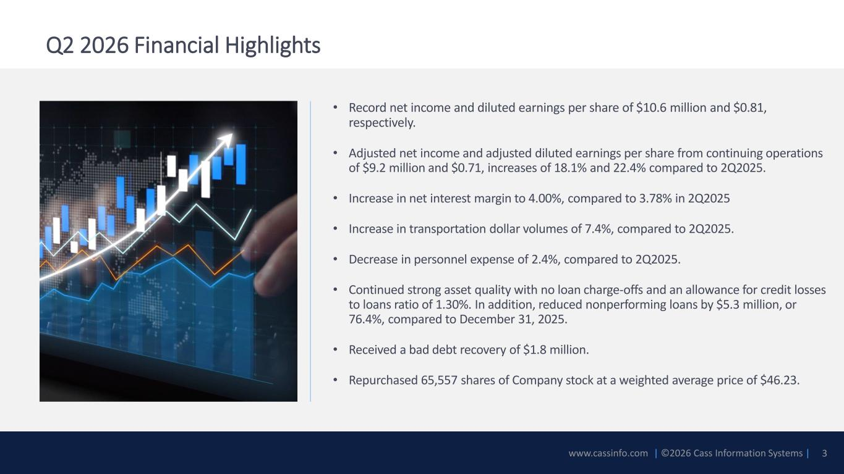
www.cassinfo.com | ©2026 Cass Information Systems | • Record net income and diluted earnings per share of $10.6 million and $0.81, respectively. • Adjusted net income and adjusted diluted earnings per share from continuing operations of $9.2 million and $0.71, increases of 18.1% and 22.4% compared to 2Q2025. • Increase in net interest margin to 4.00%, compared to 3.78% in 2Q2025 • Increase in transportation dollar volumes of 7.4%, compared to 2Q2025. • Decrease in personnel expense of 2.4%, compared to 2Q2025. • Continued strong asset quality with no loan charge-offs and an allowance for credit losses to loans ratio of 1.30%. In addition, reduced nonperforming loans by $5.3 million, or 76.4%, compared to December 31, 2025. • Received a bad debt recovery of $1.8 million. • Repurchased 65,557 shares of Company stock at a weighted average price of $46.23. Q2 2026 Financial Highlights 3

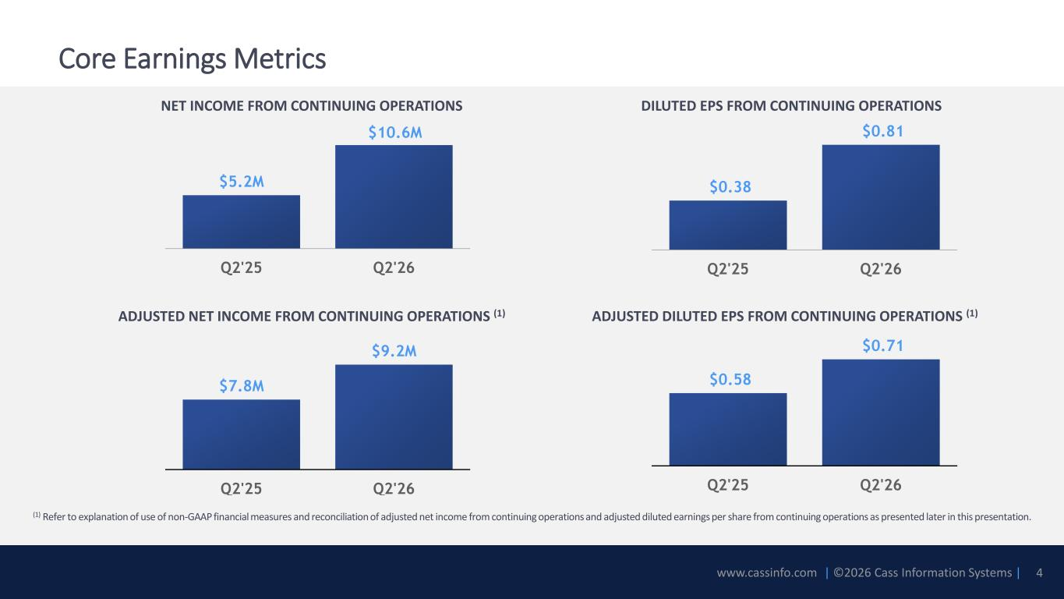
www.cassinfo.com | ©2026 Cass Information Systems | Core Earnings Metrics $7.8M $9.2M Q2'25 Q2'26 $0.58 $0.71 Q2'25 Q2'26 ADJUSTED NET INCOME FROM CONTINUING OPERATIONS (1) ADJUSTED DILUTED EPS FROM CONTINUING OPERATIONS (1) (1) Refer to explanation of use of non-GAAP financial measures and reconciliation of adjusted net income from continuing operations and adjusted diluted earnings per share from continuing operations as presented later in this presentation. $5.2M $10.6M Q2'25 Q2'26 NET INCOME FROM CONTINUING OPERATIONS $0.38 $0.81 Q2'25 Q2'26 DILUTED EPS FROM CONTINUING OPERATIONS 4

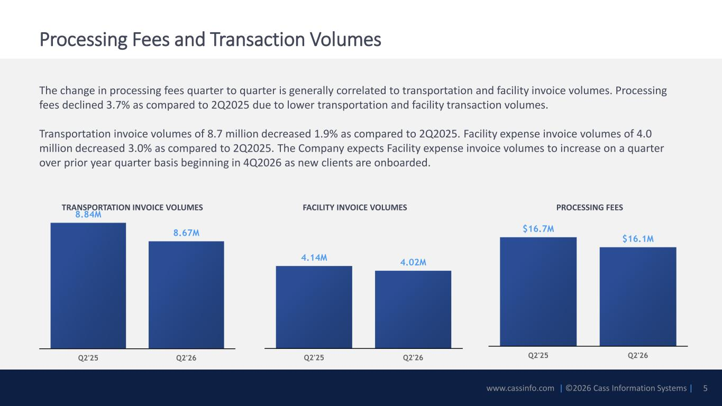
www.cassinfo.com | ©2026 Cass Information Systems | The change in processing fees quarter to quarter is generally correlated to transportation and facility invoice volumes. Processing fees declined 3.7% as compared to 2Q2025 due to lower transportation and facility transaction volumes. Transportation invoice volumes of 8.7 million decreased 1.9% as compared to 2Q2025. Facility expense invoice volumes of 4.0 million decreased 3.0% as compared to 2Q2025. The Company expects Facility expense invoice volumes to increase on a quarter over prior year quarter basis beginning in 4Q2026 as new clients are onboarded. 8.84M 8.67M Q2'25 Q2'26 4.14M 4.02M Q2'25 Q2'26 $16.7M $16.1M Q2'25 Q2'26 Processing Fees and Transaction Volumes TRANSPORTATION INVOICE VOLUMES FACILITY INVOICE VOLUMES PROCESSING FEES 5

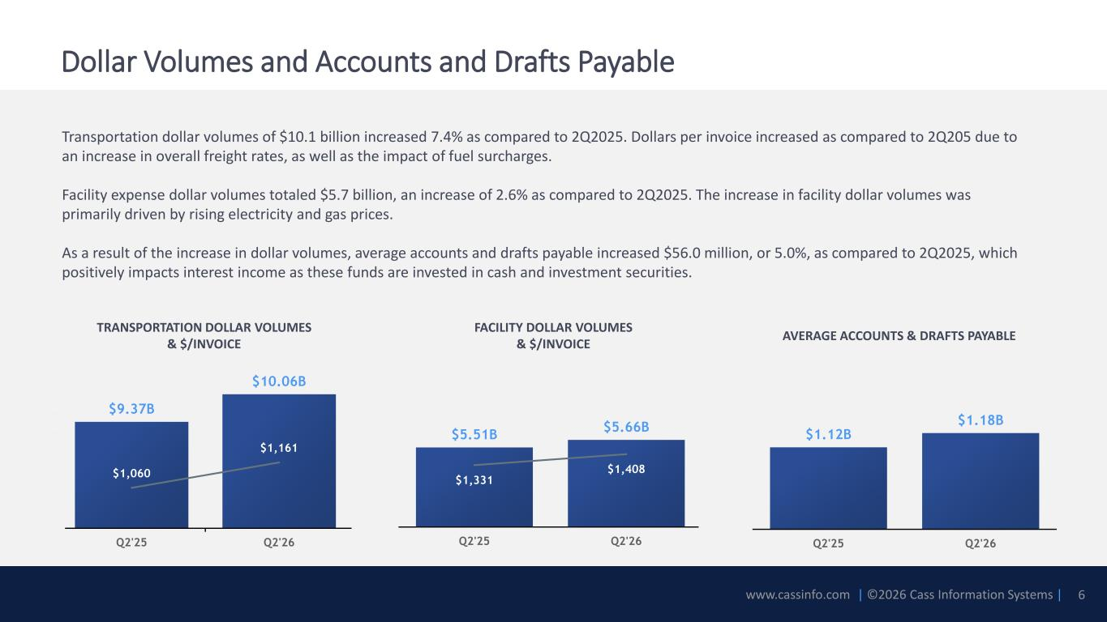
www.cassinfo.com | ©2026 Cass Information Systems | $5.51B $5.66B $1,331 $1,408 900 1100 1300 1500 1700 1900 Q2'25 Q2'26 $9.37B $10.06B $1,060 $1,161 900 1000 1100 1200 1300 1400 1500 6.7E+09 7.2E+09 7.7E+09 8.2E+09 8.7E+09 9.2E+09 9.7E+09 1.02E+10 Q2'25 Q2'26 $1.12B $1.18B Q2'25 Q2'26 Transportation dollar volumes of $10.1 billion increased 7.4% as compared to 2Q2025. Dollars per invoice increased as compared to 2Q205 due to an increase in overall freight rates, as well as the impact of fuel surcharges. Facility expense dollar volumes totaled $5.7 billion, an increase of 2.6% as compared to 2Q2025. The increase in facility dollar volumes was primarily driven by rising electricity and gas prices. As a result of the increase in dollar volumes, average accounts and drafts payable increased $56.0 million, or 5.0%, as compared to 2Q2025, which positively impacts interest income as these funds are invested in cash and investment securities. Dollar Volumes and Accounts and Drafts Payable TRANSPORTATION DOLLAR VOLUMES & $/INVOICE FACILITY DOLLAR VOLUMES & $/INVOICE 6 AVERAGE ACCOUNTS & DRAFTS PAYABLE

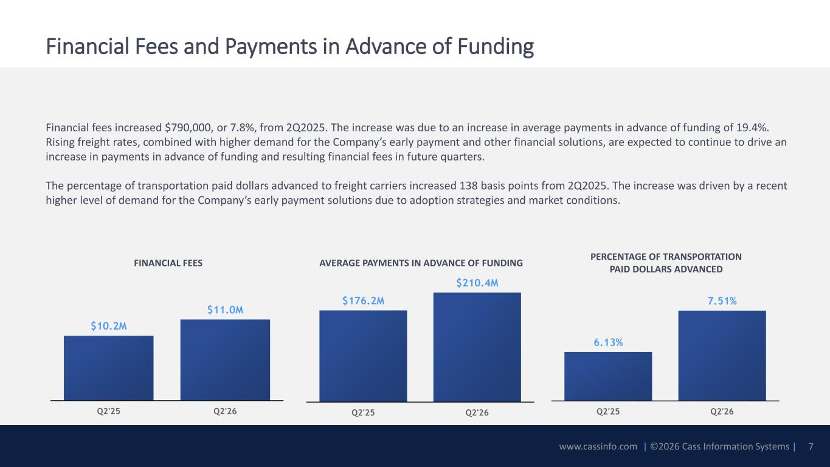
www.cassinfo.com | ©2026 Cass Information Systems | Financial Fees and Payments in Advance of Funding Financial fees increased $790,000, or 7.8%, from 2Q2025. The increase was due to an increase in average payments in advance of funding of 19.4%. Rising freight rates, combined with higher demand for the Company’s early payment and other financial solutions, are expected to continue to drive an increase in payments in advance of funding and resulting financial fees in future quarters. The percentage of transportation paid dollars advanced to freight carriers increased 138 basis points from 2Q2025. The increase was driven by a recent higher level of demand for the Company’s early payment solutions due to adoption strategies and market conditions. $176.2M $210.4M Q2'25 Q2'26 $10.2M $11.0M Q2'25 Q2'26 AVERAGE PAYMENTS IN ADVANCE OF FUNDINGFINANCIAL FEES 7 6.13% 7.51% Q2'25 Q2'26 PERCENTAGE OF TRANSPORTATION PAID DOLLARS ADVANCED

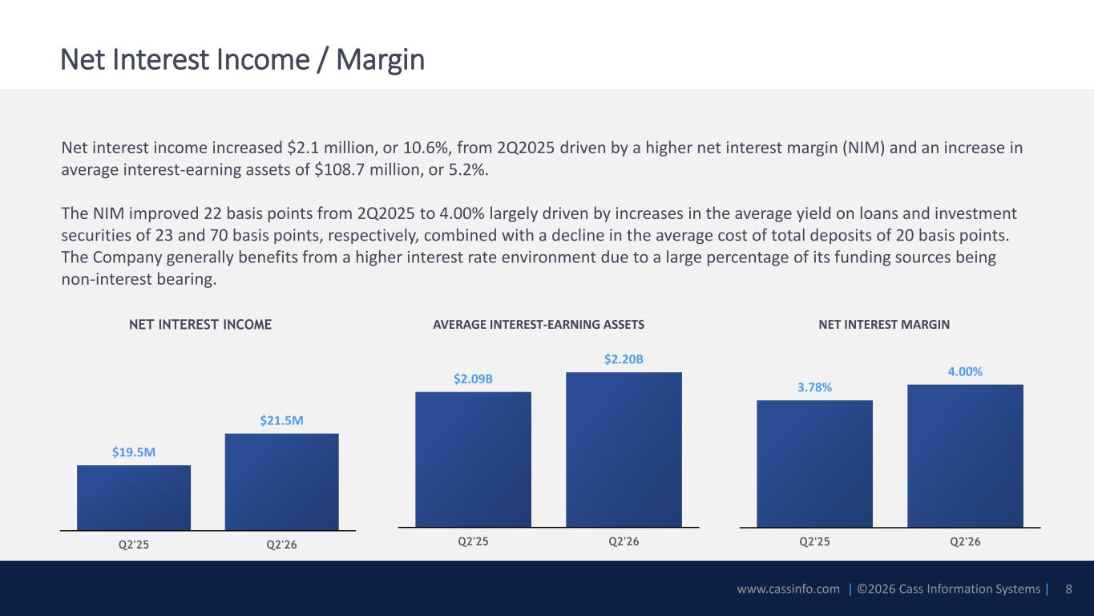
www.cassinfo.com | ©2026 Cass Information Systems | Net interest income increased $2.1 million, or 10.6%, from 2Q2025 driven by a higher net interest margin (NIM) and an increase in average interest-earning assets of $108.7 million, or 5.2%. The NIM improved 22 basis points from 2Q2025 to 4.00% largely driven by increases in the average yield on loans and investment securities of 23 and 70 basis points, respectively, combined with a decline in the average cost of total deposits of 20 basis points. The Company generally benefits from a higher interest rate environment due to a large percentage of its funding sources being non-interest bearing. Net Interest Income / Margin NET INTEREST INCOME AVERAGE INTEREST-EARNING ASSETS NET INTEREST MARGIN $19.5M $21.5M Q2'25 Q2'26 $2.09B $2.20B Q2'25 Q2'26 3.78% 4.00% Q2'25 Q2'26 8

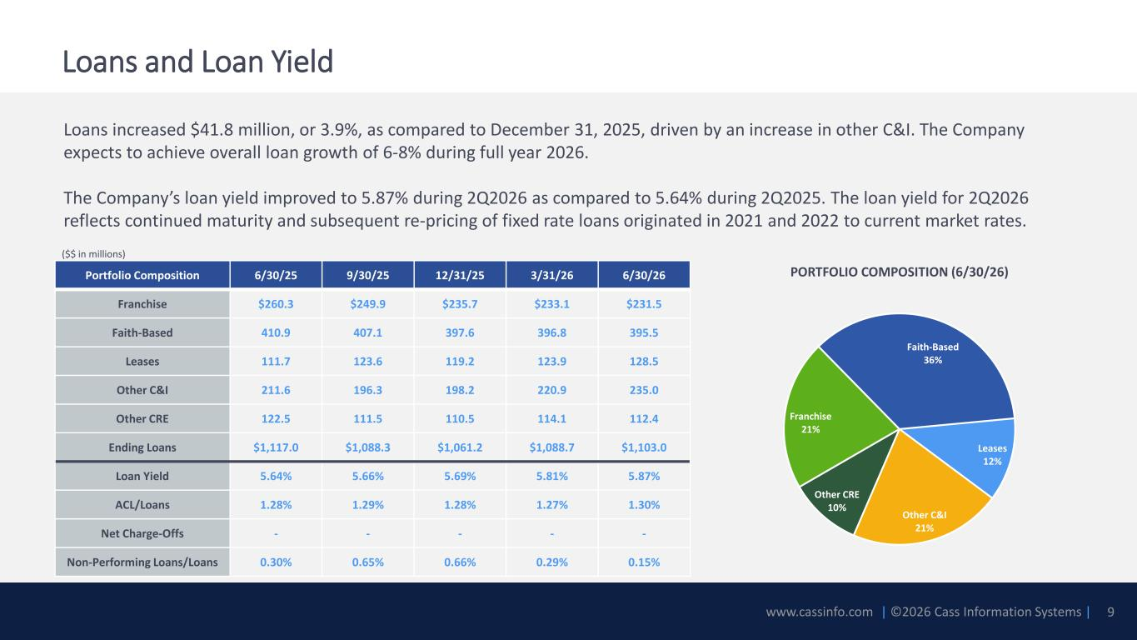
www.cassinfo.com | ©2026 Cass Information Systems | Loans increased $41.8 million, or 3.9%, as compared to December 31, 2025, driven by an increase in other C&I. The Company expects to achieve overall loan growth of 6-8% during full year 2026. The Company’s loan yield improved to 5.87% during 2Q2026 as compared to 5.64% during 2Q2025. The loan yield for 2Q2026 reflects continued maturity and subsequent re-pricing of fixed rate loans originated in 2021 and 2022 to current market rates. Loans and Loan Yield 9 Portfolio Composition 6/30/25 9/30/25 12/31/25 3/31/26 6/30/26 Franchise $260.3 $249.9 $235.7 $233.1 $231.5 Faith-Based 410.9 407.1 397.6 396.8 395.5 Leases 111.7 123.6 119.2 123.9 128.5 Other C&I 211.6 196.3 198.2 220.9 235.0 Other CRE 122.5 111.5 110.5 114.1 112.4 Ending Loans $1,117.0 $1,088.3 $1,061.2 $1,088.7 $1,103.0 Loan Yield 5.64% 5.66% 5.69% 5.81% 5.87% ACL/Loans 1.28% 1.29% 1.28% 1.27% 1.30% Net Charge-Offs - - - - - Non-Performing Loans/Loans 0.30% 0.65% 0.66% 0.29% 0.15% Franchise 21% Faith-Based 36% Leases 12% Other C&I 21% Other CRE 10% PORTFOLIO COMPOSITION (6/30/26) ($$ in millions)

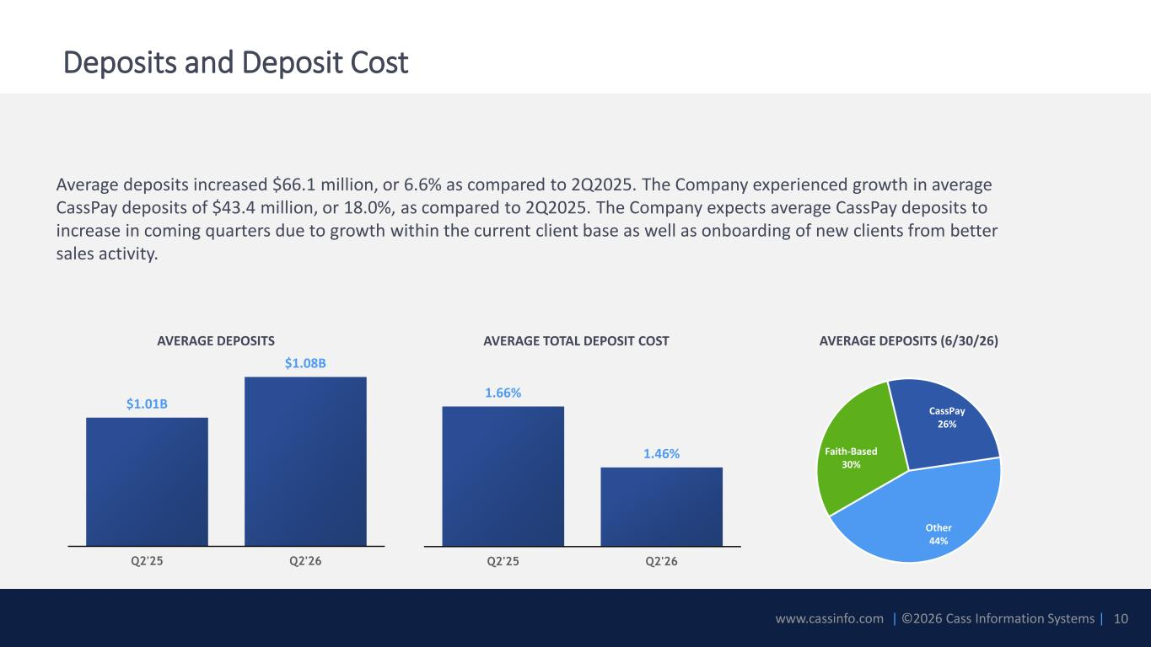
www.cassinfo.com | ©2026 Cass Information Systems | Average deposits increased $66.1 million, or 6.6% as compared to 2Q2025. The Company experienced growth in average CassPay deposits of $43.4 million, or 18.0%, as compared to 2Q2025. The Company expects average CassPay deposits to increase in coming quarters due to growth within the current client base as well as onboarding of new clients from better sales activity. Deposits and Deposit Cost 10 AVERAGE DEPOSITS AVERAGE TOTAL DEPOSIT COST $1.01B $1.08B Q2'25 Q2'26 1.66% 1.46% Q2'25 Q2'26 AVERAGE DEPOSITS (6/30/26) Faith-Based 30% CassPay 26% Other 44%

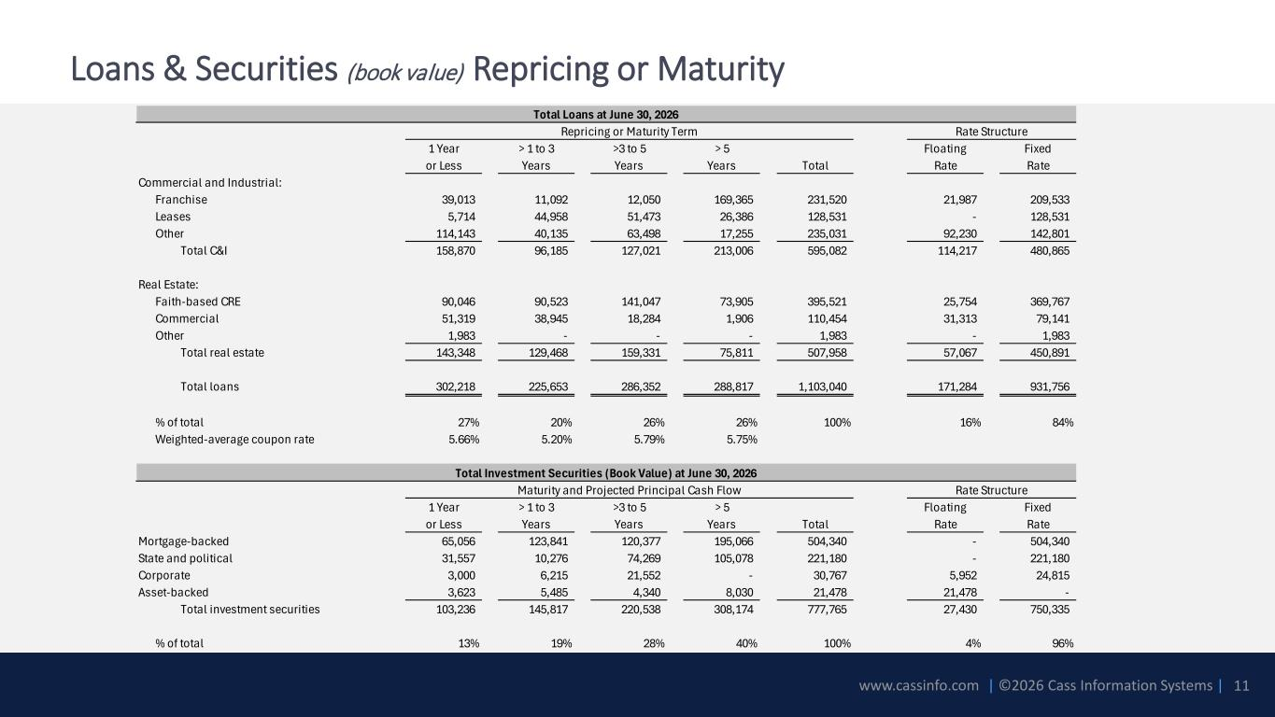
www.cassinfo.com | ©2026 Cass Information Systems | Loans & Securities (book value) Repricing or Maturity 11 1 Year > 1 to 3 >3 to 5 > 5 Floating Fixed or Less Years Years Years Total Rate Rate Commercial and Industrial: Franchise 39,013 11,092 12,050 169,365 231,520 21,987 209,533 Leases 5,714 44,958 51,473 26,386 128,531 - 128,531 Other 114,143 40,135 63,498 17,255 235,031 92,230 142,801 Total C&I 158,870 96,185 127,021 213,006 595,082 114,217 480,865 Real Estate: Faith-based CRE 90,046 90,523 141,047 73,905 395,521 25,754 369,767 Commercial 51,319 38,945 18,284 1,906 110,454 31,313 79,141 Other 1,983 - - - 1,983 - 1,983 Total real estate 143,348 129,468 159,331 75,811 507,958 57,067 450,891 Total loans 302,218 225,653 286,352 288,817 1,103,040 171,284 931,756 % of total 27% 20% 26% 26% 100% 16% 84% Weighted-average coupon rate 5.66% 5.20% 5.79% 5.75% 1 Year > 1 to 3 >3 to 5 > 5 Floating Fixed or Less Years Years Years Total Rate Rate Mortgage-backed 65,056 123,841 120,377 195,066 504,340 - 504,340 State and political 31,557 10,276 74,269 105,078 221,180 - 221,180 Corporate 3,000 6,215 21,552 - 30,767 5,952 24,815 Asset-backed 3,623 5,485 4,340 8,030 21,478 21,478 - Total investment securities 103,236 145,817 220,538 308,174 777,765 27,430 750,335 % of total 13% 19% 28% 40% 100% 4% 96% Total Loans at June 30, 2026 Repricing or Maturity Term Rate Structure Total Investment Securities (Book Value) at June 30, 2026 Maturity and Projected Principal Cash Flow Rate Structure

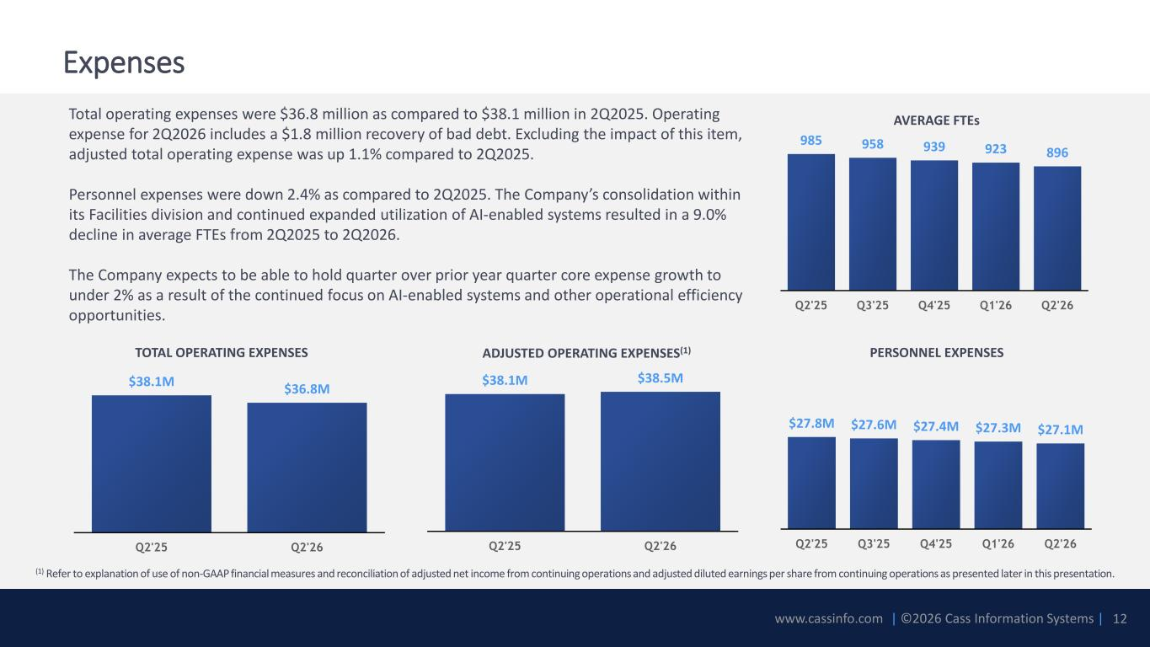
www.cassinfo.com | ©2026 Cass Information Systems | $27.8M $27.6M $27.4M $27.3M $27.1M Q2'25 Q3'25 Q4'25 Q1'26 Q2'26 $38.1M $36.8M Q2'25 Q2'26 $38.1M $38.5M Q2'25 Q2'26 Total operating expenses were $36.8 million as compared to $38.1 million in 2Q2025. Operating expense for 2Q2026 includes a $1.8 million recovery of bad debt. Excluding the impact of this item, adjusted total operating expense was up 1.1% compared to 2Q2025. Personnel expenses were down 2.4% as compared to 2Q2025. The Company’s consolidation within its Facilities division and continued expanded utilization of AI-enabled systems resulted in a 9.0% decline in average FTEs from 2Q2025 to 2Q2026. The Company expects to be able to hold quarter over prior year quarter core expense growth to under 2% as a result of the continued focus on AI-enabled systems and other operational efficiency opportunities. Expenses PERSONNEL EXPENSES 12 ADJUSTED OPERATING EXPENSES(1)TOTAL OPERATING EXPENSES (1) Refer to explanation of use of non-GAAP financial measures and reconciliation of adjusted net income from continuing operations and adjusted diluted earnings per share from continuing operations as presented later in this presentation. AVERAGE FTEs 985 958 939 923 896 Q2'25 Q3'25 Q4'25 Q1'26 Q2'26

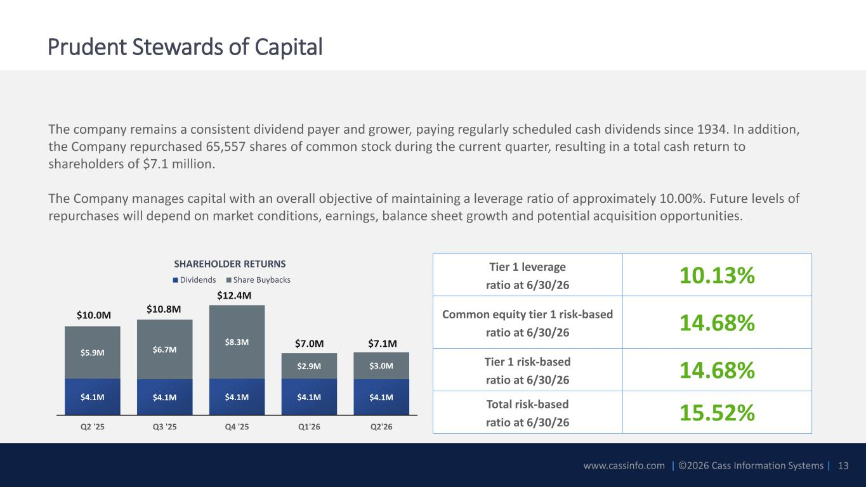
www.cassinfo.com | ©2026 Cass Information Systems | The company remains a consistent dividend payer and grower, paying regularly scheduled cash dividends since 1934. In addition, the Company repurchased 65,557 shares of common stock during the current quarter, resulting in a total cash return to shareholders of $7.1 million. The Company manages capital with an overall objective of maintaining a leverage ratio of approximately 10.00%. Future levels of repurchases will depend on market conditions, earnings, balance sheet growth and potential acquisition opportunities. Prudent Stewards of Capital SHAREHOLDER RETURNS 13 $4.1M $4.1M $4.1M $4.1M $4.1M $5.9M $6.7M $8.3M $2.9M $3.0M Q2 '25 Q3 '25 Q4 '25 Q1'26 Q2'26 Dividends Share Buybacks Tier 1 leverage ratio at 6/30/26 10.13% Common equity tier 1 risk-based ratio at 6/30/26 14.68% Tier 1 risk-based ratio at 6/30/26 14.68% Total risk-based ratio at 6/30/26 15.52% $12.4M $10.8M$10.0M $7.1M$7.0M

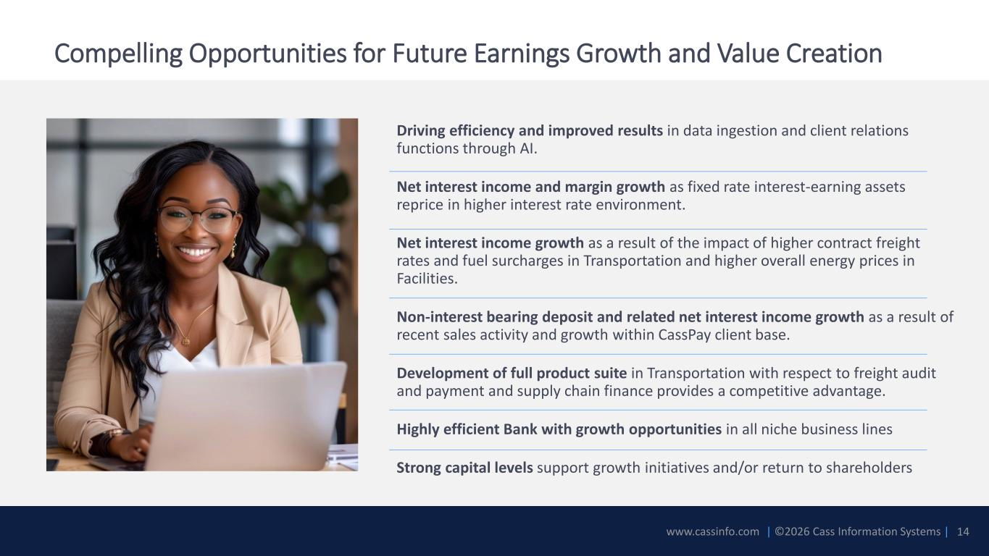
www.cassinfo.com | ©2026 Cass Information Systems | Compelling Opportunities for Future Earnings Growth and Value Creation Driving efficiency and improved results in data ingestion and client relations functions through AI. Net interest income and margin growth as fixed rate interest-earning assets reprice in higher interest rate environment. Net interest income growth as a result of the impact of higher contract freight rates and fuel surcharges in Transportation and higher overall energy prices in Facilities. Non-interest bearing deposit and related net interest income growth as a result of recent sales activity and growth within CassPay client base. Development of full product suite in Transportation with respect to freight audit and payment and supply chain finance provides a competitive advantage. Highly efficient Bank with growth opportunities in all niche business lines Strong capital levels support growth initiatives and/or return to shareholders 14


www.cassinfo.com | ©2026 Cass Information Systems | Appendix 15

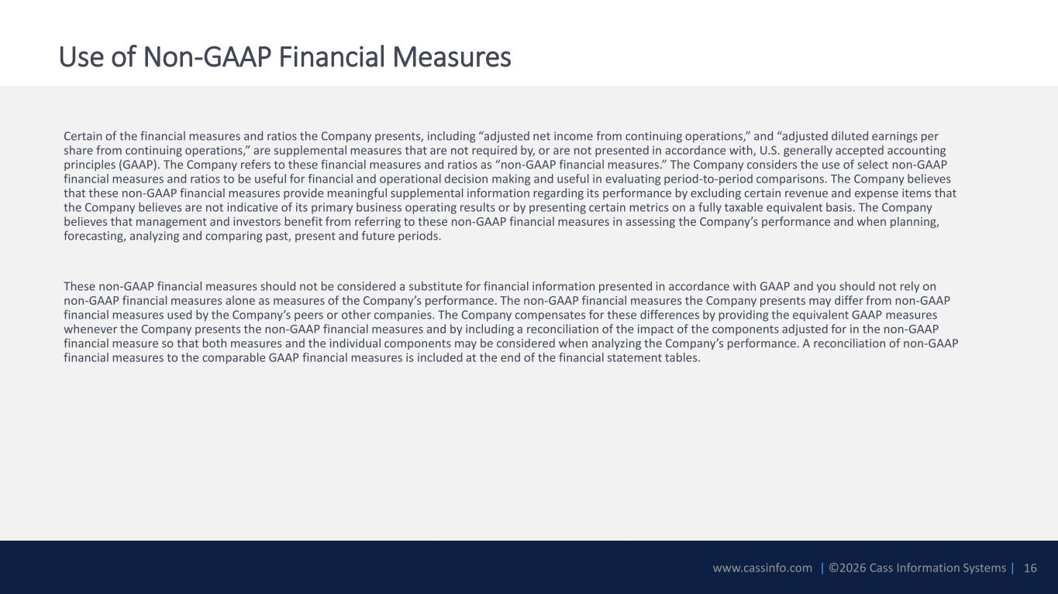
www.cassinfo.com | ©2026 Cass Information Systems | Use of Non-GAAP Financial Measures Certain of the financial measures and ratios the Company presents, including “adjusted net income from continuing operations,” and “adjusted diluted earnings per share from continuing operations,” are supplemental measures that are not required by, or are not presented in accordance with, U.S. generally accepted accounting principles (GAAP). The Company refers to these financial measures and ratios as “non-GAAP financial measures.” The Company considers the use of select non-GAAP financial measures and ratios to be useful for financial and operational decision making and useful in evaluating period-to-period comparisons. The Company believes that these non-GAAP financial measures provide meaningful supplemental information regarding its performance by excluding certain revenue and expense items that the Company believes are not indicative of its primary business operating results or by presenting certain metrics on a fully taxable equivalent basis. The Company believes that management and investors benefit from referring to these non-GAAP financial measures in assessing the Company’s performance and when planning, forecasting, analyzing and comparing past, present and future periods. These non-GAAP financial measures should not be considered a substitute for financial information presented in accordance with GAAP and you should not rely on non-GAAP financial measures alone as measures of the Company’s performance. The non-GAAP financial measures the Company presents may differ from non-GAAP financial measures used by the Company’s peers or other companies. The Company compensates for these differences by providing the equivalent GAAP measures whenever the Company presents the non-GAAP financial measures and by including a reconciliation of the impact of the components adjusted for in the non-GAAP financial measure so that both measures and the individual components may be considered when analyzing the Company’s performance. A reconciliation of non-GAAP financial measures to the comparable GAAP financial measures is included at the end of the financial statement tables. 16

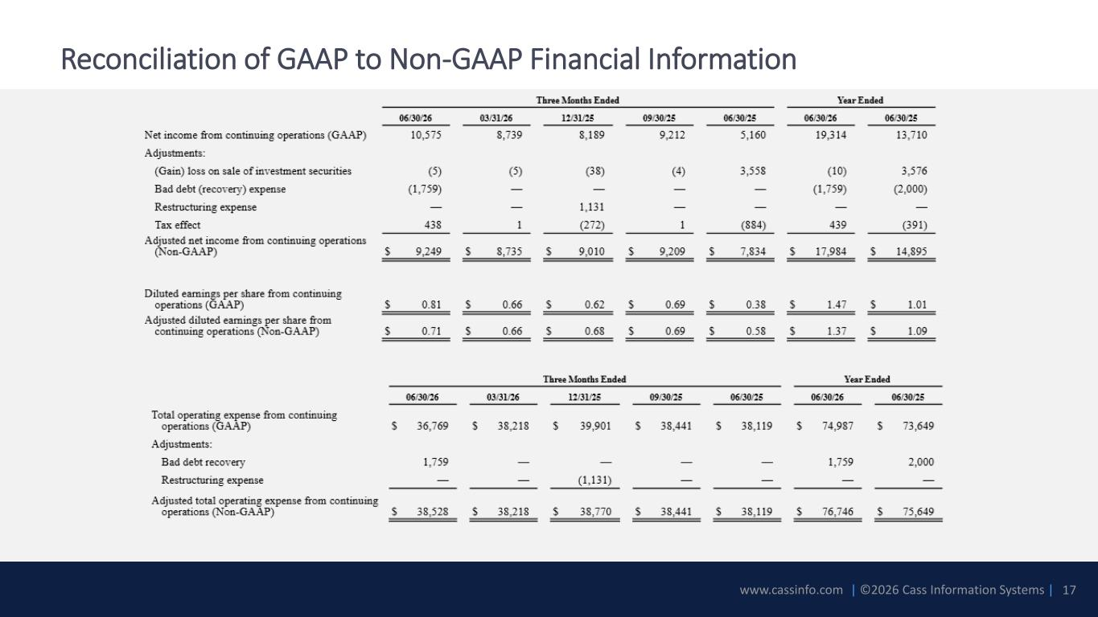
www.cassinfo.com | ©2026 Cass Information Systems | Reconciliation of GAAP to Non-GAAP Financial Information 17

